NCF-SMAN2
Desktop Fanless Network Appliance with Intel Gemini Lake/Gemini Lake-R platform processor, 4 x LAN, SATA and M.2 SSD slot
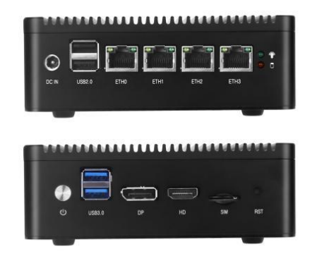
Feature:
●Onboard Intel Gemini Lake/Gemini Lake-R J/N series processors
●Integrated Intel UHD Core Graphics 600
●HDMI, DP display interface, support dual-screen display
●Single channel DDR4, maximum support 8G/2400MHz
●1 x mPCIE Slot, support 3G/4G module
●1 x M.2 Key M, support 2242/2280 SSD
●4 x 2.5G network card, 10/100/1000/2500 adaptive
●12V power supply
Specification: NCF-SMAN2
Model No. |  | NCF-SMAN2
Form Factor |  | Desktop
Platform | Processor Options | Intel Gemini Lake/Gemini Lake-R Platform Processors
Platform | CPU Socket | Onboard
Platform | Chipset | SoC
OS Support |  | Windows10/11/Linux
BIOS |  | AMI UEFI BIOS
Display |  | Intel UHD HD Graphics 600 with DirectX 12 support, OpenGL 4.4
 |  | 1 x HDMI, maximum resolution 4096X2160@30Hz
 |  | 1 x DP, maximum resolution 4096X2160@30Hz
System Memory | Technology | DDR4/2400MT/s
System Memory | Max. Capacity | 8GB
System Memory | Socket | 1 x 260pin SODIMM
Networking | Ethernet Ports | 4 x Intel I225V 2.5 Gigabit Ethernet, supports wake-up on LAN, network card startup
Networking | Bypass | -
Storage | SATA | 1 x SATA3.0
Storage | M.2 | 1 x M.2 KEY M
Front I/O Interface | Power Button | 1 x Power Button
Front I/O Interface | Reset Button | 1 x Reset Button
Front I/O Interface | USB | 2 x USB 3.0
Front I/O Interface | Display | 1 x HDMI, 1 x DP
Front I/O Interface | SIM | 1 x SIM slot
Rear I/O Interface | Power | 1 x DC interface
Rear I/O Interface | LED | 1 x Power LED, 1 x HDD LED
Rear I/O Interface | USB | 2 x USB 2.0
Rear I/O Interface | Ethernet | 4 x LAN
Expansion | mPCIe | 1 x mPCIE slot, support 3G/4G-LTE module
Expansion | Wi-Fi | Optional
Cooling | Processor | CPU Heat Sink
Cooling | System | Fanless
Environmental Parameters | Temperature | Storage temperature：-20℃～70℃  Working temperature: -10℃～60℃
Environmental Parameters | Humidity | 5 ~ 90% non condensing
System Dimensions | (WxHxD) | 136 x 126 x 47mm
System Dimensions | Weight | -
Package Dimensions | (WxHxD) | -
Package Dimensions | Weight | -
Power | Input | DC_12V Input
Ordering Information
Model | CPU | Thread | Frequency | Memory | Storage | LAN | USB | Power
SMAN2-J4125-S | J4125 | 4C4T | 2.00-2.70GHz | 1*DDR4 SODIMM | 1*SATA3.0，1*M.2 KEY M | 4 | 4 | DC_12V
SMAN2-N4000-S | N4000 | 2C2T | 1.10-2.60GHz | 1*DDR4 SODIMM | 1*SATA3.0，1*M.2 KEY M | 2 | 4 | DC_12V
SMAN2-N5000-S | N5000 | 4C4T | 1.10-2.70GHz | 1*DDR4 SODIMM | 1*SATA3.0，1*M.2 KEY M | 2 | 4 | DC_12V

Packing List
1 | 1 x SATA signal cable
2 | 1 x Screw bag
3 | 1 x Power cord
4 | 1 x SATA power cable
Optional Accessories
1 | Power cord 3P 180cm, USA
2 | Power cord 3P 180cm, Europe
3 | Power cord 3P 180cm, UK
4 | Power cord 3P 180cm, Japan
5 | Power cord 3P 180cm, India

Contact:
Allen Dai / Sales Manager
Armortec Technology Limited
Email: allen.y.dai@armortec.net
Skype: allen.dai89
Tel: +86 150 1266 9595

