EPC-N5242Z-V
Fanless Mini Desktop Industrial Computer with Integrated Intel® Celeron J4125, 2 LAN
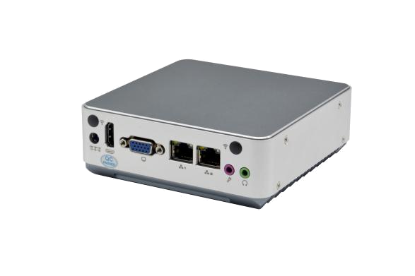
Feature:
● Integrated Intel® Processor Celeron J4125 quad-core eight-thread processing
● 1* DDR4 SODIMM memory slot, supporting 2400MHz memory, up to 16GB
● Support 1*VGA and 1*HDMI display output
● Support 2* Realtek8111H Gigabit network card, support network wake up, PXE function
● Support 4*USB interface
● Support DC 12V power input
● Fan cooling structure, all aluminum alloy material
Specification:
Model | EPC-N5242Z-V
Chassis | Structure | All aluminum alloy
Chassis | Colour | Iron gray
Chassis | Dimension (L x W x H) | 128mmx128mmx46mm
Chassis | Weight (Net weight of bare metal) | 1.55KG
Chassis | Installation | Desktop / embedded
Motherboard | CPU | Integrated Intel® Processor Celeron J4125 quad-core eight-thread processor, TDP 15W
Motherboard | Chipset | SOC
Motherboard | Display | Integrated Intel® HD Graphics 600
Motherboard | Ram | 1 x DDR4 SODIMM slot, supporting 2400MHz memory and a maximum of 16GB memory
Front panel interface | POWER | 1 x power switch
Front panel interface | LED | 1 x PWR LED, 1 x HDD LED
Front panel interface | USB | 4 x USB 3.0 interface
Front panel interface | PS/2 | 1 x PS/2 interface, keyboard and mouse in one
Front panel interface | LAN | 2 x RJ45 Gigabit network port, 2 x Realtek8111H
Front panel interface | Display interface | 1 x VGA port, 1 x HDMI port
Front panel interface | Audio | 1 x Line out interface, 1 x MIC interface
Front panel interface | Power supply | 1 x DC power adapter interface, support DC12V power input
HDD | M.2 | 1*M.2 slot, 2280 Support SATA mode
Extend | M.2 | 1*M.2 slot M.2 2230, support WiFi
OS | Microsoft Windows | Windows 10,11，64bit
OS | Linux | Ubuntu
OS | Watch Dog | Support hardware reset function (256 levels, 0~255 seconds)
Power | Power type | External power adapter
Power | Input | DC 12V
Power | Output | AC TO DC, 36W / 60W (optional)
Environment | Operating Temp. | -10℃～60℃
Environment | Storage Temp. | -20℃～70℃
Environment | Relative Humidity | 5%-95% Relative humidity, no condensation
Environment | Vibration | 0.5g rms/5-500HZ/random/operating

System Dimension:
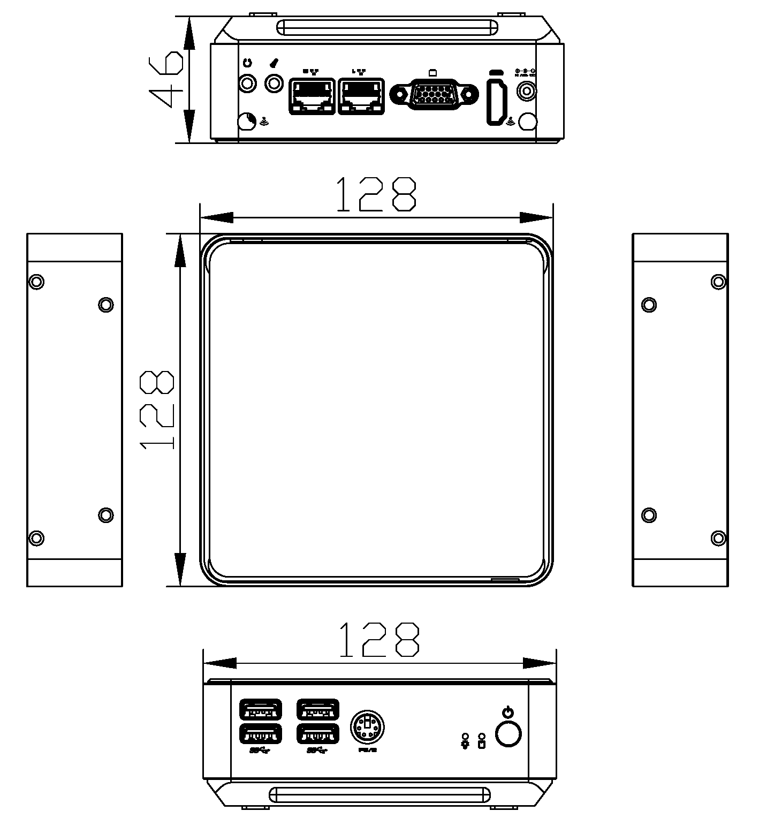

External I/0 view of the rear panel
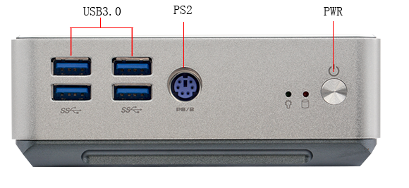
Contact:

Front panel external I/0 view
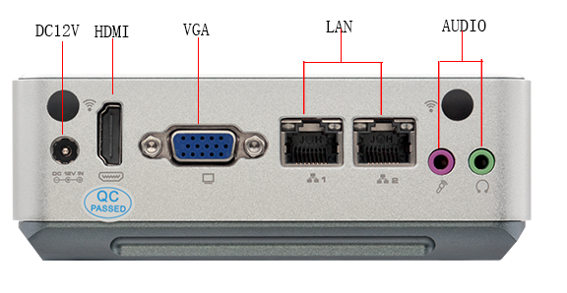
Allen Dai / Sales Manager
Armortec Technology Limited
Email: allen.y.dai@armortec.net
Skype: allen.dai89
Tel: +86 150 1266 9595

