FW-SK62

1U Rackmount Network Appliance based on Intel Celeron 3865U 1.8 GHz Dual Core Processor 6 LAN 2 SFP
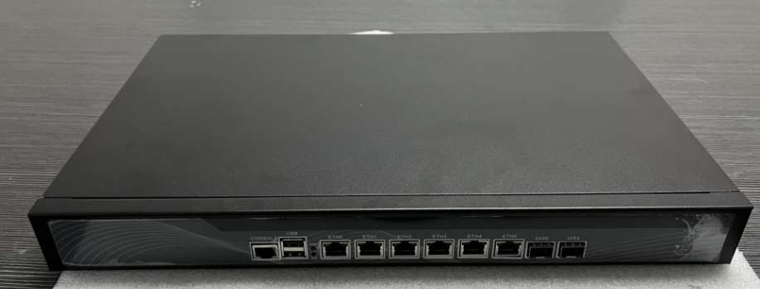

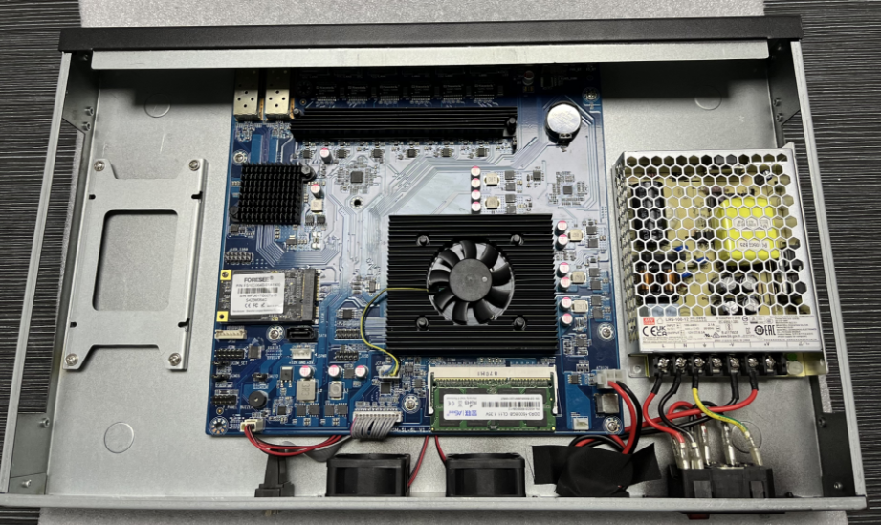

Feature:
- Intel Dual-core Celeron 3865U Dual Core 1.8GHz
- Built-in 6 GbE LAN ports and 2 GbE SFP
- Supports 1* SODIMM DDR3, up to 8 GB DDR3 Memory
- Intel 82574L GbE LAN controller and i350 SFP controller
- 2 x system cooling fans
Overview:
The FW-SK62 is a cost-effective, high performance 1U rackmount network security system based on Intel Celeron 3865U Dual-core CPU, taking advantage of the advances in Intel's Cougar Point architecture. The Celeron 3865U CPU is targeted at UTM, firewall, VPN, IPS and WAN optimization applications from SMB to Enterprise environment. The system has 6 built-in GbE LAN ports, 2 built-in GbE SFP ports, 1 x DDR3 1600 SO-DIMMs, 2 x system cooling fans and open frame power supply.
Specification: FW-SK62

Model No. |  | FW-SK62
Form Factor |  | 1U 19” Rackmount
Platform | Processor Options | Support Intel Celeron 3865U 1.8G Dual Core processor
Platform | CPU Socket | BGA1356
Platform | Chipset | SoC
Platform | Security Acceleration | N/A
BIOS |  | AMI UEFI BIOS
System Memory | Technology | 1600MHz DDR3 memory
System Memory | Max. Capacity | 8GB
System Memory | Socket | 1 x SODIMM DDR3
Networking | Ethernet Ports | 6 x Intel 82574L 1GbE Lan  2 x Intel I350-AM2: 2 x 1GbE SFP
Networking | Bypass | -
I/O Interface | Reset Button | -
I/O Interface | LED | Power/Storage
I/O Interface | Power Button | -
I/O Interface | Console | 1x RJ45
I/O Interface | USB | 2 x USB 2.0 ports at rear  1 x USB 2.0 via internal headers
I/O Interface | LCD Module | -
I/O Interface | Display | 1x VGA
I/O Interface | Power Input | 1 x AC
Storage | HDD/SSD Support | 1 x 2.5'' bays
Storage | Onboard Storage | SATA 3.0Gb/s connector x 1  Mini PCIe Socket x 1, support Msata
Expansion | PCIe | -
Expansion | Mini-PCIe | -
Miscellaneous | Watchdog | Yes
Miscellaneous | Internal RTC with Li Battery | Yes
Miscellaneous | TPM | -
Cooling | Processor | CPU fan
Cooling | System | 2 x cooling fans
Environmental Parameters | Temperature | 0℃～45℃/-20℃～70℃
Environmental Parameters | Humidity | 0-95% (relative humidity; non-condensing)
System Dimensions | (WxHxD) | 432 x 266 x 46 mm
System Dimensions | Weight | 4.2 kg
Package Dimensions | (WxHxD) | -
Package Dimensions | Weight | -
Power | Type/Watts | 100W Open Frame PSU
Power | Input | 90~264V@47~63Hz
Approvals and Compliance |  | -

Packing List
1 | 2 x Rackmount ear
2 | 1 x SATA signal cable
3 | 1 x Screw bag
4 | 1 x Power cord
5 | SATA power cable
Optional Accessories
1 | Power cord 3P 180cm, USA
2 | Power cord 3P 180cm, Europe
3 | Power cord 3P 180cm, UK
4 | Power cord 3P 180cm, Japan
5 | Power cord 3P 180cm, India
Contact:
Allen Dai / Sales Manager
Armortec Technology Limited
Email: allen.y.dai@armortec.net
Skype: allen.dai89
Tel: +86 150 1266 9595

