NC-6010
Desktop Network Appliance with Intel Celeron J1900/1800 Processors, 6LAN, Mini PCIe and m-SATA slot, BYPASS
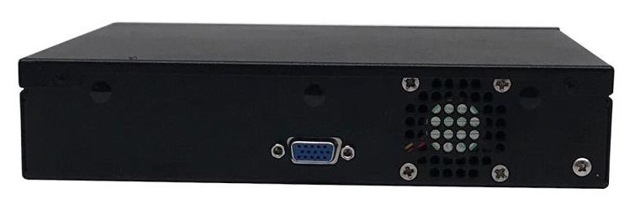
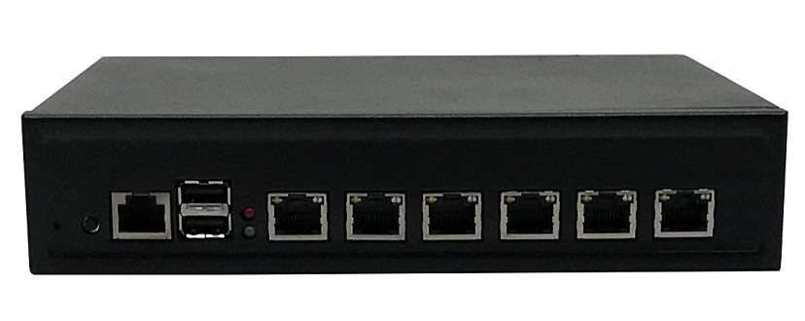

Feature:
Intel® Celeron J1900 (Codenamed Bay Trail)
6x GbE RJ45, 1x RJ45 Console Port
Max. 8GB DDR3L 1600/1333MHz UDIMM
1x Mini-PCIe Socket (PCIe/USB2.0 Signal)
Mini Desktop Form Factor
2x USB 2.0, 1x VGA
Overview:
The NC-6010, powered by the Celeron J1900 (Codenamed Bay Trail)processor, is a desktop form factor network appliance designed for entry-level network security, gateway or vCPE.
Specification: NC-6010
Model No. |  | NC-6010
Form Factor |  | Desktop
Platform | Processor Options | Intel Celeron J1900/J1800
Platform | CPU Socket | Onboard
Platform | Chipset | SoC
OS Support |  | Linux, Ubuntu, CentOS, pfSense, Windows 7 or above
BIOS |  | AMI BIOS
System Memory | Technology | DDR3L 1600/1333 MHz
System Memory | Max. Capacity | 8GB
System Memory | Socket | 1x 204pin SODIMM
Networking | Ethernet Ports | Intel Ethernet Controller WGI211ATL, Gigabit Ethernet x 6
Networking | Bypass | Optional
Storage | HDD/SSD Support | 1 x 2.5 inch HDD bays
Storage | CF/SD | -
Storage | mSATA | 1x m-SATA
I/O Interface | Reset Button | Reset Button x 1(alternative to Power button)
I/O Interface | LED | Power LED x 1, HDD Active x 1, LAN LED x 8(Optoinal Status LED x  1)
I/O Interface | Power Button | Power Button x 1(alternative to reset button)
I/O Interface | Console | 1x RJ45
I/O Interface | USB | 2x USB 2.0
I/O Interface | LCD Module | -
I/O Interface | Display | 1x VGA
I/O Interface | Power Input | 60W, 12V DC-in power connector
Expansion | PCIe | -
Expansion | Mini-PCIe | Yes
Miscellaneous | Watchdog | Yes
Miscellaneous | Internal RTC with Li Battery | Yes
Miscellaneous | TPM | -
Cooling | Processor | CPU Heat Sink
Cooling | System | 1x cooling fans
Environmental Parameters | Temperature | 0℃～45℃/ -20℃～70℃
Environmental Parameters | Humidity | 5 ~ 90% non condensing
System Dimensions | (WxHxD) | 210x43.9x214mm
System Dimensions | Weight | 4.5 kg
Package Dimensions | (WxHxD) | 230x50x234mm
Package Dimensions | Weight | 5.47kg
Power | Type/Watts | 60W Open Frame PSU
Power | Input | 90~264V@47~63Hz
Approvals and Compliance |  | CE, FCC, RoHS

System Dimension:
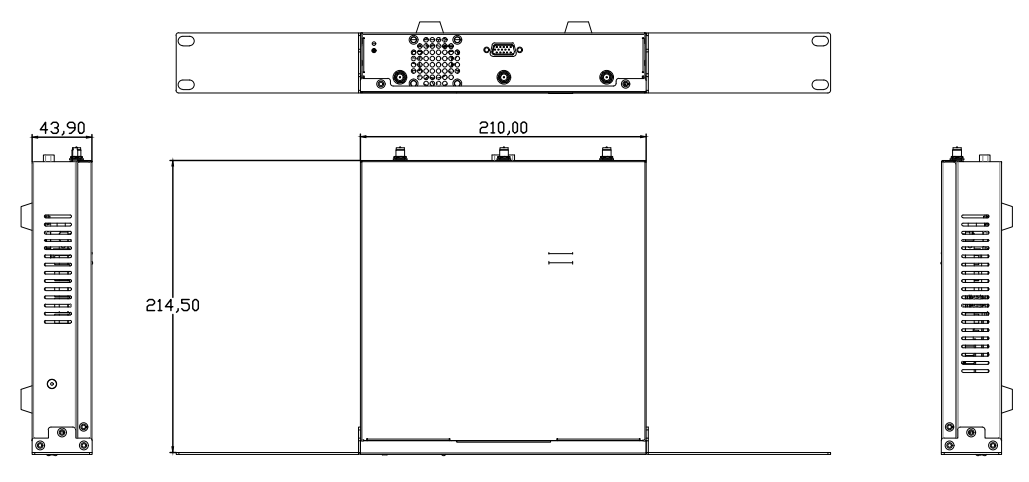

Ordering Information
Part number | CPU | Memory | VGA | LVDS | LAN | USB | COM | BYPASS | Power
FM-69F | Celeron J1900 | 1 x SODDR3 | 1 | - | 6 x Intel 211AT | 6 | 2 | - | DC 12V
FM-69F_B | Celeron J1900 | 1 x SODDR3 | 1 | - | 6 x Intel 211AT | 6 | 2 | 2 | DC 12V

Packing List
1 | SATA data cable
2 | SATA power cable
3 | VGA extension cable
4 | Driver CD

Optional Accessories
1 | Rear I/O panel

Contact:
Allen Dai / Sales Manager
Armortec Technology Limited
Email: allen.y.dai@armortec.net
Skype: allen.dai89
Tel: +86 150 1266 9595

