FW-7563-2O
1U Rackmount Network Appliance with Intel Core i3/i5/i7 or Xeon with 6 GbE LAN, 2 GbE SFP supporting mSATA and Wi-Fi/LTE card
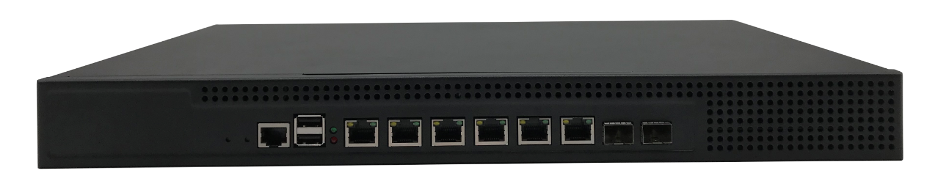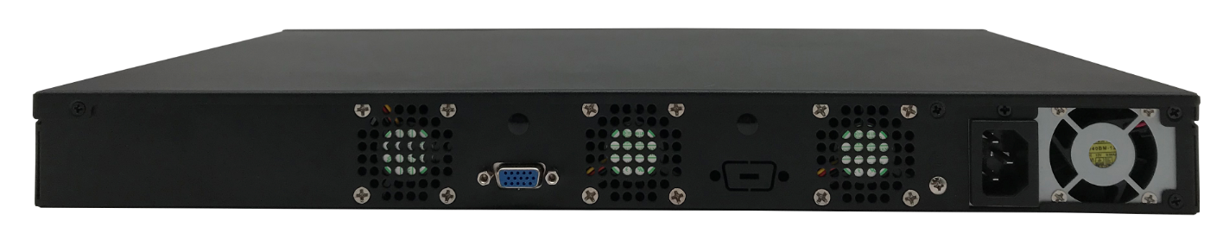

Overview:
Thank you for choosing the FW-7564-2O. The system is powered by Intel Core Processors, codenamed Ivy Bridge/Sandy Bridge, with the Intel B75 Series Chipset. It supports up to 16GB of DDR3 system memory at 1600MHz on dual-channel DIMM banks. The FW-7564-2O is equipped with advanced I/O capacity which includes an RJ-45 console port, 4 Serial-ATA ports (comply with SATA Standard 3.0 and 2.0), a mini SATA slot and a CompactFlash slot.

The onboard Ethernet ports be configured with bypass depending on the module specification.

Feature:
Adopts the dedicated multi Ethernet application scheme to design
Based on Intel B75 express chipset
Integrated with 6 x Intel 82583V 1000M Ethernet cards, supports 2 pairs BYPASS
Integrated 1 x Intel i350, supporting 2 x GbE SFP ports
Provides 1 Mini PCIe slot, supports Wi-Fi/LTE modules
Provides 1 mSATA slot, supports SSD, transit rate reaches 6Gbps
Supports SSD, SATA HDD, CF card storage
Specification: FW-7563-2O
Model No. |  | FW-7563-2O
Form Factor |  | 1U Rackmount
Platform | Processor Options | Intel Sandy Bridge/ Ivy Bridge 32nm/22nm Core i7/i5/i3, Pentium, Celeron, Xeon E3 1200 v2.
Platform | CPU Socket | LGA1155
Platform | Chipset | Intel B75
OS Support |  | Linux, Ubuntu, CentOS, pfSense, Windows All
BIOS |  | AMI 32M
System Memory | Technology | DDR3 1600/1333/1066MHz
System Memory | Max. Capacity | 16GB
System Memory | Socket | 2 x SO-DIMM
Networking | Ethernet Ports | 6 x Intel 82583V GbE LAN  2 x GbE SFP via Intel i350
Networking | Bypass | 1 pair of BYPASS
Storage | HDD Bays | 1 x 3.5 inch, or 2 x 2.5 inch
Storage | CF/SD | 1 x CF socket onboard
Storage | mSATA | 1 x mSATA socket onboard
I/O Interface | Reset Button | 1 x Reset Button
I/O Interface | LED | 1 x Power LED, 1 x HDD LED
I/O Interface | Power Button | 1 x Power Button
I/O Interface | Console | 1 x RJ45 Console
I/O Interface | USB | 2 x USB 2.0
I/O Interface | LCD Module | N/A
I/O Interface | Display | 1 x VGA output
I/O Interface | Power Input | 1 x AC Inlet
Expansion | PCIe | N/A
Expansion | Mini-PCIe | 1 x Mini PCIe
Miscellaneous | Watchdog | Yes
Miscellaneous | Internal RTC with Li Battery | Yes
Miscellaneous | TPM | Yes
Cooling | Processor | 1 x Bronze CPU Fan
Cooling | System | 3 x 4020 System Fan
Environmental Parameters | Temperature | -15~60℃
Environmental Parameters | Humidity | 0% ~ 95%, non condensing
Physical Dimensions | (WxHxD) | 430*270*44mm
Physical Dimensions | Weight | 4.5KG
Package Dimensions | (WxHxD) | 530*370*150mm
Package Dimensions | Weight | 5.0KG
Power | Type/Watts | 220W
Power | Input | 4A 100-127V~ or 2A 200-240V~ 47-63Hz
Approvals and Compliance |  | CE, FCC

System Structure
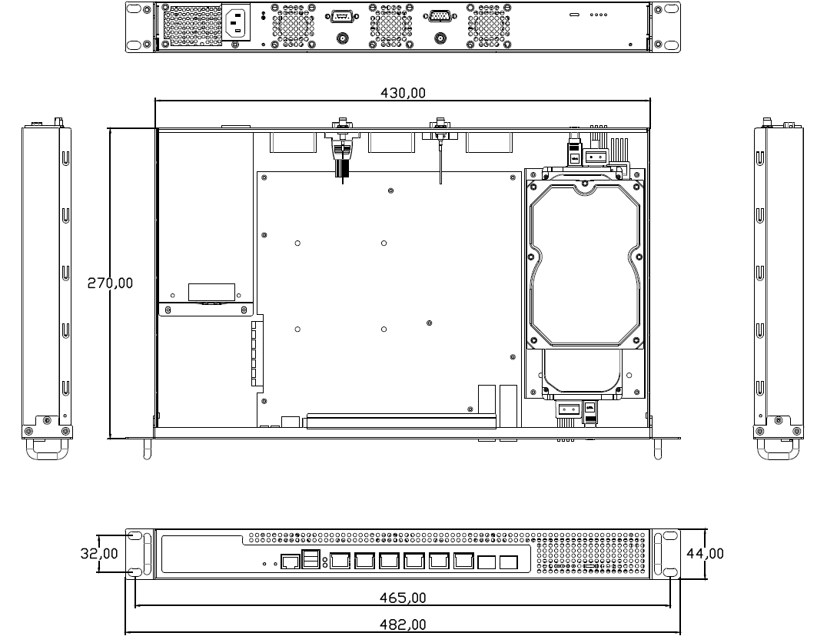
Ordering Information
Part number | PCH | DDR3 | 1Gb LAN port | Bypass | Console | USB 2.0 | 2.5'' HDD | 3.5'' HDD | PCIe Expansion | Power
FW-7563-2O | B75 | 2 | 6 x Intel 82583V | 2 | 1 | 2 | 2 | 1 | - | AC 220W single ATX
Packing List
1 | SATA data cable
2 | Power cord 3P 180cm, China
3 | Rack ears
4 | Accessory screw bag
Optional Accessories
1 | Power cord 3P 180cm, USA
2 | Power cord 3P 180cm, Europe
3 | Power cord 3P 180cm, UK
4 | Power cord 3P 180cm, Japan
5 | Power cord 3P 180cm, India

Contact:
Allen Dai / Sales Manager
Armortec Technology Limited
Email: allen.y.dai@armortec.net
Skype: allen.dai89
Tel: +86 150 1266 9595

