Integrated Intel Celeron J1900 quad core 22nm processor(2.0GHz), compatible with Intel Bay Trail -I/M/D full series CPU
Intel Bay Trail SOC chipset
Integrated Intel HD graphics core, supports VGA/HDMI/LVDS video output
SO-DIMM DDR3 memory slot, supports 1333 memory, Max. 8Gb
Onboard 1 mini-PCIE slots, supports Wifi/3G modules
Supports 1 x 2.5 inch notebook HDD bay
Integrated Realtek ALC662 6 channel high definition audio controller

ITX-M50 VER:2.0 Motherboard Photos

1. Motherboard Front View
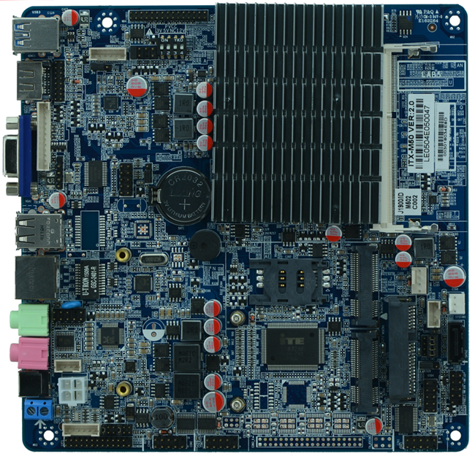
2. I/O Panel Front View
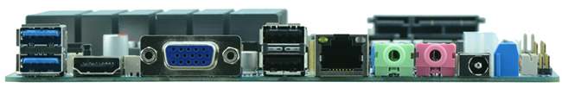
3. I/O Panel Side View
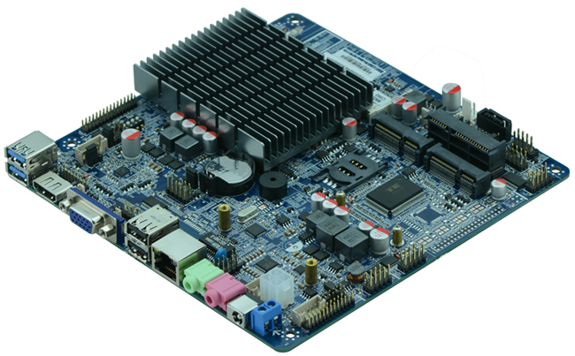
4. Memory Side View
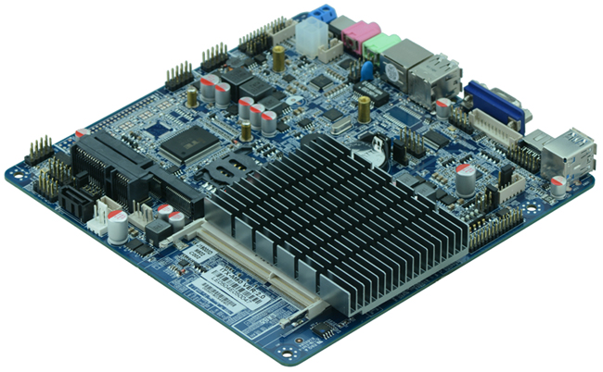
Product Model | ITX-M50 VER:2.0
CPU | Integrated J1900 quad core 22nm processor 2.0GHz
Chipset | Intel Bay Trail SOC platform, cpu integrated
Memory | 1 x SO-DIMM DDR3 memory slot, supports 1333/1066 Mhz, Max. 8GB.
Video | Integrated Intel HD graphics core  Offers VGA, HDMI, LVDS video output(supports dual channel 24bit)  Supports dual display by any combination(LVDS screen voltage supports 12V output, by default 3.3V, before using LVDS, pls be aware of its working voltage before setting to avoid burning out, for detail pls refer to JP10 jumper setting)
Expansion Slot | 1 x mini PCI-e slot, supports wifi/3G module  1 x MSATA slot, suppports SSD
LAN | 1 x RTL 1000M Ethernet controller, supports Wake On Lan, PXE booting
Storage | 1 x 2.5 inch notebook HDD bay onboard, can install HDD directly  1 x SATA HDD interface(alternative to 2.5 inch HDD)
Audio | Onboard Realtek ALC662 6 channel high fidelity audio chip, supports MIC, line out.
Rear I/O Panel | 1 x 12-19V DC_JACK input  1 x HDMI port  1 x VGA port  2 x USB 2.0 ports  2 x USB 3.0 ports  1 x RJ45 LAN port  1 x Line out(green)  1 x MIC(red)
Internal I/O Interface | 1 x LVDS connector, supports dual channel 24 bit LCD(dual 8), 2 x15-pin  1 x JVGA1 header, same signal with DB15, 12-pin  2 x RS232 connector(supports 5V/12V electrification function)  1 x LPT header, 2x 13pin  2 x USB 2.0 headers  1 x PS/2 mouse and keyboard interface, 6 pin  1 x FP1 front panel function button and indicator light header, 2 x 5-pin  1 x audio connector(front panel audio port)  1 x power amplifier headers 4pin  1 x PWROUT HDD power supply connector  1 x ATX 4pin power JACK, can be input and output according to power supply output voltage  1 x LVDS INVERTER
Fan connector | 1 x CPU Fan connector and 1 x System Fan connector
GPIO | Supports 4 channel GPIO
BIOS | AMI 32MB Flash ROM
Watch Dog | Supports hardware reset function(256 level, 0-255 seconds)
PSU | DC_12V single power supply input
Working Temp | -10℃～60℃
Storing Temp | -20℃～70℃
Working Humidity | 5%-95% relative humidity, non-condensing
Dimension | 170mm x 170mm  Mini ITX form factor

