Integrated Intel Celeron J1800 dual core 22nm processor(2.41GHz), compatible with Intel Bay Trail -I/M/D full series CPU
Intel Bay Trail SOC chipset
Integrated Intel HD graphics core, supports VGA/HDMI video output, supports 1080P
SO-DIMM DDR3 memory slot, supports 1333 memory, Max. 8Gb
Onboard 1 mini-PCIE slots, supports Wifi/3G modules
Supports 1 x 2.5 inch notebook HDD bay
Integrated Realtek ALC662 6 channel high definition audio controller

ITX-M50_N18 VER:1.5 Motherboard Photos

1. Motherboard Front View
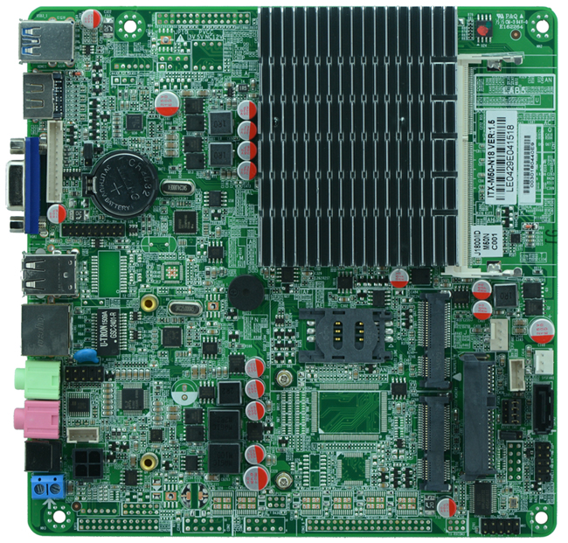
2. I/O Panel Front View
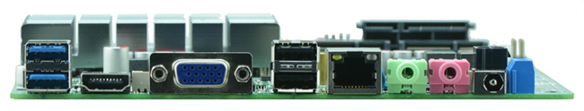
3. I/O Panel Side View
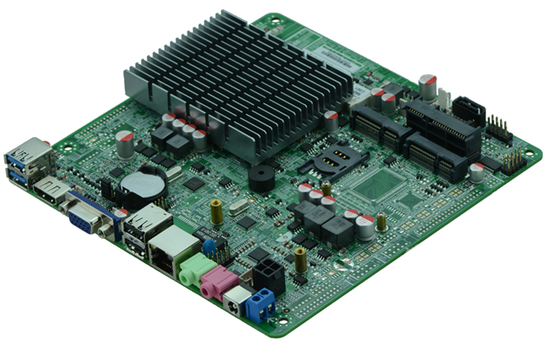
4. Memory Side View
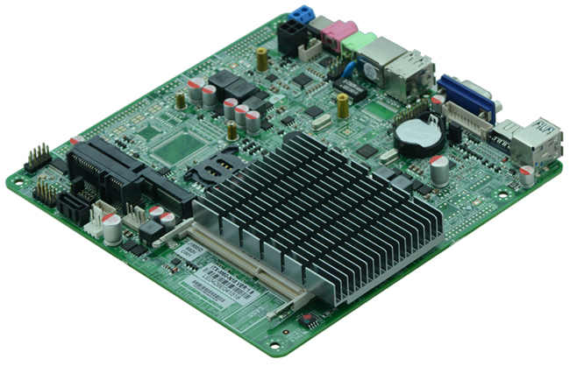
Product Model | ITX-M50 _N18 VER:1.5
CPU | Integrated J1800 dual core 22nm processor 2.41GHz
Chipset | Intel Bay Trail SOC platform, cpu integrated
Memory | 1 x SO-DIMM DDR3 memory slot, supports 1333/1066 Mhz, Max. 8GB.
Video | Integrated Intel HD graphics core  Offers VGA, HDMI video output
Expansion Slot | 1 x mini PCI-e slot, supports wifi/3G module  1 x MSATA slot, suppports SSD
LAN | 1 x RTL 1000M Ethernet controller, supports Wake On Lan, PXE booting
Storage | 1 x 2.5 inch notebook HDD bay onboard, can install HDD directly  1 x SATA HDD interface(alternative to 2.5 inch HDD)
Audio | Onboard Realtek ALC662 6 channel high fidelity audio chip, supports MIC, line out.
Rear I/O Panel | 1 x 12-19V DC_JACK input  1 x HDMI port  1 x VGA port  2 x USB 2.0 ports  2 x USB 3.0 ports  1 x RJ45 LAN port  1 x Line out(green)  1 x MIC(red)
Internal I/O Interface | 1 x JVGA1 header, same signal with DB15, 12-pin  2 x USB 2.0 headers  1 x USB 3.0 header  1 x FP1 front panel function button and indicator light header, 2 x 5-pin  1 x audio connector(front panel audio port)  1 x power amplifier headers 4pin  1 x PWROUT HDD power supply connector  1 x ATX 4pin power JACK, can be input and output according to power supply output voltage
Fan connector | 1 x CPU Fan connector and 1 x System Fan connector
GPIO | Supports 4 channel GPIO
BIOS | AMI 64MB Flash ROM
Watch Dog | Supports hardware reset function(256 level, 0-255 seconds)
PSU | DC 12V-19V single power supply input
Working Temp | -10℃～60℃
Storing Temp | -20℃～70℃
Working Humidity | 5%-95% relative humidity, non-condensing
Dimension | 170mm x 170mm  Mini ITX form factor

