Integrated Intel Celeron 1037 dual core processor(1.8GHz)
Intel HM65 express chipset
Integrated Intel HD graphics core, supports VGA, dual HDMI and LVDS video output
SO-DIMM DDR3 memory slot, supports 1333/1066 memory, Max. 8Gb
Onboard 2 mini-PCIE slots, supports SSD/wireless Wifi/USB Wifi/3G modules
Supports 1 2.5’’ HDD bay
Supports 2 RS232 headers
Supports 2 RTL8111E 1000M Ethernet controllers, supports Wake On LAN
Integrated Realtek ALC662 6 channel high definition audio controller

ITX-M11 VER:1.0 Motherboard Photos

1. Motherboard Front View
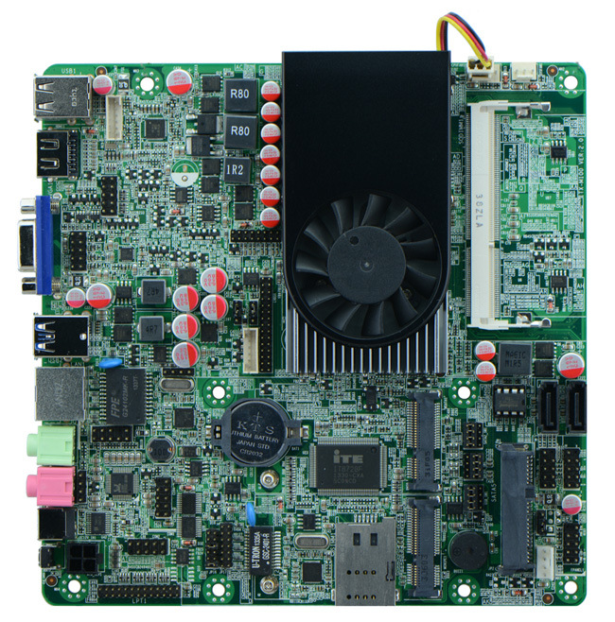
2. I/O Panel Front View
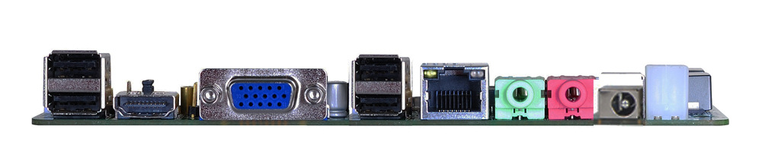
3. I/O Panel Side View
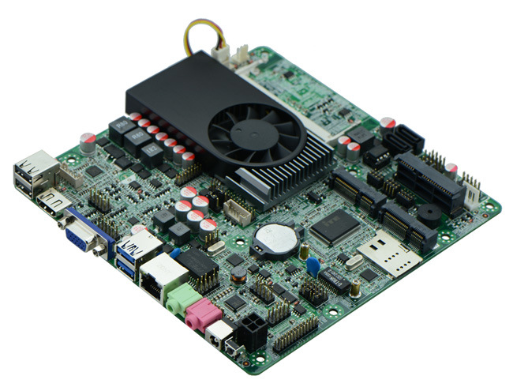
4. Memory Side View
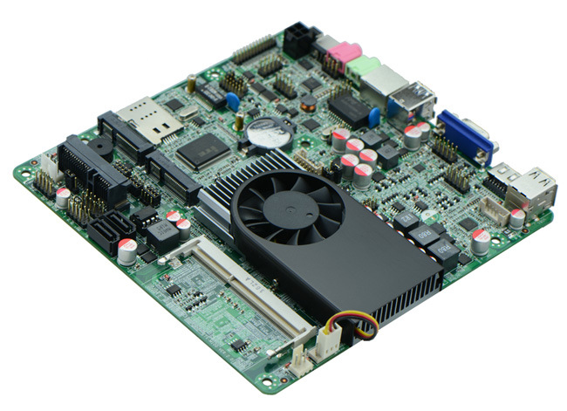
5. With HDD onboard
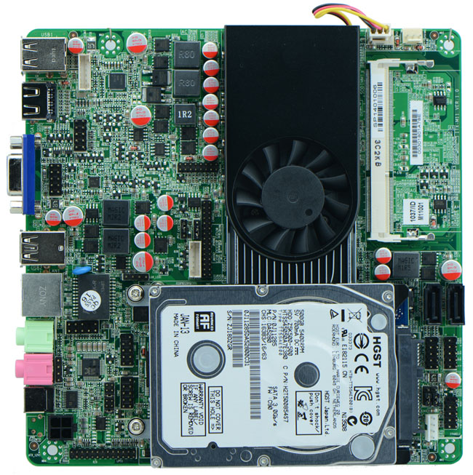

Product Model | ITX-M11 VER: 1.0
CPU | Onboard Intel 1037U dual core 22nm processor (1.8Ghz)
Chipset | Intel HM65 Chipset
Memory | 1 x SO-DIMM DDR3 memory slot, supports 1333/1066 Mhz, Max. 8GB.
Video | Integrated Intel HD graphics core  Offers 1 VGA, 2 HDMI and 1 LVDS video output(supports dual channel 24bit)  Supports HDMI1/VGA sync/async  Supports LVDS/VGA sync/async  Supports LVDS/HDMI1 sync/async  Supports HDMI1/HDMI2 sync/async
Expansion Slot | 1 x mini PCI-e slot, supports wifi/3G module  1 x MSATA3 slot, suppports SSD/USB Wifi(by default)
LAN | 1 x RTL8105E 100M Ethernet controller, supports Wake On Lan, PXE booting(And can add a Ethernet port through internal header, customization needed)
Storage | 2 x SATA3 HDD interface(select from SATA1 and MSATA, SATA1 by default)  1 x SATA3 notebook HDD bay(SATA2 optional, by default notebook HDD)
Audio | Onboard Realtek ALC662 6 channel high fidelity audio chip, supports MIC, line out.
Rear I/O Panel | 1 x 12V DC_JACK input  1 x HDMI port  1 x VGA port  4 x USB 2.0 ports, 2 of which can support USB 3.0(customization needed)  1 x RJ45 LAN port  1 x Line out(green)  1 x MIC(red)  1 x Power or Reset switch(optional)
Internal I/O Interface | 1 x LVDS connector, supports dual channel 24 bit LCD, 2 x15-pin  1 x JHDMI header, 2 x 8-pin  1 x JVGA1 header, same signal with DB15, 12-pin  2 x RS232 connector, pin9 with electrification function  1 x LPT headert  1 x LAN header, 2 x 7-pin  4 x USB 2.0 connectors, if mini PCIe is USB signal, then supports 2 USB  1 x PS/2 mouse and keyboard connector, 6-pin  1 x FP1 front panel function button and indicator light header, 2 x 5-pin  1 x audio connector(front panel audio port)  2 x power amplifier headers 2-pin  1 x SIM slot  1 x PWROUT HDD power supply connector  1 x ATX_12V power JACK, can be +12v input and output power interface  1 x LVDS INVERTER
Fan connector | 1 x CPU Fan connector and 1 x System Fan connector, 4-pin
GPIO | Supports 4 channel GPIO
BIOS | AMI 32MB Flash ROM
Watch Dog | Supports hardware reset function(256 level, 0-255 seconds)
PSU | ITX-M18_D2 DC_12V single power supply  ITX-M18_A2 ATX PSU
Working Temp | -10℃～60℃
Storing Temp | -20℃～70℃
Working Humidity | 5%-95% relative humidity, non-condensing
Dimension | 170mm x 170mm  Mini ITX form factor

