Supports Intel LGA1150 32nm/22nm Core i3/i5/i7 processor
Intel H81 express chipset
Supports VGA, dual HDMI and LVDS video output, supports 1080P video playback
Supports dual channel SO-DIMM DDR3 memory
Integrated RTL8111E 1000M Ethernet controllers, supports Wake On LAN, PXE function
2 RS232 headers, supports electrification function
Onboard 2 mini-PCIE slots, supports SSD, Wifi, 3G module

I. ITX-D81 Motherboard Front View
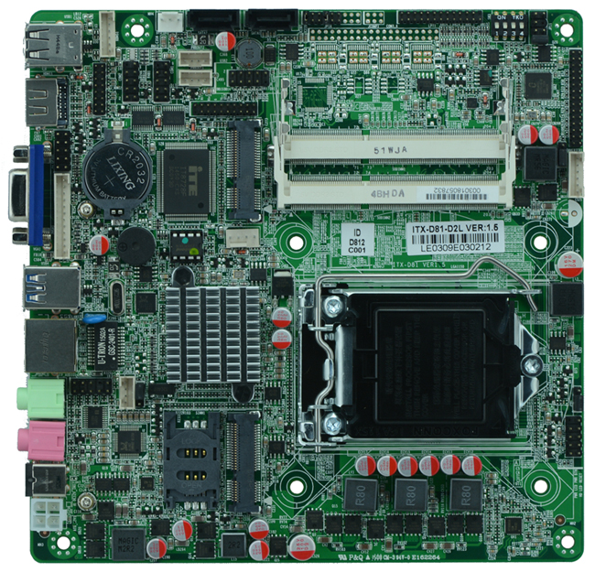
II. I/O Panel Front View
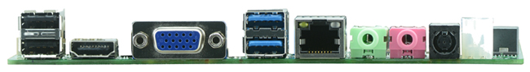
III.Motherboard side view
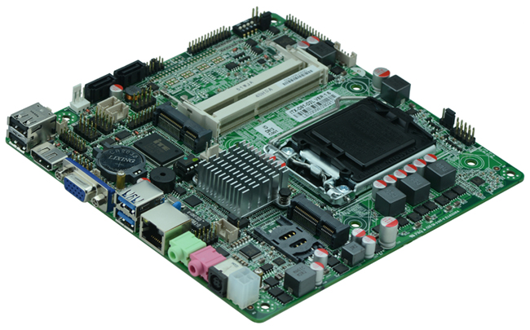

IV. ITX-D81 memory side view
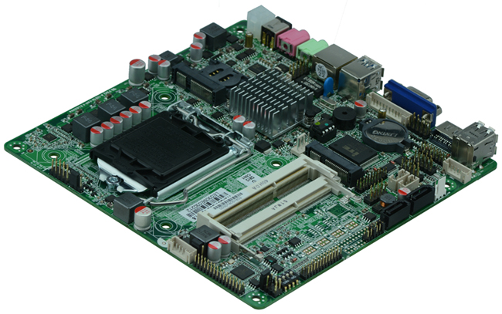
Product Model | ITX-D81
CPU | Supports LGA1150 Intel Core i3/i5/i7 32nm/22nm processor
Chipset | Intel H81 express chipset
Memory | 2 x SO-DIMM DDR3 memory slot, supports 1333/1066 Mhz,(Requires CPU to cooperate with chipset to support, each memory slot supports Max. 8GB)
Video | Integrated Intel HD graphics core, supports VGA, (dual)HDMI, LVDS display output, LVDS supports dual channel 24 bit, supports sync/async(LVDS screen voltage supports 12V output, by default 3.3V, before using LVDS, please be aware of its rated voltage and then set to avoid burning the screen, for detail please refer to JP11 jumper setting)
Expansion Slot | 1 x mini PCI-e slot, supports wifi/3G
LAN | 1 x RTL8111E 1000M Ethernet controller, supports Wake On Lan, PXE booting
Storage | 2 x SATA HDD interface(SATA1 is SATAIII with 6Gbps transit rate)  1 x MSATA slot, supports SSD interface, transit rate reaches 6Gbps
Audio | Onboard Realtek ALC662 6 channel high fidelity audio chip, supports MIC, line out, supports amplifier 3Ω2W.
Rear I/O Panel | 2 x USB 2.0 ports  2 x USB 3.0 ports  1 x HDMI port  1 x VGA port  1 x RJ45 LAN port  2 x standard single layer audio port(MIC and Line-out)  1 x 12 - 19V DC_JACK input
Internal I/O Interface | 1 x LVDS connector, supports dual channel 24bit LCD(dual 8) 2 x 15-pin  1 x JVGA header, same signal with DB15, 12-pin  1 x JHDMI header, can work together with HDMI, 2 x 8-pin  2 x COM headers  1 x LPT header, 2 x13-pin  2 x USB 2.0 headers, 2 x 5-pin  2 x USB 3.0 headers, 2 x 10-pin  1 x KB/MS header, 6-pin  1 x AUDIO front audio header, 2 x 5-pin  1 x amplifier header, can be connected to amplifier output, 4-pin  1 x FP1, 2 x 5-pin front panel power button and indicating light header, 2 x 5-pin  1 x ATX 4pin power header, supports 12-19V input and output  1 x LVDS INVERTER header, 6-pin  1 x PWROUT HDD power supply header, 4-pin
Fan connector | 1 x CPUFAN, 4-pin; and 1 x SYSFAN, 3-pin
GPIO | Supports 4 channel GPIO
BIOS | 32MB SMT Flash ROM
Watch Dog | Supports hardware reset function(256 level, 0-255 seconds)
PSU | DC 12_19V single power supply input
Working Temp | -10℃～60℃
Storing Temp | -20℃～70℃
Working Humidity | 5%-95% relative humidity, non-condensing
Dimension | 170mm x 170mm  Mini ITX form factor

