Supports Intel LGA1155 core 32nm/22nm i3/i5/i7 processor
Intel H61 B75 express chipset
Supports VGA, dual HDMI and LVDS video output, supports 1080P video playback
Supports 1 SO-DIMM DDR3 memory, Max. 8Gb
Integrated RTL8111E 1000M Ethernet controllers, supports Wake On LAN, PXE function
6 RS232 headers, supports electrification function, COM2 supports RS422/485 mode
Onboard 2 mini-PCIE slots, supports SSD, Wifi
Integrated 2 USB 3.0 ports, support USB 3.0/2.0/1.1

I. ITX-D61(D75) Motherboard Front View
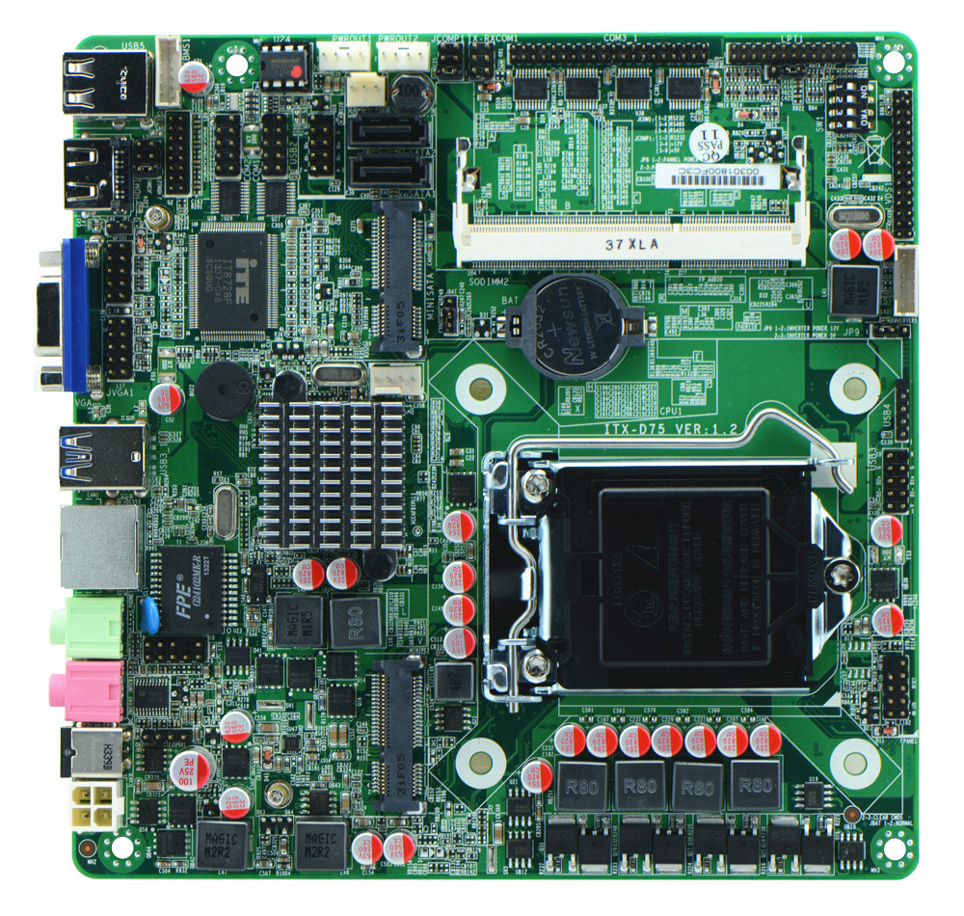
II. I/O Panel Front View
1. ITX-D61_D6L I/O panel front view
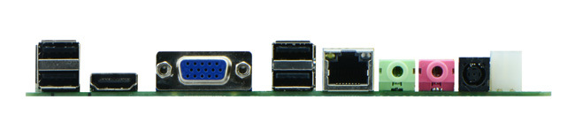
2. ITX-D75_D6L
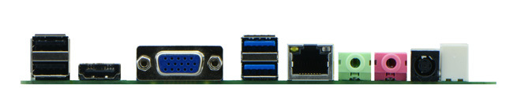
III.Motherboard side view
1. ITX-D61_D6L I/O side view
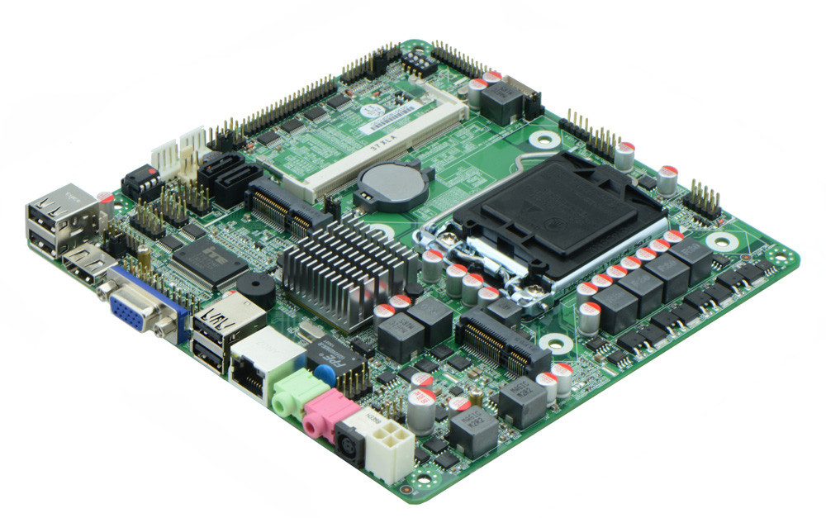
2. ITX-D61_D6L Memory Side View
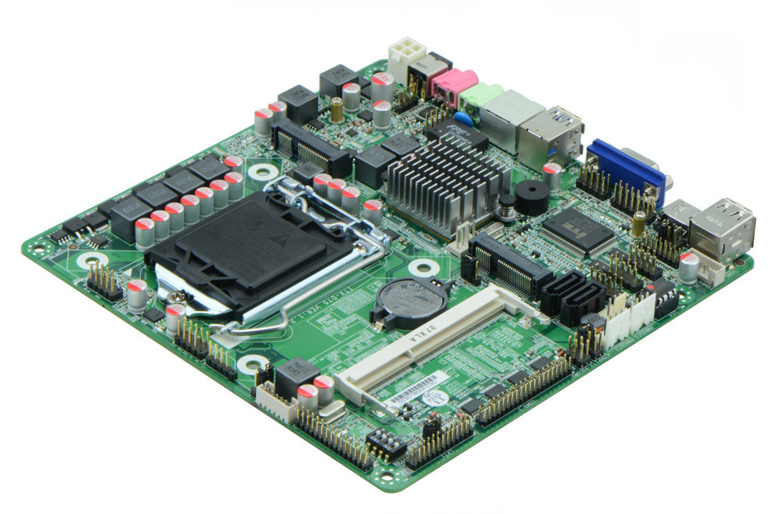
3. ITX-D75_D6L I/O side view
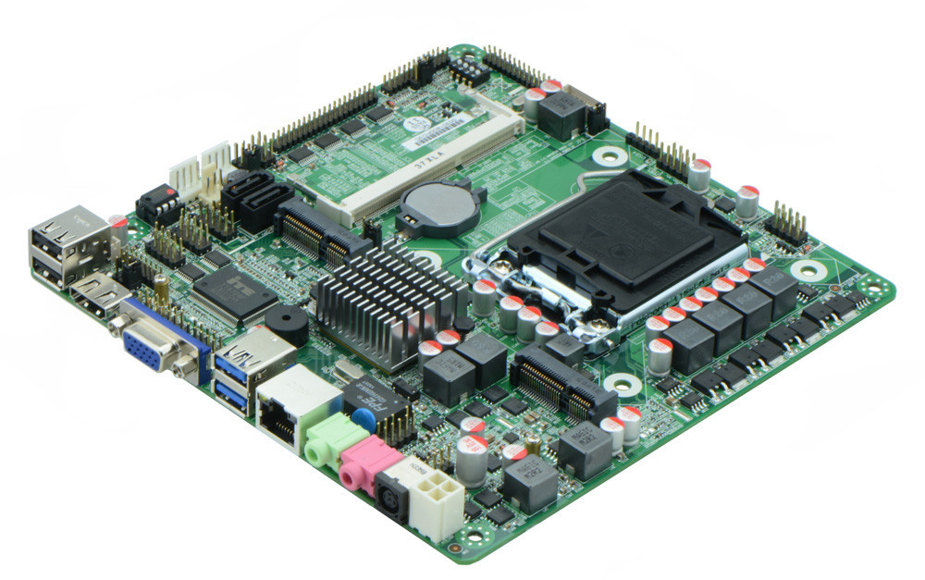
4. ITX-D75_D6L memory side view
Product Model | ITX-D61/D75 _D6L
CPU | Supports LGA1155 Intel Core i3/i5/i7 32nm/22nm processor
Chipset | Intel B75 Chipset(ITX-D75_D61 configures)  Intel H61 Chipset(ITX-D61_D6L configures)
Memory | 1 x SO-DIMM DDR3 memory slot, supports 1333/1066 Mhz, Max. 8GB.
Video | Integrated Intel HD graphics core, supports VGA, HDMI, LVDS display output, LVDS supports dual channel 24 bit, supports sync/async
Expansion Slot | 1 x mini PCI-e slot, supports wifi
LAN | 1 x RTL8111E 1000M Ethernet controller, supports Wake On Lan, PXE booting
Storage | 2 x SATA HDD interface(SATA2 is SATAIII)  1 x MSATA slot, supports SSD interface, transit rate reaches 6Gbps
Audio | Onboard Realtek ALC662 6 channel high fidelity audio chip, supports MIC, line out.
Rear I/O Panel | 1 x 19V DC_JACK input  1 x HDMI port  1 x VGA port  4 x USB 2.0 ports(ITX-D75_D6L supports 2 USB 3.0)  2 x standard single layer audio port(MIC and Line-out)  1 x RJ45 LAN port
Internal I/O Interface | 1 x LVDS connector, 2 x 15-pin  1 x JHDMI header, 2 x 8-pin  1 x JVGA header, same signal with DB15, 2 x 5-pin  6 x RS232 connector, COM2 support 485/422  1 x LPT header  1 x TX-RXCOM RS422/485 interface  5 x USB 2.0 connectors  1 x KB/MS interface  1 x front panel audio interface  1 x power amplifier interface, can be connected to speakers output  1 x FP1 front panel function button and indicator light header, 2 x 5-pin  1 x ATX_19V power JACK, can be +19v input and output power interface, 2 x 2-pin  1 x LVDS INVERTER interface(1 x 6-pin)  2 x PWROUT interface, HDD power supply interface
Fan connector | 1 x CPU Fan connector, 4-pin; and 1 x System Fan connector, 3-pin
GPIO | Supports 4 channel GPIO
BIOS | AMI 32MB Flash ROM
Watch Dog | Supports hardware reset function(256 level, 0-255 seconds)
PSU | DC_19V single power supply input
Working Temp | -10℃～60℃
Storing Temp | -20℃～70℃
Working Humidity | 5%-95% relative humidity, non-condensing
Dimension | 170mm x 170mm  Mini ITX form factor

