Intel Atom dual core D2550 processor(1.86GHz)
Intel Atom D2550+NM10 express chipset
Built in Intel GMA3600 graphics core(shared memory of 128/224 Mb)
1 x SO-DIMM DDR3 1066/800 memory, Max. 4Gb
1 x mini-PCIE slot, supports Wifi/3G modules
1 x MSATA(can be connected to SSD, Wifi, select this or SATA2 )
1 RTL8111E 1000M Ethernet controller
Mini ITX form factor(170mm x 170mm)

ITX-M27 Motherboard Photos

1. Motherboard Front View
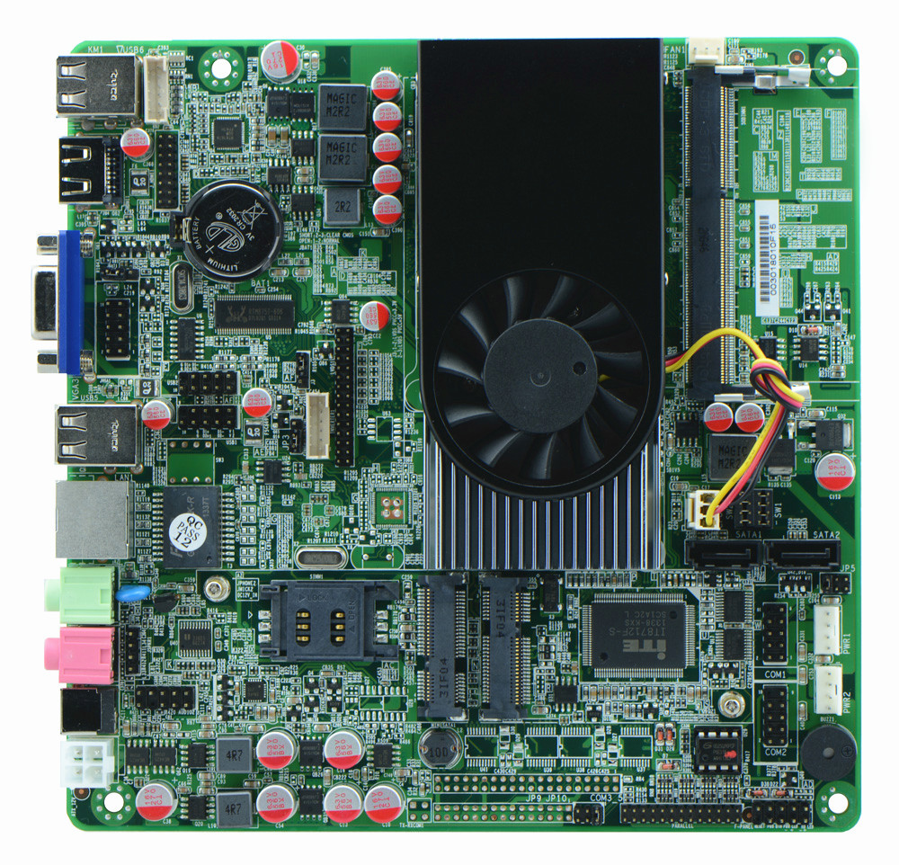
2. I/O Panel Front View
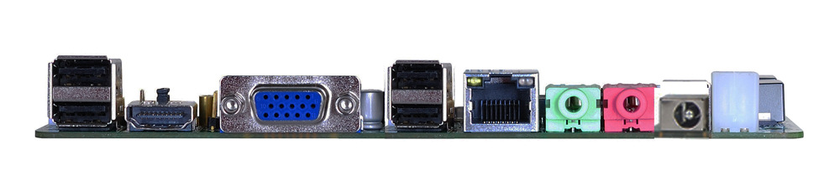
3. I/O Panel Side View
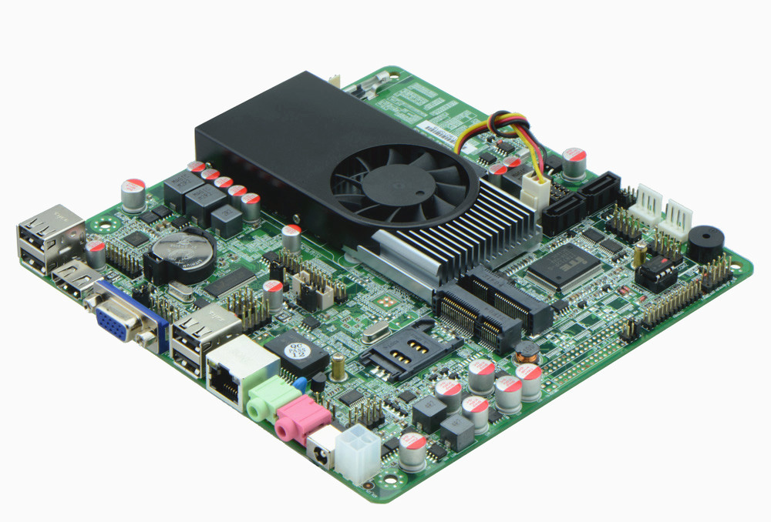
4. Memory Side View
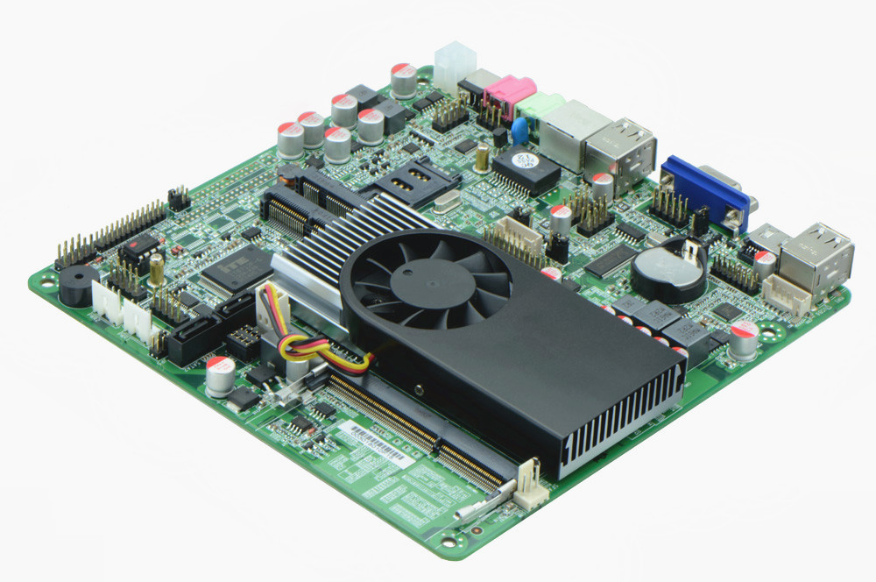

Product Model | ITX-M27
CPU | Integrated Intel Atom D2550 dual core processor(1.86GHz)
Chipset | Intel NM10 Chipset
Memory | 1 x SO-DIMM DDR3 memory slot, supports 1066/800 Mhz, Max. 4GB.
Video | Built in Intel GMA3600 graphics core(128/224 Mb shared memory), supports 1080P video playback, supports VGA/HDMI/LVDS display output, LVDS, supports single channel 24 bit.
Expansion Slot | 1 x mini PCI-e slot, supports wifi/3G module
LAN | 1 x RTL8111E 1000M Ethernet controller, supports Wake On Lan
Storage | 2 x SATA2 HDD interface, select from SATA2 and SSD, jumper controls switch  1 x MSATA slot, supports SSD and Wifi
Audio | Onboard Realtek ALC662 6 channel high fidelity audio chip, supports MIC, line out.
Rear I/O Panel | 1 x 12V DC_JACK input  1 x HDMI port  1 x VGA port  4 x USB 2.0 ports  1 x RJ45 LAN port  1 x Line out(green)  1 x MIC(red)
Internal I/O Interface | 1 x LVDS connector, 2 x15-pin, single channel 24 bit  1 x JHDMI header, same signal as HDMI, 2 x 8-pin  1 x JVGA header, same signal with DB15, 2 x 5-pin  1 x LPT connector  2 x RS232 connectors  4 x USB 2.0 connectors  1 x KB/MS connector  1 x audio connector(front panel audio port)  1 x CD-IN power amplifier connector, supports direct speaker output  1 x FP1 front panel function button and indicator light header, 2 x 5-pin  1 x LVDS INVERTER connector  1 x ATX_12V power JACK, can be +12v input and output power interface  1 x SIM slot
Fan connector | 1 x CPU Fan connector and 1 x System Fan connector, 3-pin
GPIO | Supports 4 channel GPIO
BIOS | AMI 16MB Flash ROM
Watch Dog | Supports hardware reset function(256 level, 0-255 seconds)
PSU | DC_12V single power supply input
Working Temp | -10℃～60℃
Storing Temp | -20℃～70℃
Working Humidity | 5%-95% relative humidity, non-condensing
Dimension | 170mm x 170mm  Mini ITX form factor

