Integrated Intel Celeron 1037 dual core processor(1.8GHz)
Intel NM70 express chipset
Integrated Intel HD graphics, supports VGA, HDMI and LVDS video output, supports 1080P
SO-DIMM DDR3 memory slot, supports 1333/1066 memory, Max, 8GB
Onboard 2 mini-PCIE slots, supports SSD/Wifi
Supports Max. 10 RS232 Serial ports
Onboard 2 RTL8111E 1000M Ethernet controllers, supports Wake On LAN and PXE
Integrated Realtek ALC662 6 channel high definition audio controller
DC power supply, voltage range 9-24V

ITX-M847_K10 VER:2.0 Motherboard Photos

1. Motherboard Front View
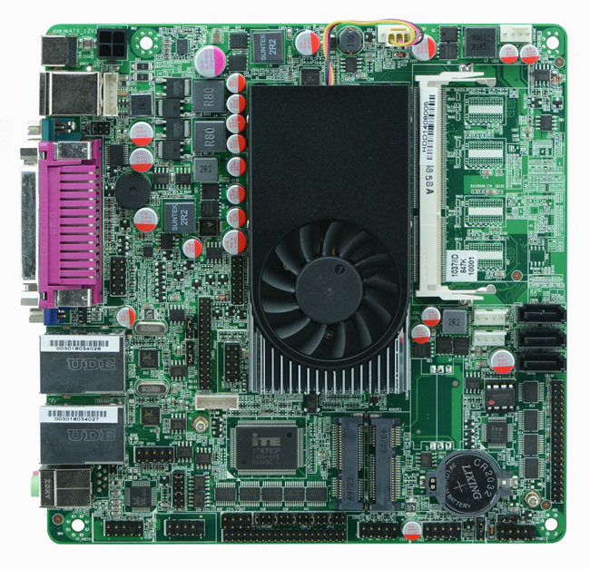
2. I/O Panel Front View
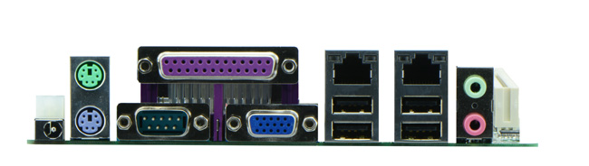
3. I/O Panel Side View
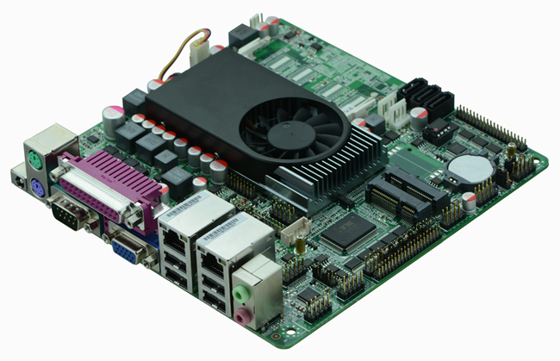
4. Memory Side View
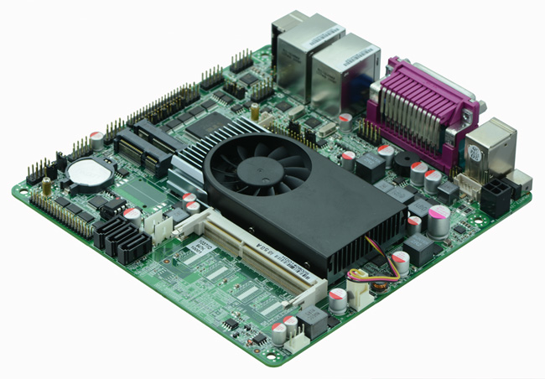

Product Model | ITX-M847_K10 VER: 1.2
CPU | Onboard Intel 1037U dual core 22nm processor (1.8Ghz)
Chipset | Intel NM70 Chipset
Memory | 1 x SO-DIMM DDR3 memory slots, supports 1333/1066 Mhz, Max. 8GB.
Video | Integrated Intel HD graphics core  Provides 2 x VGA, 1 x HDMI, 1 x dual channel 24bit LVDS output, supports dual display by arbitrary combination
Expansion Slot | 1 x mini PCI-e slot, supports wifi module  1 x MSATA slot, suppports SSD/Wifi, SSD Max. transfer rate 6Gbps
LAN | 2 x RTL8111E 1000M Ethernet controller, supports Wake On Lan, PXE booting.
Storage | 3 x SATAII HDD interface, Max. transfer rate 3Gbps
Audio | Onboard Realtek ALC662 6 channel high fidelity audio chip, supports MIC, line out.
Rear I/O panel | 1 x PS/2 keyboard and mouse connector  1 x DB9 COM port, PIN9 with electrification function  1 x LPT port  1 x DB15 VGA port  2 x RJ-45 LAN ports  4 x USB 2.0 ports  1 x audio I/O interface(MIC and line out)  1 x 12V DC_JACK input(Supports 8-36V input, suggest using 9-24V)
Internal I/O interface | 9 x COM, COM2 and COM3 support RS485/422  1 x LVDS connector, supports dual channel 24 bit LCD(dual 8)  1 x JHDMI connector, 2 x 8-pin  1 x JVGA1 connector, 2 x 5-pin, cannot work together with DB15(VGA port)  4 x USB 2.0 connectors, if Mini PCIe is USB signal, then supports 2 USB 2.0  1 x audio connector  1 x FP1 front panel function button and indicator light header, 2 x 5-pin  1 x TX-RXCOM RS422/485 header, 2 x 4-pin  1 x PS/2 mouse and keyboard connector, 6-pin  1 x ATX_12V, available for +12V input and output power interface  2 x PWROUT HDD power interface
Fan connector | 1 x CPU Fan connector and 1 x System Fan connector, 4-pin
GPIO | Supports 4 channel GPIO
BIOS | AMI 32MB Flash ROM
Watch Dog | Supports hardware reset function(256 level, 0-255 seconds)
PSU | Supports DC 8-36V input, suggest using 9-24V
Working Temp | -10℃～60℃
Storing Temp | -20℃～70℃
Working Humidity | 5%-95% relative humidity, non-condensing
Dimension | 170mm x 170mm  Mini ITX form factor

