Supports Intel LGA1155 Socket Core 22nm/32nm i7/i5/i3 CPU
Intel H61 express chipset
Supports 1 x SO-DIMM DDR3 memory slot, Max. 8GB
Provides VGA, DVI port video output, supports synchronization and asynchronization display.
6 RS232 connectors, supports electrification function, COM1 supports RS485/422 modes
Supports 1 x PCI-e 16x slot, 1 x mini PCI-e slot
2 x SATAIII HDD interface, Max. transfer rate 6Gb/s
Integrated Realtek ALC662 6 channel high fidelity audio controller
Mini ITX Form Factor (170x170mm)

ITX-M61 VER:2.2 Motherboard Photos

1. ITX-M61 VER:2.2 Motherboard Front View
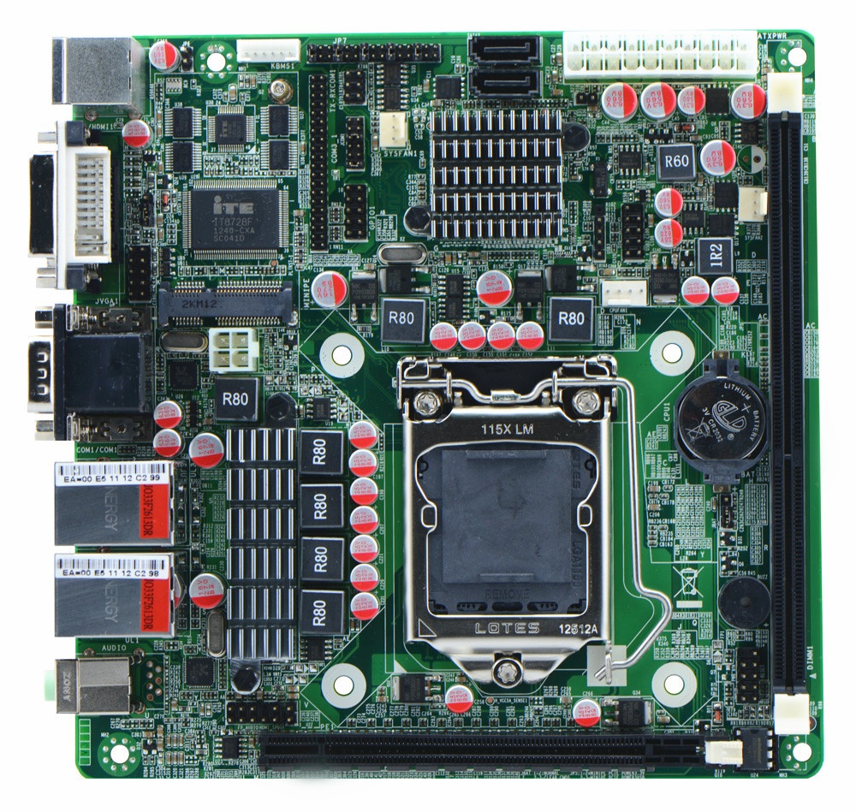
2. ITX-M61 VER:2.2 I/O Panel Front View
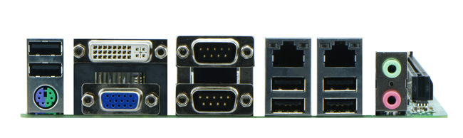
3. ITX-M61 VER:2.2 I/O Panel Side View
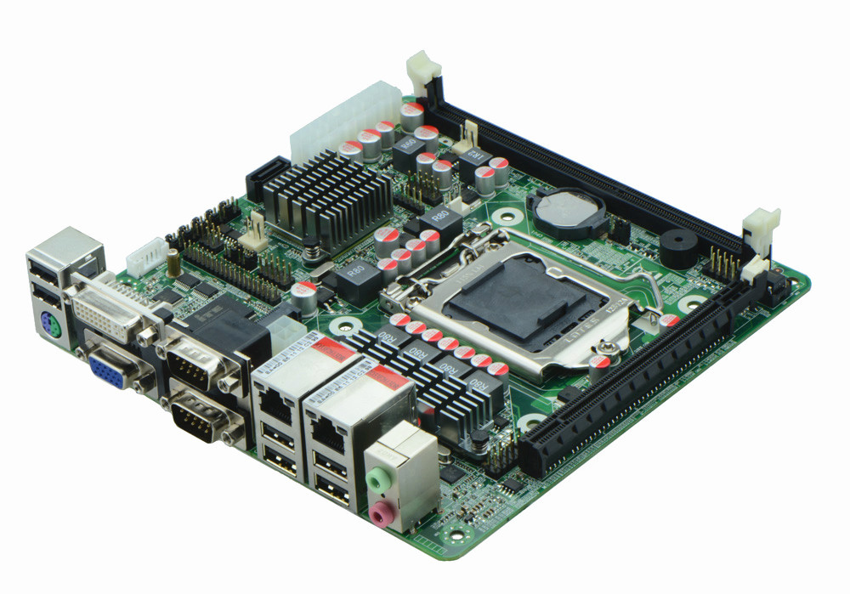
4. ITX-M61 VER:2.2 Memory Side View
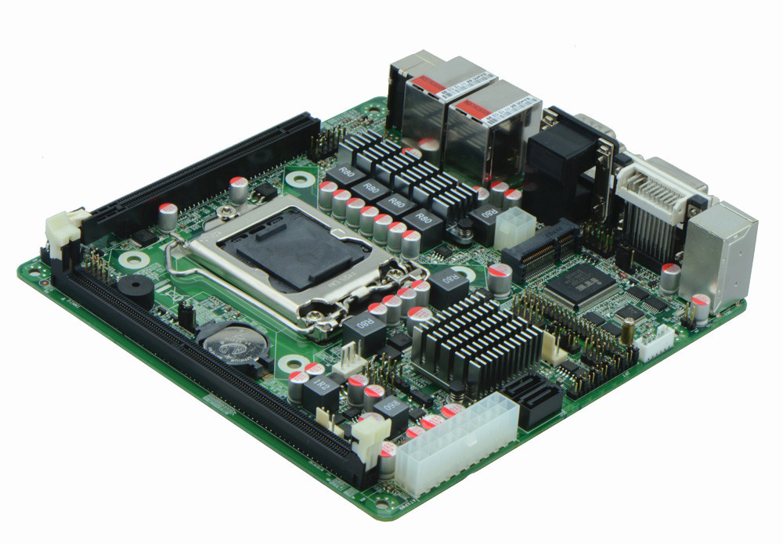

Product Model | ITX-M61 VER:2.2
CPU | Supports LGA1155 Intel Core i7/i5/i3 22nm/32nm processor
Chipset | Intel H61 Chipset
Memory | 1 x SO-DIMM DDR3 memory slot, supports 1066/1333MHz, Max. 8GB
Video | Integrated Intel HD graphics controller  Supports DVI/VGA synchronization/asynchronization
Expansion Slot | 1 x mini PCI-e slot, supports SSD/Wifi/USB Wifi module  1 x PCI-e 2.0 16x slot
LAN | 2 x RTL8111E 1000M Ethernet controller, supports Wake On Lan
Storage | 2 x SATAII HDD interface, Max. transfer rate 6Gbps
Audio | Onboard Realtek ALC662 6 channel high fidelity audio chip, supports MIC, line out.
Rear I/O panel | 1 x PS/2 keyboard and mouse connector  4 x USB 2.0 ports  1 x DVI port  1 x VGA port  2 x RS232 ports, COM1 supports RS422/485 modes  2 x RJ-45 LAN ports  1 x dual layer audio port(supports MIC, line out)
Internal I/O interface | 4 x RS232 connector(pin-9 supports electrification function)  1 x TX-RXCOM RS422/485 connectors  3 x USB 2.0 connectors  1 x JVGA connector, 2 x 5-pin  1 x FP1(2 x 5-pin front panel function button and indicating light header)
Fan connector | 1 x CPU Fan connector 4-pin and 1 x System Fan connector, 3-pin
GPIO | Supports 4 channel GPIO
BIOS | AMI 32MB Flash ROM
Watch Dog | Supports hardware reset function(256 level, 0-255 seconds)
PSU | 20-pin ATX power supply
Working Temp | -10℃～60℃
Storing Temp | -20℃～70℃
Working Humidity | 5%-95% relative humidity, non-condensing
Dimension | 170mm x 170mm  Mini ITX form factor

