Embedded Intel Atom D525/D425/N455 processor(1.86GHz)
Intel ICH8M express chipset
1 x 204-pin single channel DDR3 1066/800 RAM, Max. 2Gb
1 x PCIe x1 interface(supports WIFI, 3G module)
1 x LVDS 2 x 10-pin header(supports 18 bit LVDS)
1 x MSATA interface(supports SSD)
Mini ITX Form Factor (170mm x 170mm)

I. ITX-M58_A45(A42\A52) VER:1.1 Motherboard Photos

1. Motherboard Front View
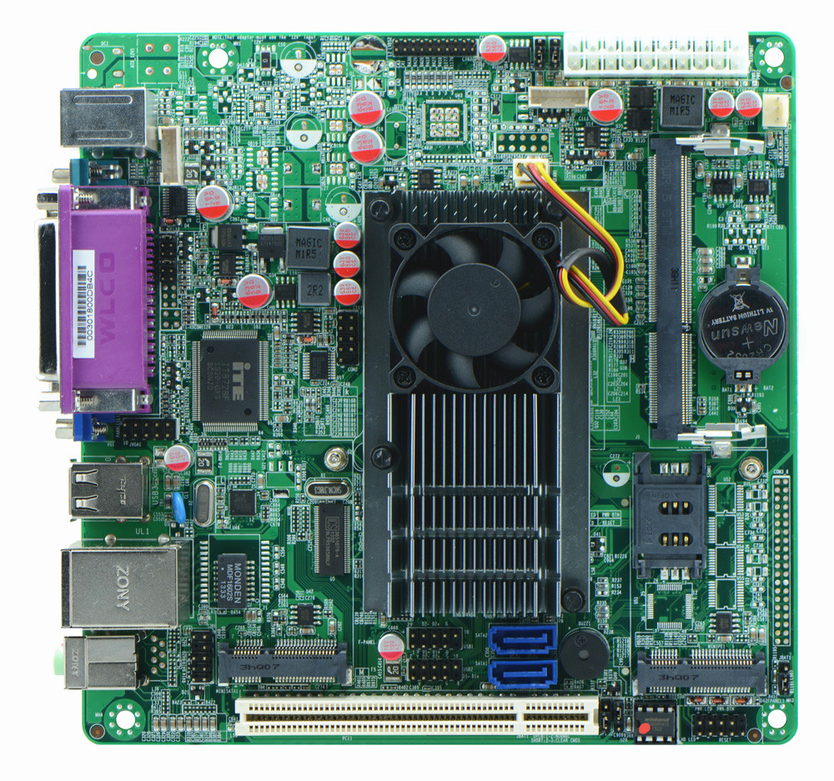
2. I/O Panel Front View
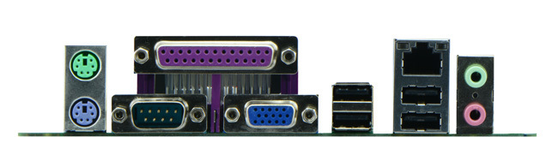
3. I/O Panel Side View
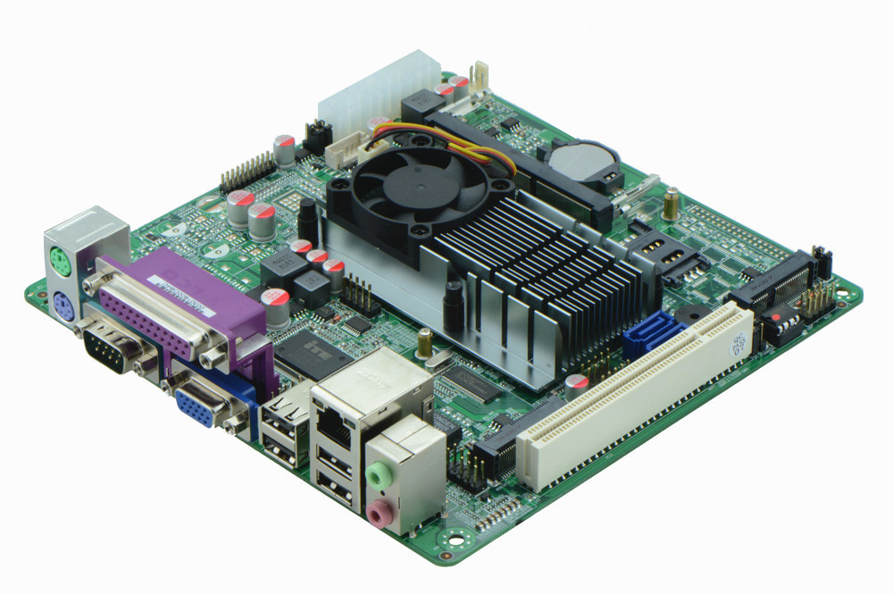
4. Memory Side View
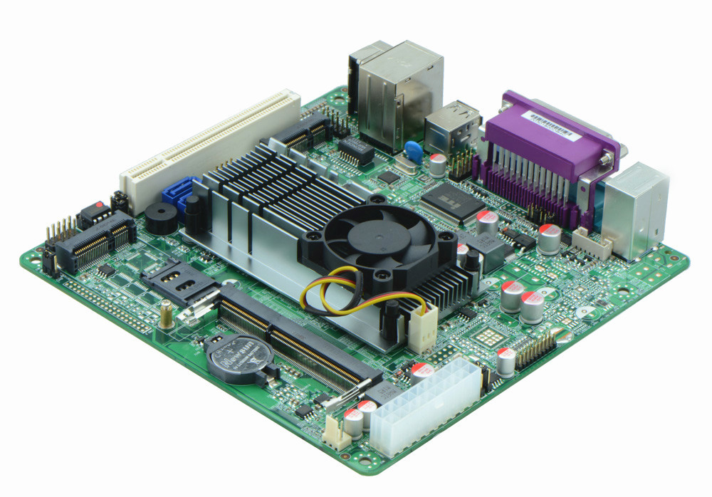
II. ITX-M58_D45(D42\D52) VER:1.1 Motherboard Photos

1. Motherboard Front View
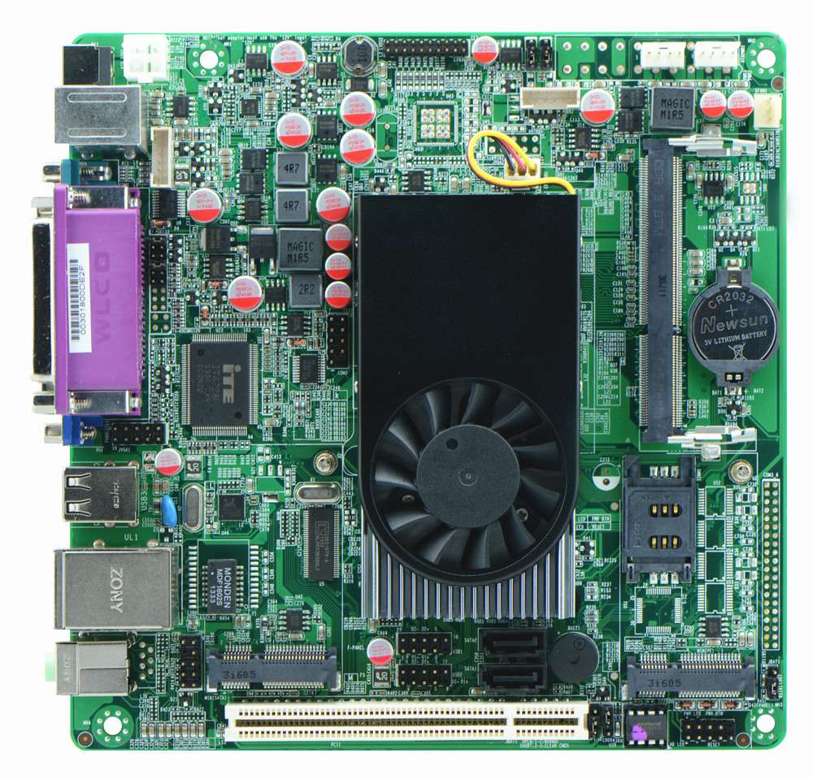
2. I/O Panel Front View
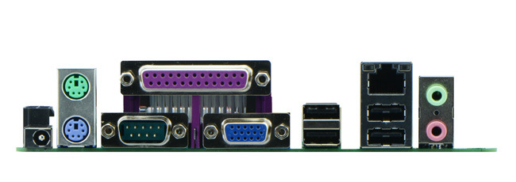
3. I/O Panel Side View
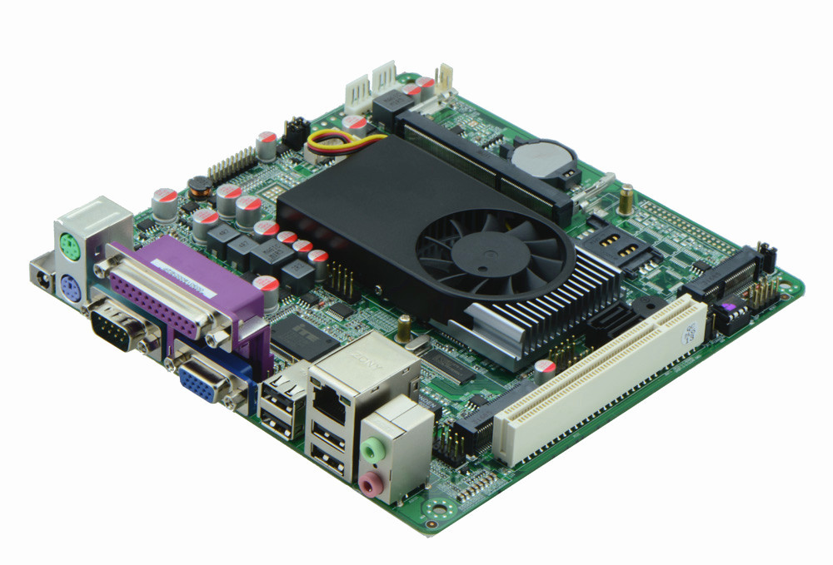
4. Memory Side View
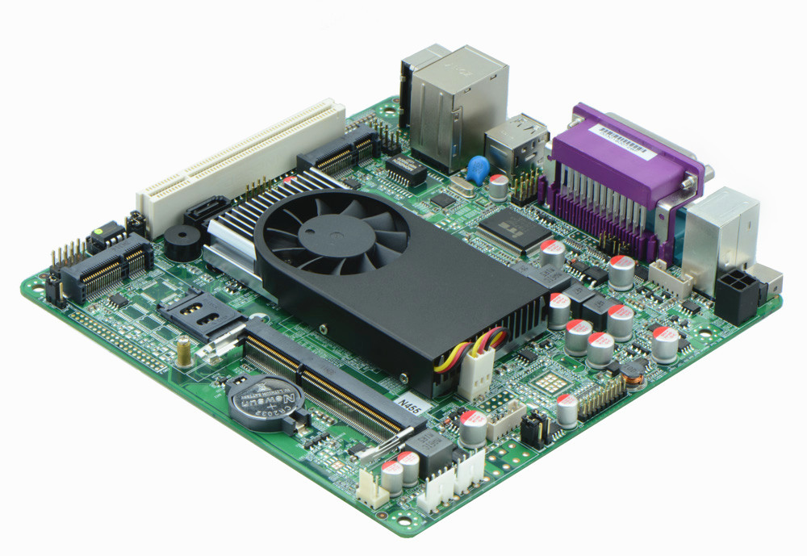

Product Model | ITX-M58_A45(42\52) ITX-M58_D45(42\52) VER：1.1
CPU | Embedded Intel Atom D525 dual core processor 1.80GHz (ITX-M58_A52\D52 configures)  Embedded Intel Atom D425 single core processor 1.80GHz (ITX-M58_A42\D42 configures)  Embedded Intel Atom N455 single core 1.66GHz (ITX-M58_A45\D45 configures)
Chipset | Intel ICH8M Chipset
Memory | 1 x SO-DIMM DDR3 memory slot, supports 1066/800 Mhz, Max. 2GB.
Graphics | Integrated Intel GMA3150 graphics card, provides VGA, LVDS video output, supports sync/async, LVDS supports single channel 18 bit
Expansion Slot | 1 mini PCIe slot, supports Wifi and 3G module  1 PCI slot
LAN | 1 x RTL8105E 100M Ethernet controller,, supports Wake On Lan, PXE booting.
Storage | 1 x MSATA slot(supports SSD)  2 x SATA2 HDD headers, transfer rate reaches 3Gbps
Audio | Onboard Realtek ALC662 6 channel high fidelity audio chip, supports MIC, line out.
Rear I/O Panel | 1 x 12V DC_JACK input  1 x PS/2 keyboard and mouse connector  1 x LPT port  1 x COM port, pin9 supports 5V/12V electrification function  4 x USB 2.0 ports  1 x RJ-45 LAN ports  1 x audio I/O port(MIC and line-out)
Internal I/O Interface | 1 x JVGA1 header, same signal with DB15, 2 x 5-pin  1 x JVGA2 header, 2 x 5-pin  1 x LVDS 2 x 10-pin  1 x COM header, pin9 supports 5V/12V electrification function  1 x audio front panel interface 2 x 5-pin  4 x USB 2.0 connectors  1 x FP1 front panel function button and indicator light header, 2 x 5-pin  1 x PS/2 keyboard mouse header  1 x LVDS power header 1 x 6-pin  2 x PWROUT, HDD power supply interface（ITX-M58_D45(42\52) configures）  1 x ATX_12V input and output power interface (M58_D45(42\52) configures)  1 x SIM slot
Fan connector | 1 x CPU Fan connector and 1 x System Fan connector, 3-pin
BIOS | AMI 8MB Flash ROM
Watch Dog | Supports hardware reset function(256 level, 0-255 seconds)
PSU | DC_12V single power supply（ITX-M58_D45\D42\D52configures）  ATX PSU（ITX-M58_A45\A42\A52 configures）
Working Temp | -10℃～60℃
Storing Temp | -20℃～70℃
Working Humidity | 0%-95% relative humidity, non-condensing
Dimension | 170mm x 170mm  Mini ITX form factor

