Integrated Intel Atom D2550/N2800 processor(1.86GHz)
Intel Atom D2550/D2500 + NM10 express chipset
Built-in Intel GMA3600 series graphics controller(shared memory 128/224Mb)
1 x 204-pin single channel DDR3 1066/800 RAM, Max. 4Gb
2 x SATA2 3Gb/s controller, SATA2 can support SSD
Integrated Realtek ALC662 6 channel high fidelity audio controller
2 x RTL8111E 1000M Ethernet controllers or 1 x RTL8105E 100M Ethernet controller(optional)
6 RS232 Serial ports, 1/9 pin support +5V/+12V switch, supports TTL function
Mini ITX Form Factor (170mm x 170mm)

ITX-H25_25(28) VER1.5 Motherboard Photos

1. Motherboard Front View
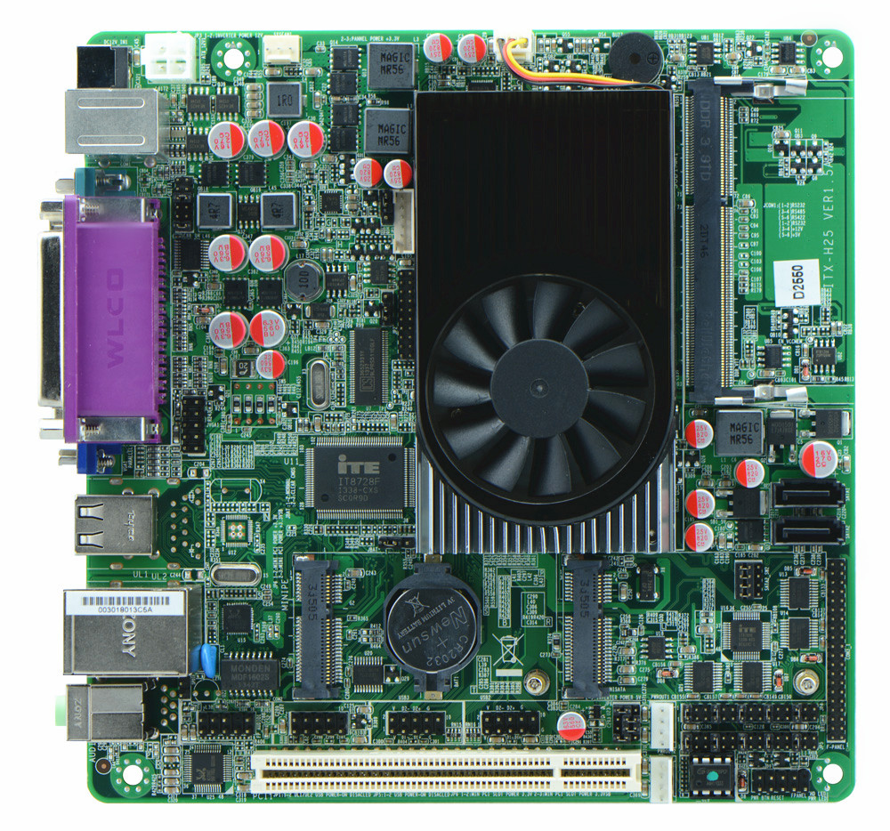
2. I/O Panel Front View
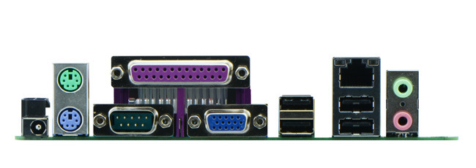
3. I/O Panel Side View
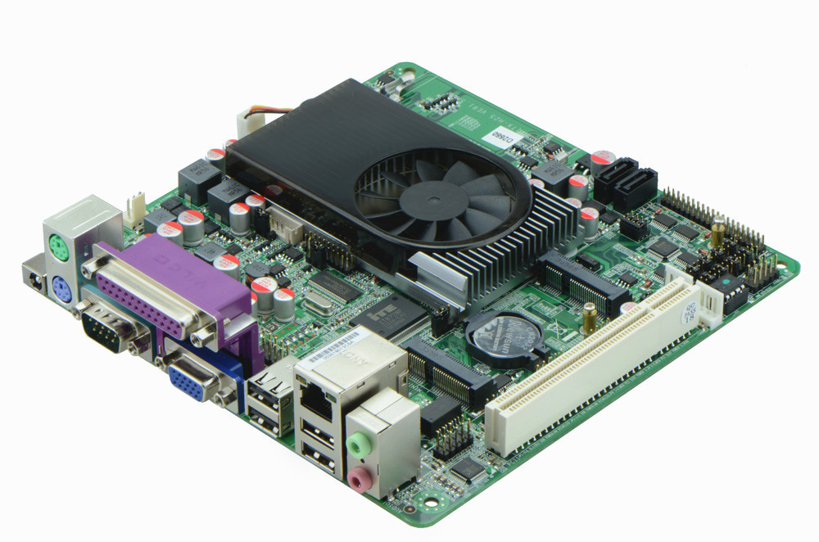
4. Memory Side View
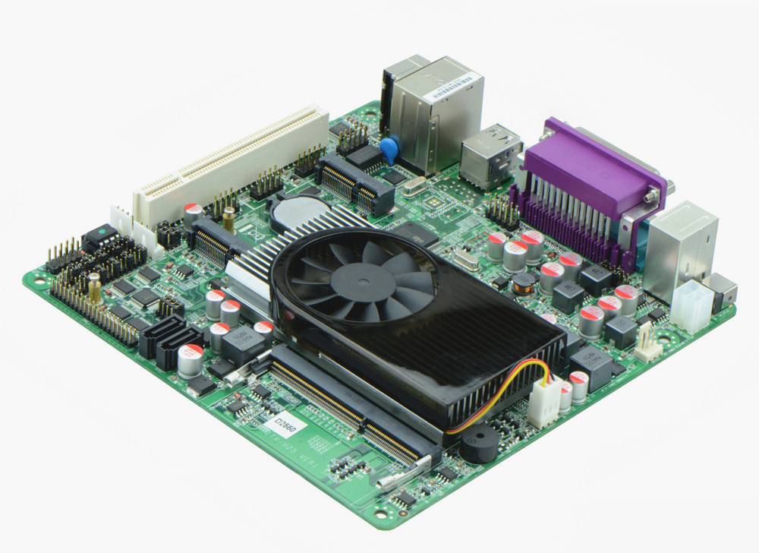

II. ITX-H25_2D6 VER:1.5A Motherboard Photos

1. Motherboard Front View
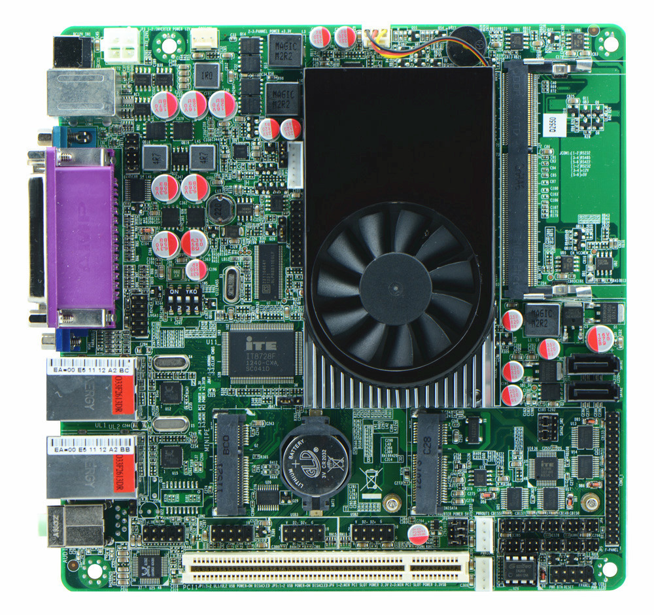
2. I/O Panel Front View
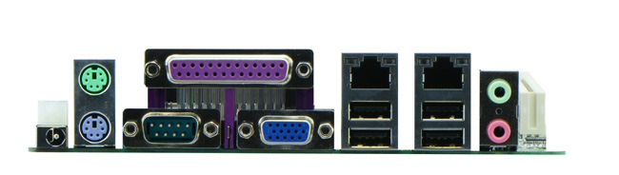
3. I/O Panel Side View
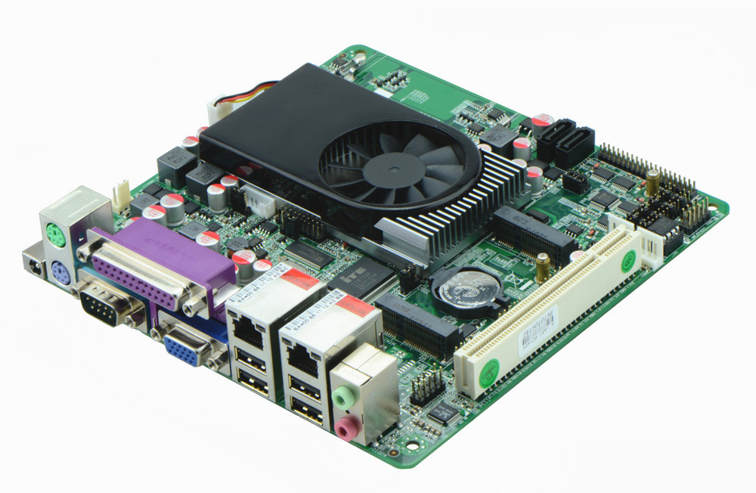
4. Memory Slot Side View
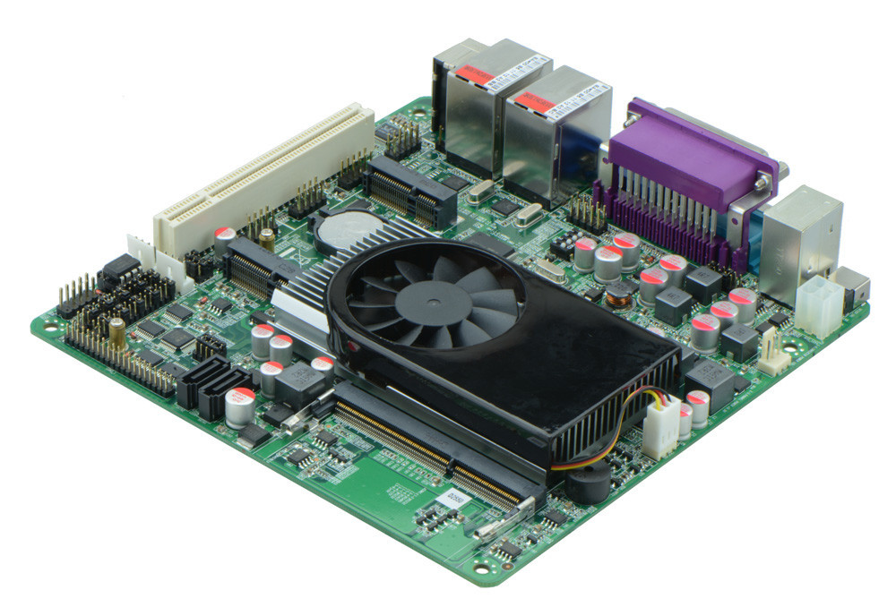

Product Model | ITX-H25_25(28) ITX-H25_2D6 VER: 1.5A
CPU | Onboard Intel Atom D2550 dual core processor(1.86GHz)  Onboard Intel Atom N2800 dual core processor(1.86GHz)(H25_28)
Chipset | Intel NM70 Chipset
Memory | 1 x SO-DIMM DDR3 memory slot, supports 1066/800 Mhz, Max. 4GB.
Graphics | Integrated Intel GMA3600 graphics card(128/244Mb shared memory)  Supports VGA, LVDS video output(LVDS supports single channel 24bit)
Expansion Slot | 1 x PCI slot  1 x mini PCIe slot(supports wifi module)
LAN | 2 x RTL8111E 1000M Ethernet controller,, supports Wake On Lan, PXE booting.  1 x RTL8105E 100M Ethernet controller
Storage | 1 x MSATA slot(supports SSD)  2 x SATA HDD interfaces, select from SATA2 and SSD
Audio | Onboard Realtek ALC662 6 channel high fidelity audio chip, supports MIC, line out.
Rear I/O Panel | 1 x RS232 Serial Port, 1/9 pin supports 5V/12V electrifying function  1 x 12V DC_JACK input  1 x PS/2 keyboard and mouse connector  4 x USB 2.0 ports  2 x RJ-45 LAN ports(ITX-H25_25(28) supports 1 RJ-45)  1 x dual layer standard audio interface(supports MIC, Line out)  1 x LPT port  1 x VGA port
Internal I/O Interface | 1 x LVDS connector, 2 x 10-pin  1 x JVGA1 same signal as DB15, 2 x 5-pin  5 x RS232 connector, pin 1/9 with 5V/12V electrification function  4 x USB 2.0 connectors  1 x audio connector(front panel audio port)  1 x FP1 front panel function button and indicator light header, 2 x 5-pin  1 x ATX_12V interface(2 x 2-pin, supports +12V input and output)  2 x PWROUT, HDD power supply interface  1 x LVDS INVERTER interface
Fan connector | 1 x CPU Fan connector and 1 x System Fan connector, 4-pin
BIOS | AMI 32MB Flash ROM
Watch Dog | Supports hardware reset function(256 level, 0-255 seconds)
PSU | DC_12V single power supply
Working Temp | -10℃～60℃
Storing Temp | -20℃～70℃
Working Humidity | 0%-95% relative humidity, non-condensing
Dimension | 170mm x 170mm  Mini ITX form factor

