Onboard AMD Trinity APU A6-4455M Quad core 2.1GHz TDP 17W
AMD A75 express chipset
Onboard AMD Radeon HD 7000 series graphics
2 x dual channel DDR3 13331066/800 RAM, Max. 16Gb
4 x SATA2 interface, transit rate reaches 300Mb/s
2 x mini PCIe slot, supports Wifi/3G module/SSD, jumper controls interface switch
2 x RTL8111E 1000M Ethernet Card, supports Wake On LAN
1 x PCIe 16x slot
6 x RS232 headers, COM2 supports RS422/485 mode

ITX-A75 VER:1.1 Motherboard Photos

1. Motherboard Front View
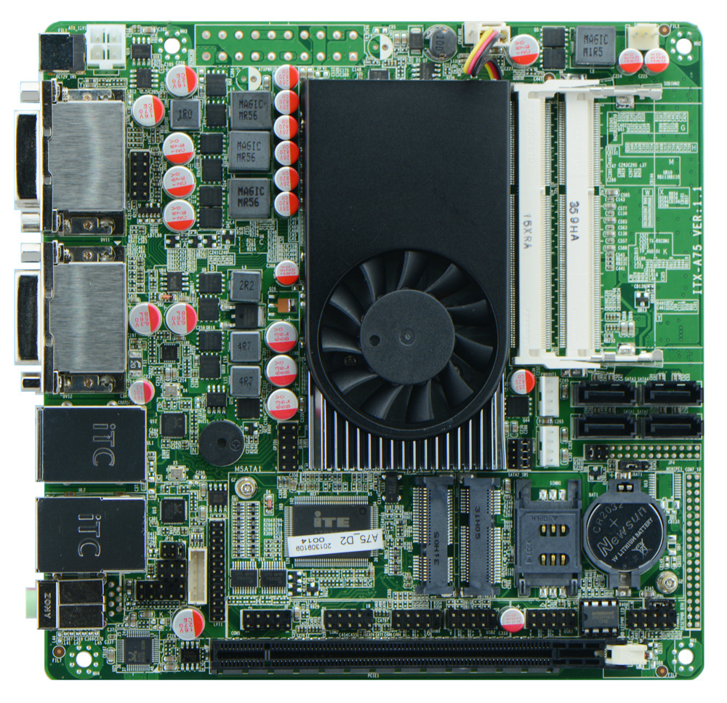
2. I/O Panel Front View
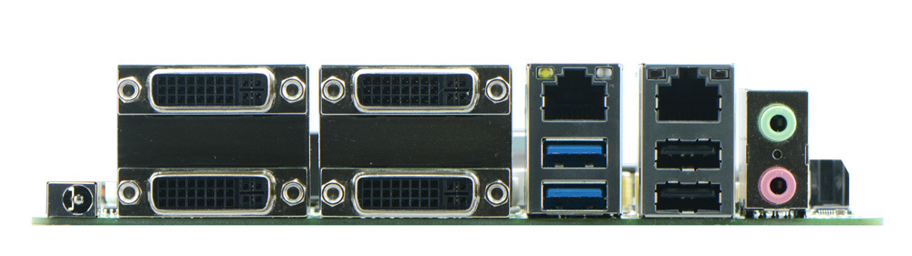
3. I/O Panel Side View
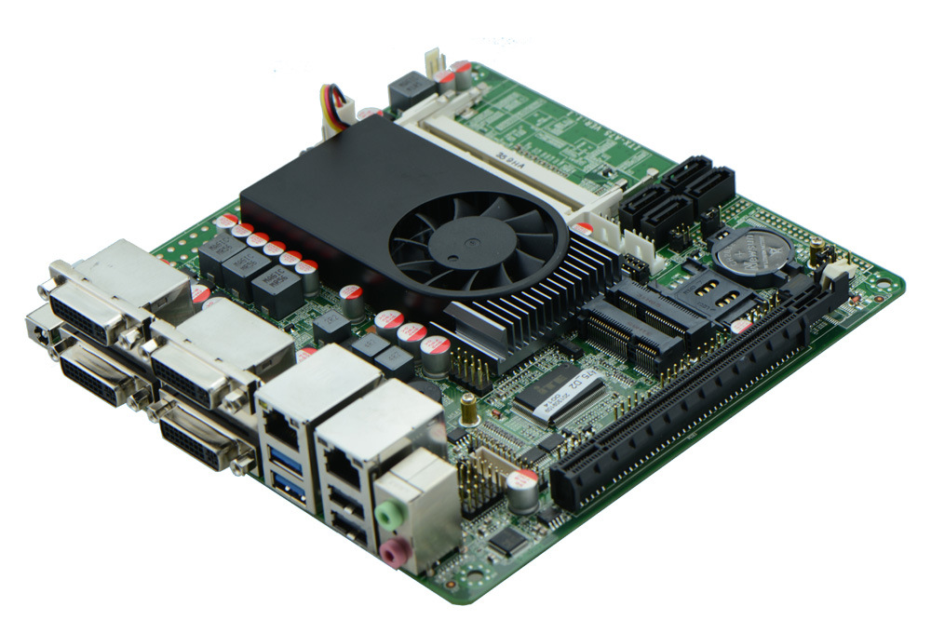
4. Memory Side View
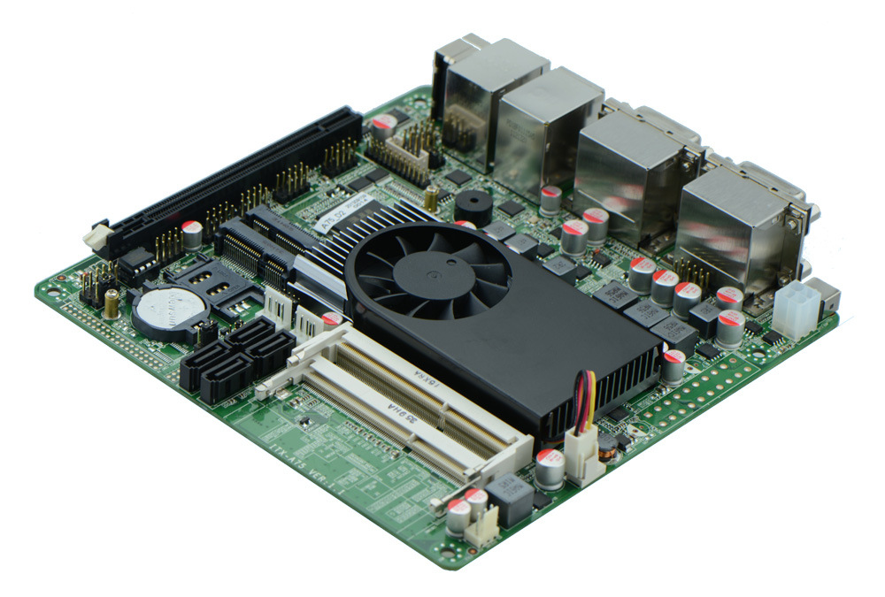

Product Model | ITX-A75 VER:1.1
CPU | Onboard AMD Trinity APU A6-4455M quad core 2.1GHz
Chipset | Intel ICH8M Chipset
Memory | 1 x SO-DIMM DDR3 memory slot, supports 1066/800 Mhz, Max. 2GB.
Graphics | Integrated AMD Radeon HD7000G series graphics core  Offers 4 DVI ports, supports quad display.
Expansion Slot | 1 x mini PCIe slot, supports Wifi and 3G module  1 x PCIe 16x slot  1 x MSATA slot, supports SSD/WIFI, jumper sets interface switch
LAN | 2 x RTL8111E 1000M Ethernet controller, supports Wake On Lan, PXE booting.
Storage | 4 x SATA2 HDD headers, transfer rate reaches 3Gbps
Audio | Onboard Realtek ALC662 6 channel high fidelity audio chip, supports MIC, line out.
Rear I/O Panel | 1 x 12V DC_JACK input  4 x DVI ports  2 x RJ-45 LAN ports  2 x USB 3.0 ports  2 x USB 2.0 ports  1 x audio I/O port(MIC and line-out)
Internal I/O Interface | 2 x RS232 headers, COM2 supports RS422/485 mode  1 x TX-RXCOM RS422/485 header  1 x audio front panel interface 2 x 5-pin  1 x LPT header, 2 x 13-pin  4 x USB 2.0 headers  1 x PS/2 keyboard mouse header  1 x SIM slot  2 x PWROUT, HDD power supply interface  1 x FP1 front panel function button and indicator light header, 2 x 5-pin  1 x ATX_12V(able to function as +12V input and output power interface)
Fan connector | 1 x CPU Fan connector and 1 x System Fan connector
GPIO | Supports 4 channel input and output GPIO
BIOS | AMI 32MB Flash ROM
Watch Dog | Supports hardware reset function(256 level, 0-255 seconds)
PSU | DC_12V single power supply
Working Temp | -10℃～60℃
Storing Temp | -20℃～70℃
Working Humidity | 0%-95% relative humidity, non-condensing
Dimension | 170mm x 170mm  Mini ITX form factor

