Embedded Intel Atom D2550 dual core processor(1.86GHz)
Intel Atom D2550 + NM10 express chipset
Built-in Intel GMA3600 series graphics controller(shared memory 128/224Mb)
1 SO-DIMM DDR3 1066/800 RAM, Max. 4Gb
2 x SATA2 3Gb/s controller
Realtek ALC662 6 channel high fidelity audio controller
Integrated 100M or 100M Ethernet card, supports Wake on LAN
Onboard mini PCIe, MSATA slots, supports SSD and Wifi module
Mini ITX Form Factor (170mm x 170mm)

ITX-A25_A2 VER1.2 Motherboard Photos

1. Motherboard Front View
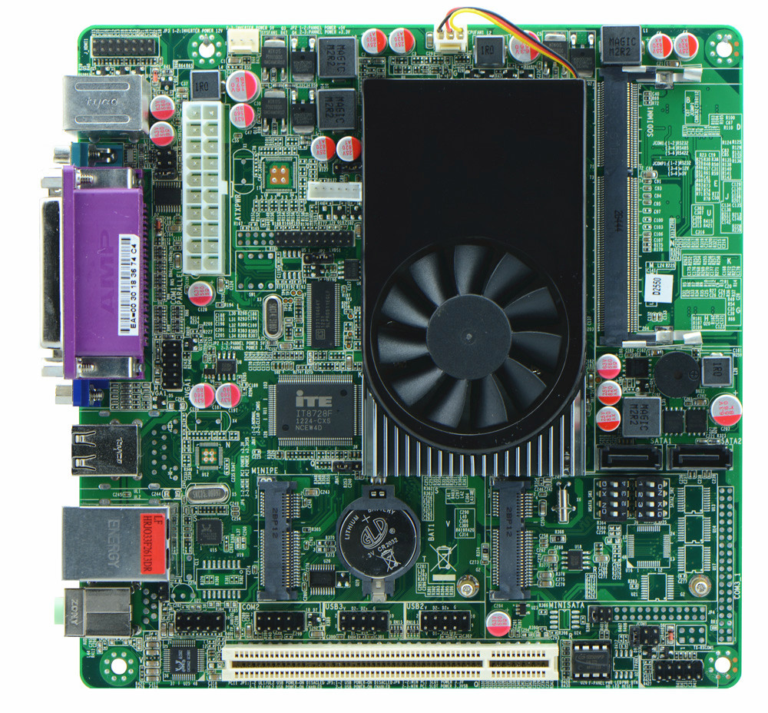
2. I/O Panel Front View
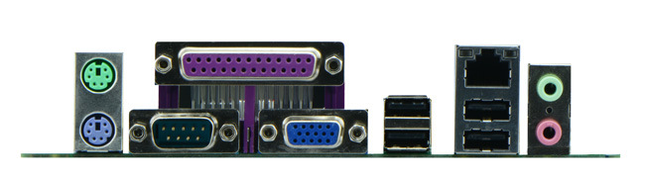
3. I/O Panel Side View
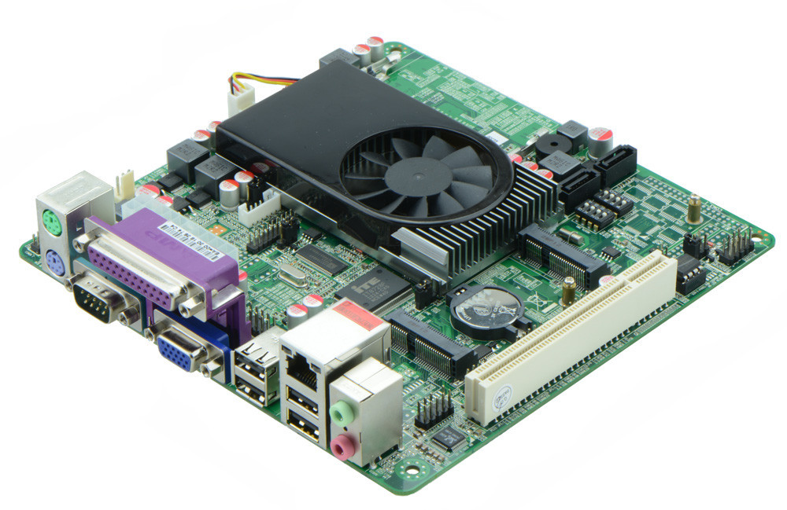
4. Memory Side View
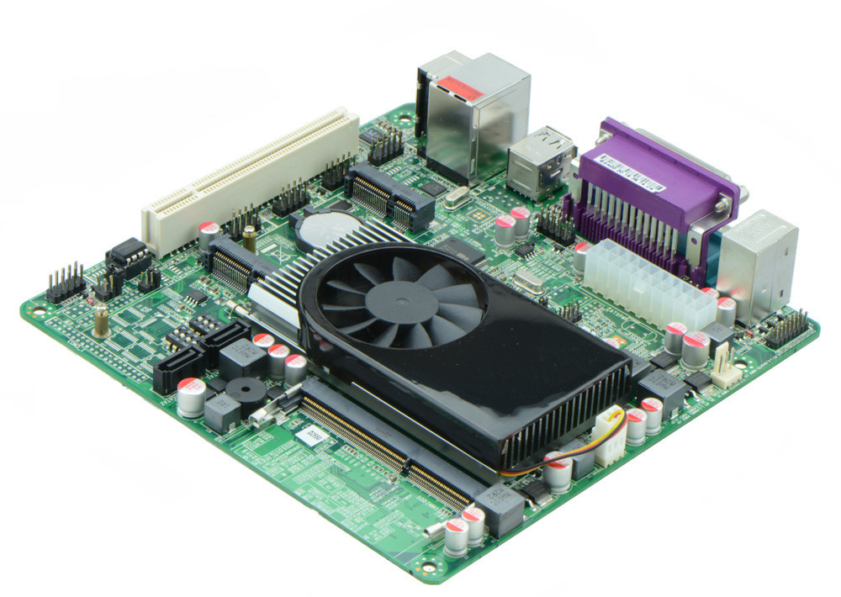

II. ITX-A25_2D6 VER:1.5A Motherboard Photos

1. Motherboard Front View
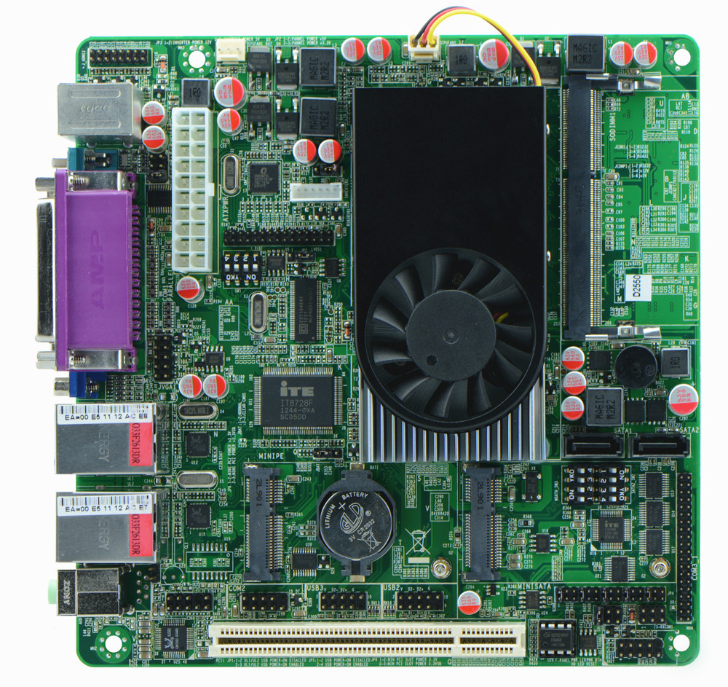
2. I/O Panel Front View
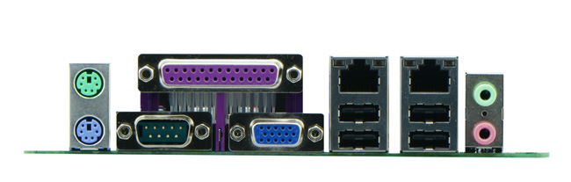
3. I/O Panel Side View
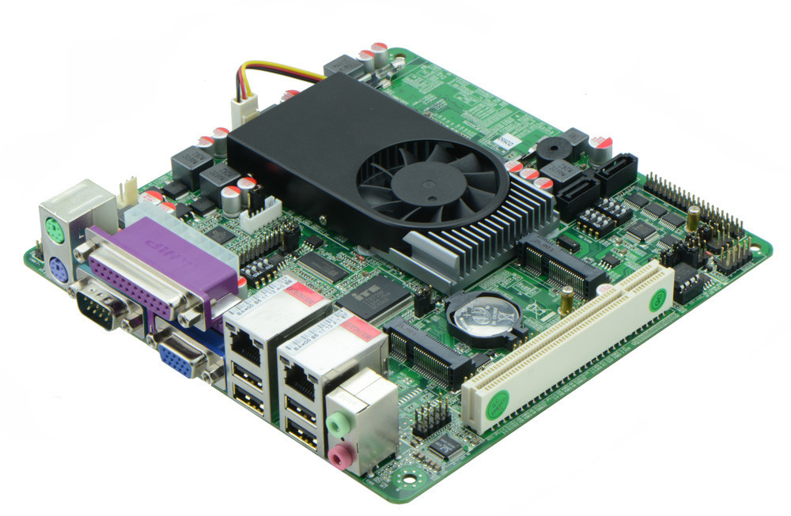
4. Memory Slot Side View
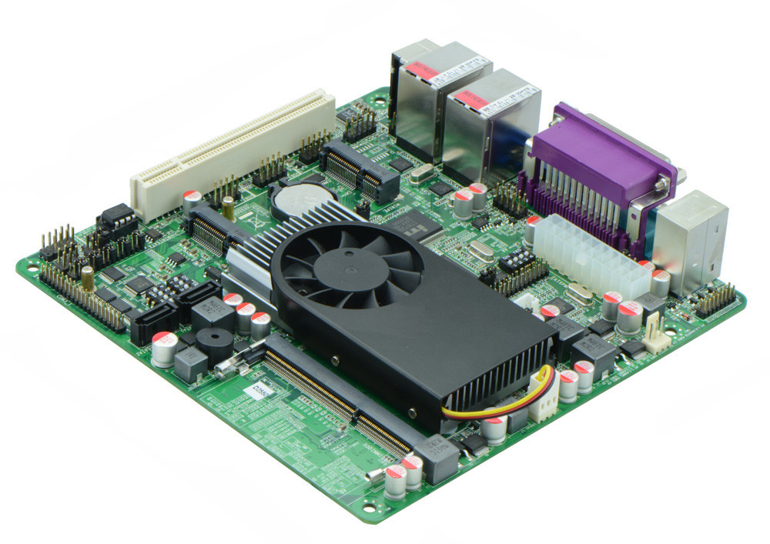

Product Model | ITX-A25_A2/ITX-A25_2D6 VER 1.2
CPU | Onboard Intel Atom D2550 dual core processor(1.86GHz)
Chipset | Intel NM10 Chipset
Memory | 1 x SO-DIMM DDR3 memory slot, supports 1066/800 Mhz, Max. 4GB.
Graphics | Integrated Intel GMA3600 graphics card, supports VGA/HDMI/LVDS video output  (ITX-A25_2D6 LVDS supports dual channel 24 bit)  (ITX-A25_A2 LVDS supports single channel 24 bit)
Expansion Slot | 1 x PCI slot  1 x mini PCIe slot(supports wifi module)
LAN | 2 x RTL8111E 1000M Ethernet controller(ITX-A25_2D6 configures)  1 x RTL8105E 100M Ethernet controller(ITX-A25_A2 configures)
Storage | 2 x SATA HDD interfaces(select from SATA2 and SSD, interface exchanged controlled by dial switch)  1 x MSATA slot(supports SSD)
Audio | Onboard Realtek ALC662 6 channel high fidelity audio chip, supports MIC, line out.
Rear I/O Panel | 1 x RS232 Serial Port, 1/9 pin supports 5V/12V electrifying function  1 x dual layer PS/2 keyboard and mouse connector  4 x USB 2.0 ports  2 x RJ-45 LAN ports(ITX-A25_A2 supports 1 RJ-45)  1 x dual layer standard audio interface(supports MIC, Line out)  1 x LPT port  1 x VGA port
Internal I/O Interface | 1 x LVDS connector, 2 x 15-pin  1 x JVGA1 connector, 2 x 5-pin  1 x HDMI connector, 2 x 8-pin  5 x COM connector, COM2 supports 422/485 function(ITX-A25_2D6 configues)  1 x TX-RXCOM 422/485 interface(ITX-A25_2D6 configures)  4 x USB 2.0 connectors  1 x audio connector, front panel audio interface 2 x 5-pin  1 x FP1 front panel function button and indicator light header, 2 x 5-pin  1 x LVDS INVERTER interfacee
Fan connector | 1 x CPU Fan connector and 1 x System Fan connector, 3-pin
BIOS | AMI 32MB Flash ROM
Watch Dog | Supports hardware reset function(256 level, 0-255 seconds)
PSU | 20-pin ATX PSU
Working Temp | -10℃～60℃
Storing Temp | -20℃～70℃
Working Humidity | 5%-95% relative humidity, non-condensing
Dimension | 170mm x 170mm  Mini ITX form factor

