Integrated Intel Celeron 1037U dual core processor(1.8GHz)
Intel NM70 express chipset
Built in Intel HD graphics core, provides VGA/HDMI/LVDS display output
Onboard DDR3 2GB express memory, Max. 4G
2 mini PCIe slot, supports SSD/wireless Wifi/3G module
Provides 6 RS232 COM headers, COM2 supports RS422/485 mode
Supports 2 Intel 82583V 1000M Ethernet controller, supports Wake On LAN
Integrated Realtek ALC662 6 channel high fidelity audio controller

EPIC-N80 Motherboard Photos

1. Motherboard Front View
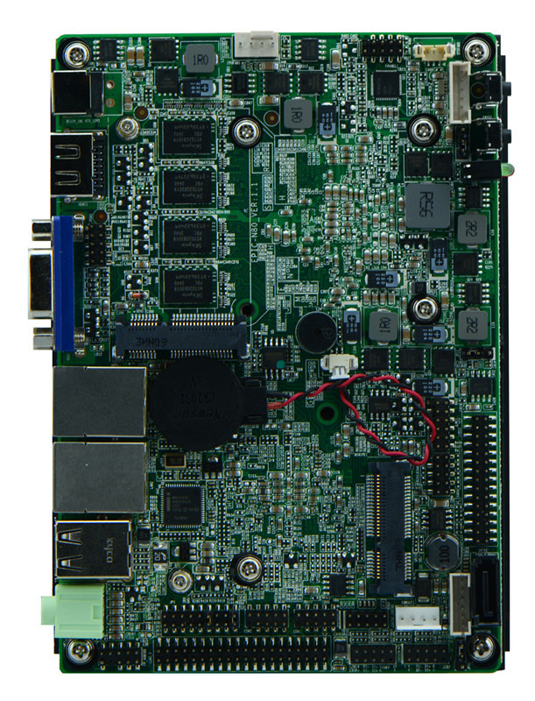
2. Motherboard Back View
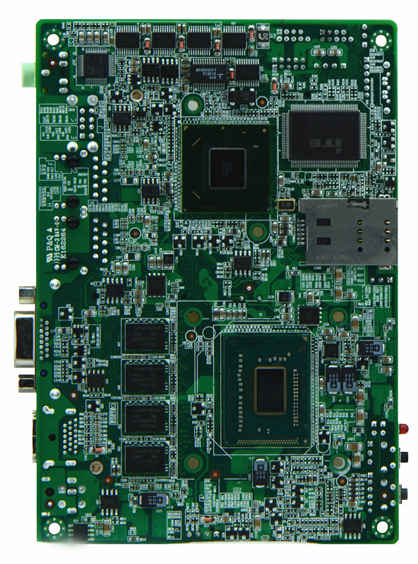
3. I/O Panel Front View
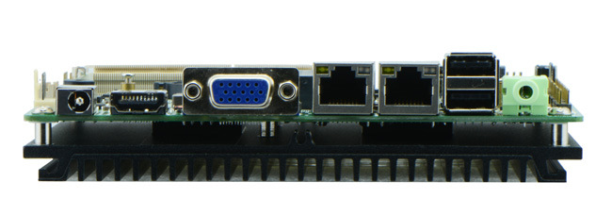
4. I/O Panel Side View
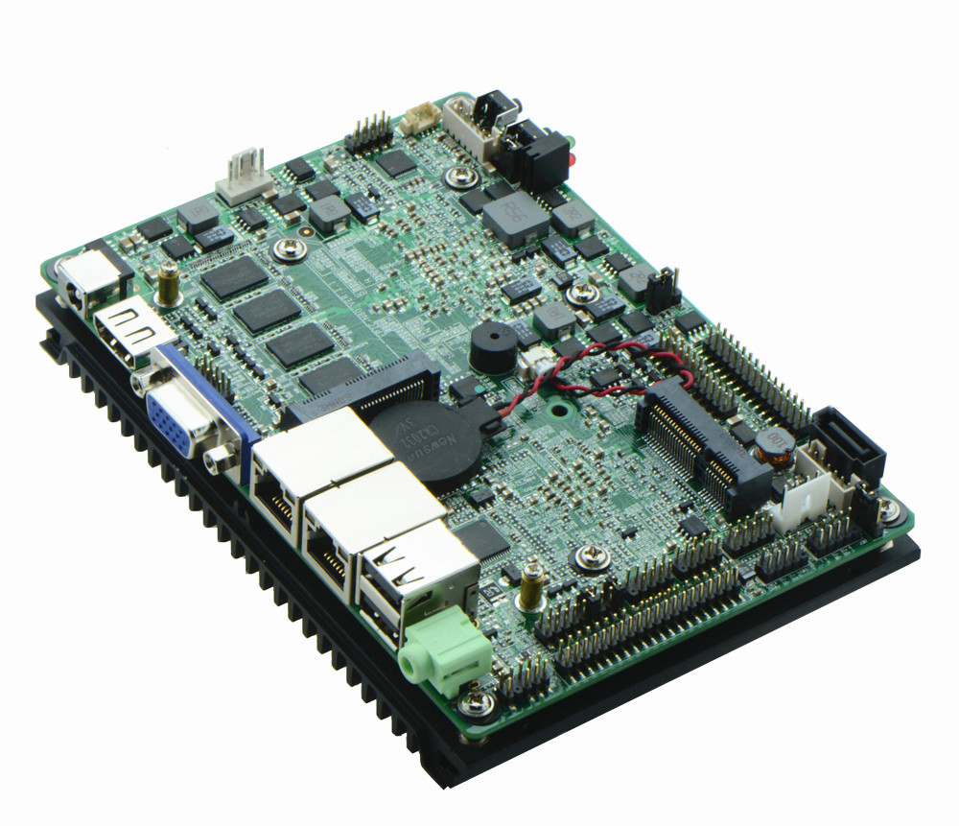
5. Memory Side View
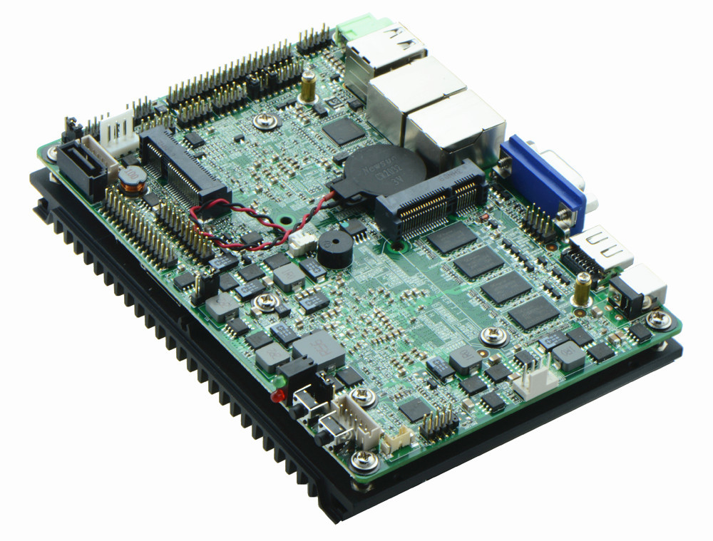

Product Model | EPIC-N80
CPU | Integrated Intel Celeron 1037U dual core processor 1.8GHz, TDP 17W
Chipset | Intel NM70 express chipset
Memory | Onboard DDR3 2GB express memory(4GB available)
Video | Intel HD Graphics core, provides VGA/HDMI/LVDS display output, LVDS support dual channel 24 bit, supports sync/async
Expansion Slot | 1 x mini PCI-e slot, supports wifi/3G module  1 x MSATA slot, supports SSD, WIFI, transit rate of SSD can reach 600 Mb/s
LAN | 2 x Intel 82583V 1000M Ethernet controller, supports Wake On Lan
Storage | 1 x SATA2 HDD interface, transit rate can reach 300 Mb/s  1 x JSATAII slot, supports SATA HDD
Audio | Onboard Realtek ALC662 6 channel high fidelity audio chip, supports MIC, line out, power amplifier
Rear I/O Panel | 1 x 12V DC_JACK input  1 x HDMI port  1 x VGA port  2 x USB 2.0 ports  2 x RJ45 LAN ports  1 x Line out(green)  1 x MIC(red)  1 x POWER, 1 x RESET, 1x LED1(POWERLED/HDDLED)
Internal I/O Interface | 1 x LVDS connector, 2 x15-pin  1 x JVGA1 header, same signal with DB15, 2 x 5-pin  6 x RS232 connectors, COM2 supports 485/422 function  1 x JLPC header, 2 x 6-pin  4 x USB 2.0 connectors  1 x PS/2 keyboard and mouse interface, 1 x 6-pin  1 x AUDIO header, front panel audio interface, 2 x 5-pin  1 x FP1 front panel function button and indicator light header, 2 x 5-pin  1 x SIM slot  2 x JSATA2 headers, 1 x 5-pin  1 x PWROUT HDD power supply headers  1 x LVDS INVERTER connector
Fan connector | 1 x CPU Fan connector, 3-pin
GPIO | Supports 4 channel GPIO
BIOS | AMI 32MB Flash ROM
Watch Dog | Supports hardware reset function(256 level, 0-255 seconds)
PSU | DC_12V single power supply input
Working Temp | -10℃～60℃
Storing Temp | -20℃～70℃
Working Humidity | 5%-95% relative humidity, non-condensing
Dimension | 148mm x 102mm

