Onboard AMD T56N dual core processor
AMD Hudson M1 chipset
Integrated HD6310 graphics core, supports VGA/HDMI/LVDS sync/async
1 DDR3 2GB express memory, Max. 4G
2 mini PCIe slot, supports SSD/wireless Wifi
Supports 4 x RS232 COM headers, COM2 supports RS232/422/485 mode
Integrated 2 x Intel 82583V 1000M Ethernet controller, supports Wake On LAN
Integrated Realtek ALC662 6 channel high fidelity audio controller
Supports 6 USB 2.0 headers

EPIC-N45 Motherboard Photos

1. Motherboard Front View
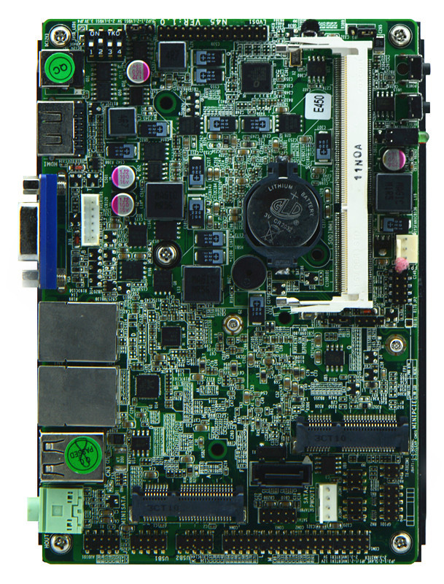
2. I/O Panel Front View
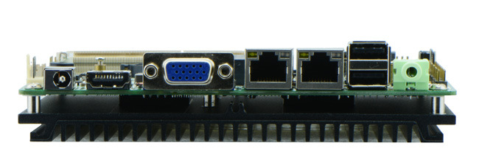
3. I/O Panel Side View
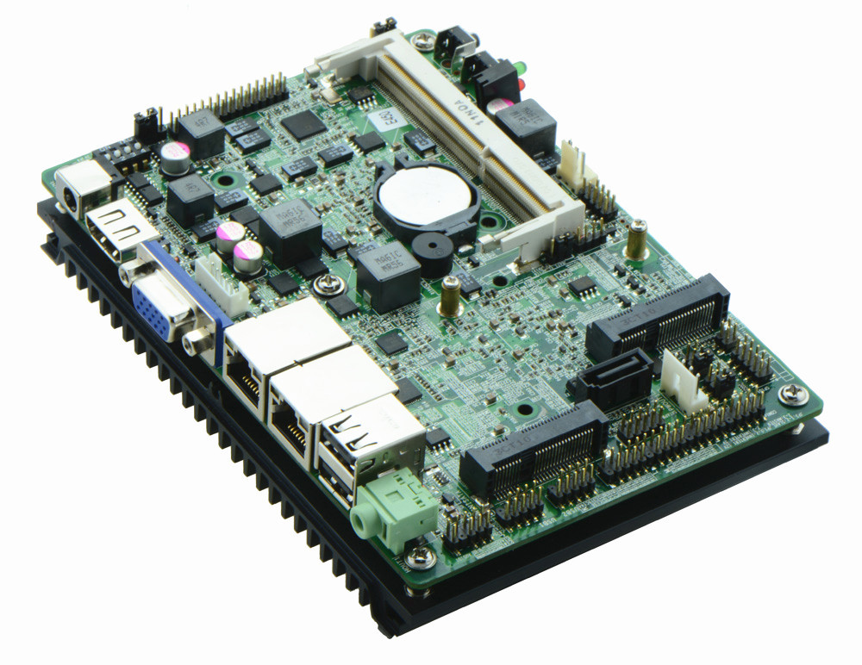
4. Memory Side View
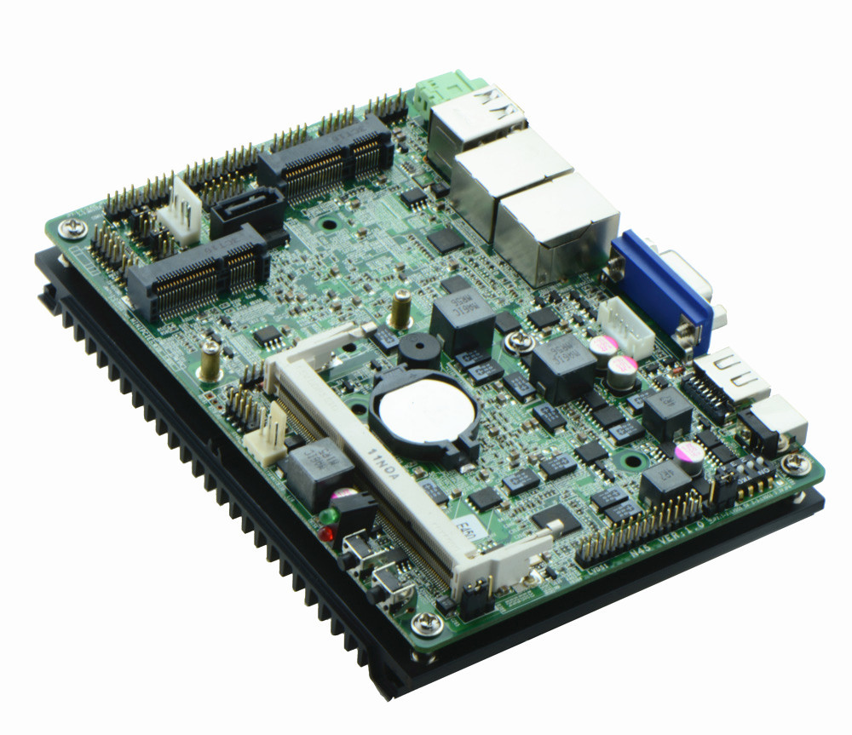

Product Model | EPIC-N45
CPU | AMD T56N dual core processor, 1.65GHz
Chipset | AMD Hudson M1 chipset
Memory | 1 x SO-DIMM DDRIII slot, supports 1066/800 MHz, Max. 4Gb
Video | Integrated AMD HD6320 graphics, provides VGA, HDMI, LVDS display output, supports sync/async, 1080P video, LVDS supports dual channel 24 bit
Expansion Slot | 1 x mini PCI-e slot, supports wifi/3G module
LAN | 2 x RTL8111E 1000M Ethernet controller, supports Wake On Lan, PXE function
Storage | 1 x SATA2 HDD interface  1 x JSATAII slot  1 x MSATA slot, supports SSD
Audio | Onboard Realtek ALC662 6 channel high fidelity audio chip, supports MIC, line out
Rear I/O Panel | 1 x 12V DC_JACK input  1 x HDMI port  1 x VGA port  2 x USB 2.0 ports  2 x RJ45 LAN ports  1 x AUDIO port(Line out)  1 x POWER, 1 x RESET, 1x LED1(POWERLED/HDDLED)
Internal I/O Interface | 1 x LVDS connector, 2 x15-pin  1 x JVGA1 header, same signal with DB15, 2 x 5-pin  4 x RS232 connectors, COM1 supports RS232/485/422 function  1 x TX-RXCOM RS422/485 header  4 x USB 2.0 connectors  1 x KB2 header  1 x AUDIO header, front panel audio interface, 2 x 5-pin  1 x FP1 front panel function button and indicator light header, 2 x 5-pin  1 x CIR header  1 x PWROUT HDD power supply headers  1 x LVDS INVERTER connector
Fan connector | 1 x CPU Fan connector, 3-pin
GPIO | Supports 4 channel GPIO
BIOS | AMI 16MB Flash ROM
Watch Dog | Supports hardware reset function(256 level, 0-255 seconds)
PSU | DC_12V single power supply input
Working Temp | -10℃～60℃
Storing Temp | -20℃～70℃
Working Humidity | 5%-95% relative humidity, non-condensing
Dimension | 148mm x 102mm

