Integrated Intel Atom N2600/N2800 processor(1.6/1.86GHz)
Intel NM10 express chipset
Supports 1 x DDR3 SO-DIMM 2GB, Max. 4Gb(2Gb for N2600)
Supports VGA, HDMI, LVDS sync/async display
Integrated 2 RTL8111E 1000M Ethernet controller
Provides 6 RS232 COM headers, COM2 supports RS232/422/485 mode
2 mini PCIe slot, supports SSD/wireless Wifi
Integrated Realtek ALC662 6 channel high fidelity audio controller

EPIC-N26(28) Motherboard Photos

1. Motherboard Front View
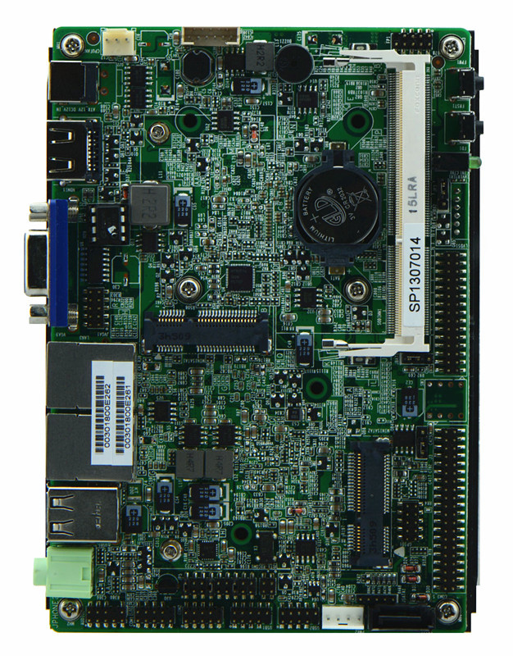
2. Motherboard Back View
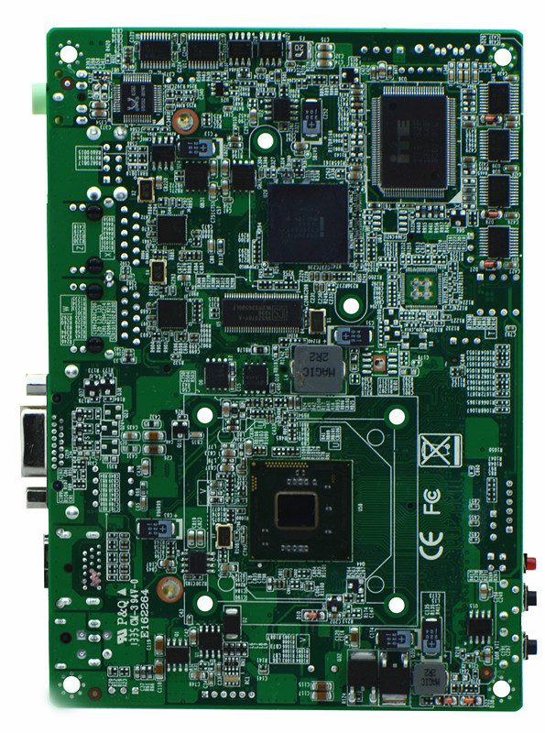
3. I/O Panel Front View
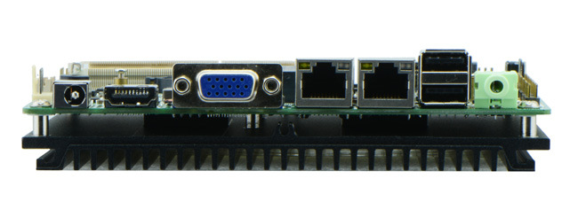
4. I/O Panel Side View
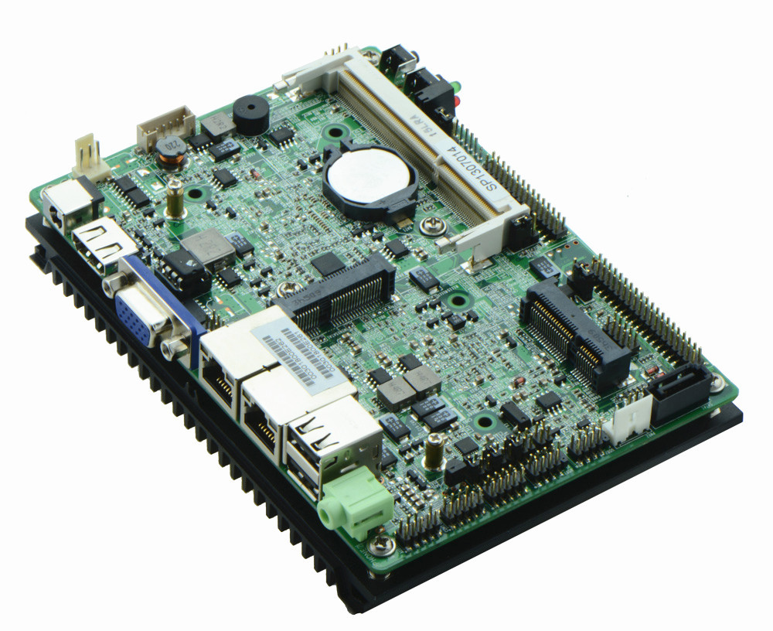
5. Memory Side View
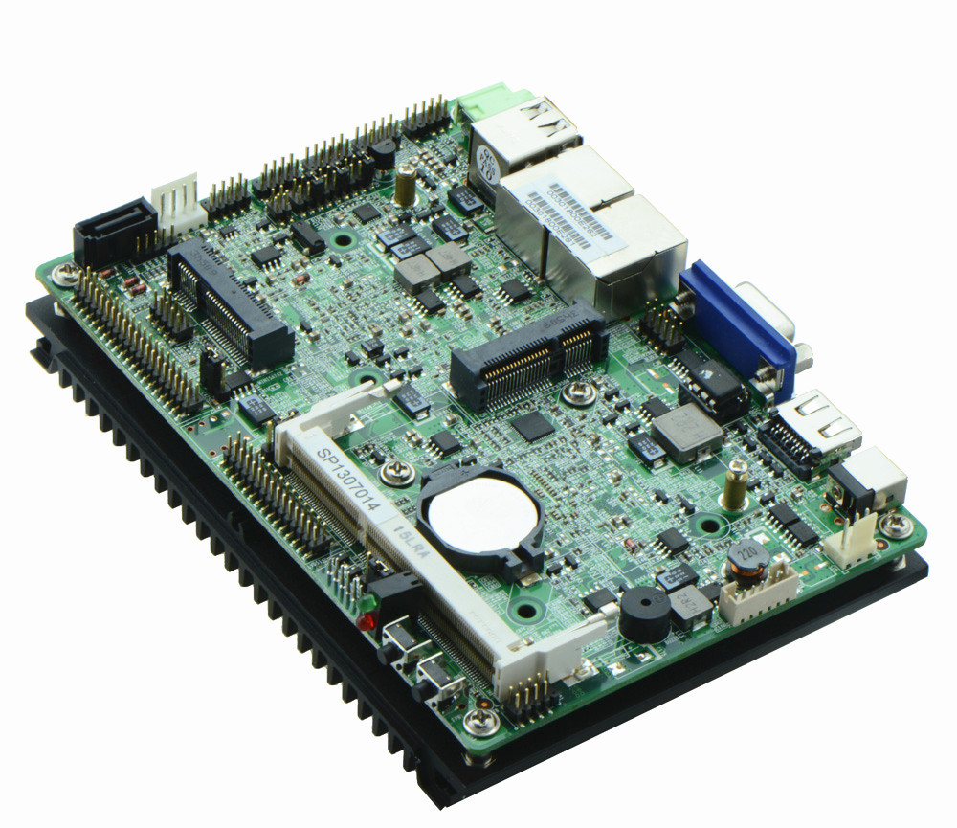

Product Model | EPIC-N26/N28
CPU | Integrated Intel Atom dual core N2600 1.66GHz processor  Integrated Intel Atom dual core N2800 1.86GHz processor
Chipset | Intel NM10 express chipset
Memory | 1 x SO-DIMM DDR3 memory slot, supports 1066/800MHz, Max. 2Gb(EPIC-N28 supports 4Gb memory)
Video | Integrated Intel GMA3600 Graphics core(EPIC-N28 integrates GMA3650 core), supports VGA/HDMI/LVDS sync/async, LVDS supports single channel 24 bit, supports sync/async
Expansion Slot | 1 x mini PCI-e slot, supports wifi
LAN | Integrated 2 x RTL8111E 1000M Ethernet controller, supports Wake On Lan, PXE function
Storage | 1 x SATA2 HDD interface  1 x MSATA slot, supports SSD
Audio | Onboard Realtek ALC662 6 channel high fidelity audio chip, supports MIC, line out
Rear I/O Panel | 1 x 12V DC_JACK input  1 x HDMI port  1 x VGA port  2 x USB 2.0 ports  2 x RJ45 LAN ports  1 x Line out port  1 x POWER, 1 x RESET, 1x LED1(POWERLED/HDDLED)(Front panel)
Internal I/O Interface | 1 x LVDS connector, 2 x15-pin  1 x JVGA header, same signal with DB15, 2 x 5-pin  6 x RS232 connectors, COM2 supports 485/422 function  1 x TX-RXCOM, RS422/485 mode  4 x USB 2.0 connectors  1 x PS/2 keyboard and mouse interface  1 x AUDIO header, front panel audio interface, 2 x 5-pin  1 x FP1 front panel function button and indicator light header, 2 x 5-pin  1 x PWROUT HDD power supply headers  1 x LVDS INVERTER connector
Fan connector | 1 x CPU Fan connector, 3-pin
GPIO | Supports 4 channel GPIO
BIOS | AMI 16MB Flash ROM
Watch Dog | Supports hardware reset function(256 level, 0-255 seconds)
PSU | DC_12V single power supply input
Working Temp | -10℃～60℃
Storing Temp | -20℃～70℃
Working Humidity | 5%-95% relative humidity, non-condensing
Dimension | 148mm x 102mm

