Integrated Intel Celeron 1037U dual core processor(1.8GHz)
Intel NM70 express chipset
Integrated Intel HD graphics core, provides VGA display
Single channel 1333/1066/800 memory, Max. 8Gb
Provides 2 mini PCIe slots, supports SSD/Wifi/3G module
Provides 6 RS232 headers, COM2/3 supports RS232/422/485 modes
6 x Intel 82583V 1000M Ethernet port
Supports SATA, CF card, SSD storage

I. NM70SL Motherboard Photos

1. Motherboard Front View
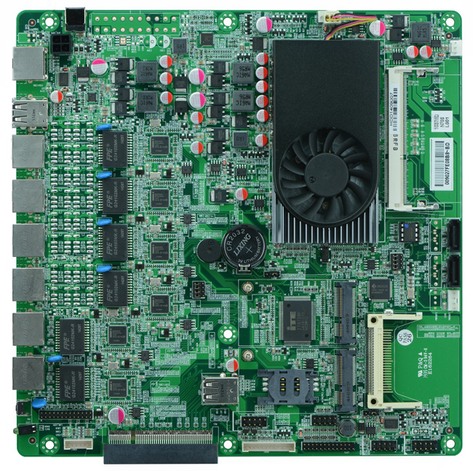
2. I/O Panel Front View
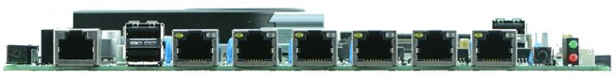
3. I/O Panel Side View
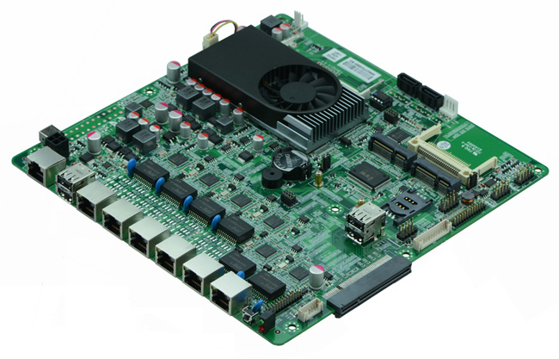
4. Memory Side View
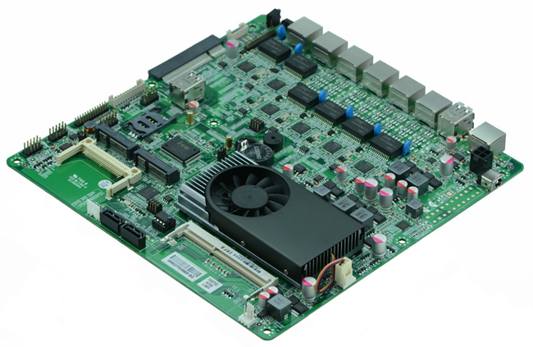

Product Model | FMN70SL
CPU | Onboard Intel Celeron 1037U dual core processor
Chipset | Intel NM70 express chipset
Memory | 1 x SO-DIMM DDR3 memory slot, supports 1333/1066 Mhz, Max. 8GB.
Video | Integrated Intel HD 2500 graphics core, supports VGA display ouput
Expansion Slot | 1 x PCI-e 8x slot, supports fiber optical and SFP module, alternative to mini PCIe slot  1 x mini PCIe slot, supports Wifi and 3G module
LAN | 6 x Intel 82583V 1000M Ethernet ports
Storage | 2 x SATA2 HDD interfaces, transfer rate reaches 3Gbps1 x MSATA slot,  1 x MSATAIII, transit rate reaches 6Gbps  1 x CF card slot
Rear I/O Panel | 1 x COM CISCO standard port  2 x USB 2.0 ports  6 x RJ-45 ports  1 x POWER switch  1 x LED1(POWERLED/HDDLED)  1 x 12V DC_JACK
Internal I/O Interface | 1 x JVGA header, 2 x 5-pin  1 x LAN_LED header, 2 x 13-pin  1 x LPT interface  4 x USB 2.0 headers  1 x RS232 headers  1 x FP1 header(2 x 5-pin, front panel function button and indicating light interface)  1 x PS/2 keyboard and mouse interface  1 x ATX_4 pin interface  2 x PWROUT, HDD power supply interface
Fan connector | 1 x CPU Fan connector, 4-pin  1 x System Fan connector, 3-pin
GPIO | Supports 4 channel GPIO
BIOS | AMI 16MB DPI Flash ROM
Watch Dog | Supports hardware reset function(256 level, 0-255 seconds)
PSU | DC_12V single PSU
Working Temp | -10℃～60℃
Storing Temp | -20℃～70℃
Working Humidity | 5%-95% relative humidity, non-condensing
Dimension | 220 x 220(mm)

