Integrated Intel Celeron 1037U dual core processor(1.8GHz)
Intel NM70 express chipset
Integrated Intel HD graphics core, provides VGA display
Dual channel 1333/1066/800 memory, Max. 16Gb
Provides 2 mini PCIe slots, supports SSD/Wifi/3G module
Provides 6 RS232 headers, COM2/3 supports RS232/422/485 modes
2 x Intel NH82580EB 1000M fiber optical Ethernet port
4 x Intel 82574L 1000M Ethernet port
Supports SATA, CF card, SSD storage

NM70SL_0 Motherboard Photos

1. Motherboard Front View
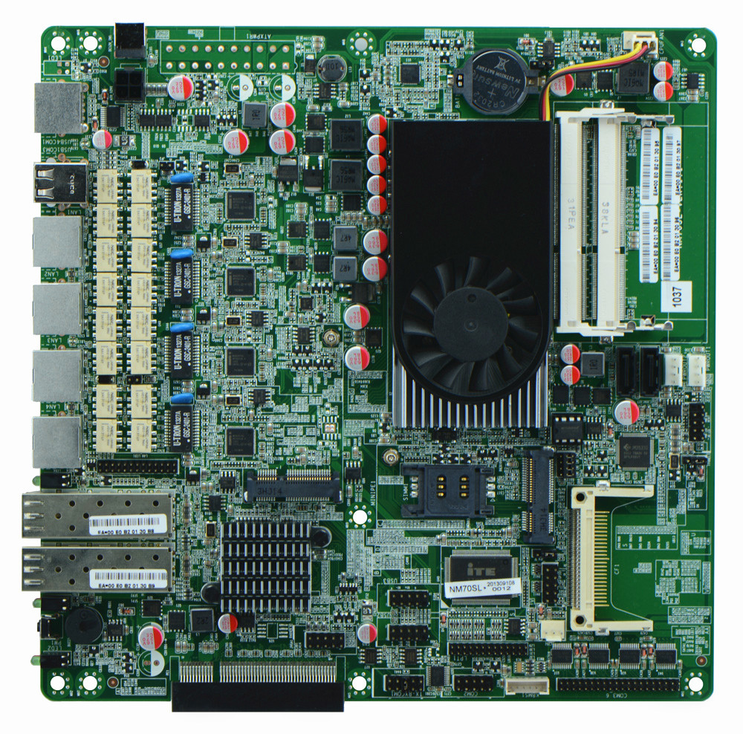
2. I/O Panel Front View
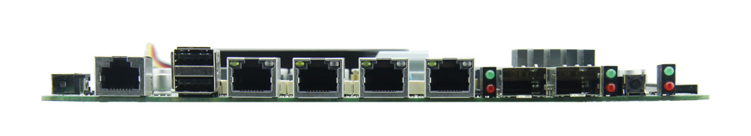
3. I/O Panel Side View
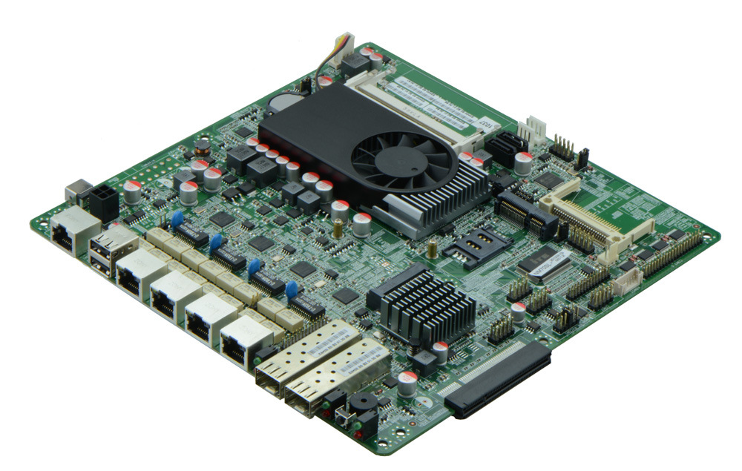
4. Memory Side View
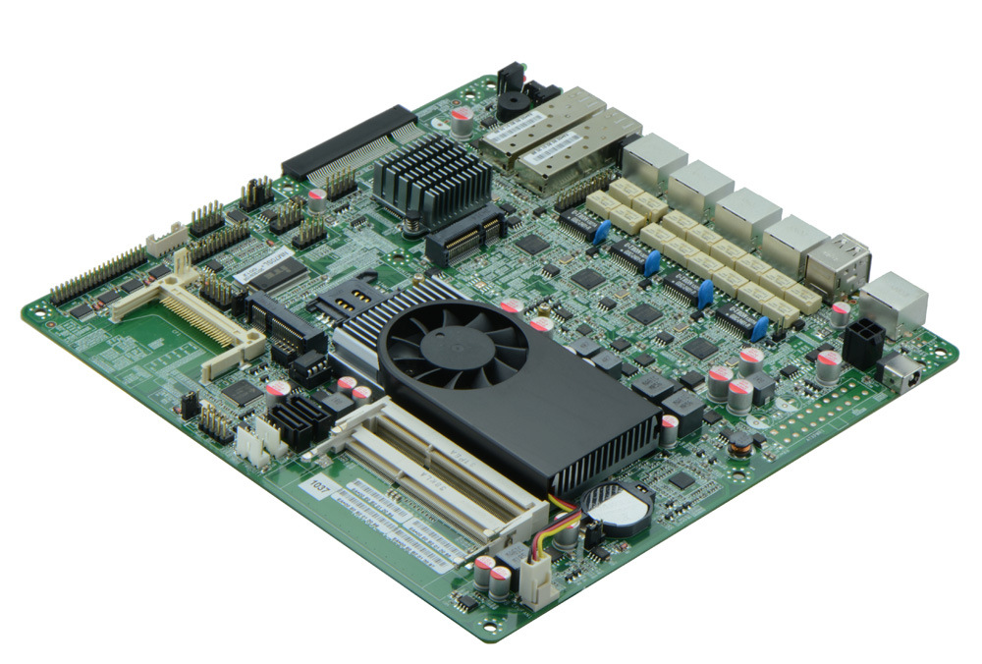
Product Model | FMN70SL_O
CPU | Onboard Intel Celeron 1037U dual core processor
Chipset | Intel NM70 express chipset
Memory | 2 x SO-DIMM DDR3 memory slot, supports 1333/1066 Mhz, Max. 16GB.
Video | Integrated Intel HD 2500 graphics core, supports VGA display ouput
Expansion Slot | 1 x PCI-e 8x slot, supports fiber optical and SFP module  1 x mini PCIe slot, supports Wifi and 3G module
LAN | 2 x Intel NH82580EB 1000M fiber optical Ethernet ports  4 x Intel 82574L 1000M Ethernet ports,  2 sets BYPASS available
Storage | 2 x SATA2 HDD interfaces, transfer rate reaches 3Gbps1 x MSATA slot,  1 x CF card slot(or SSD)  1 x MSATAIII, transit rate reaches 6Gbps
Rear I/O Panel | 1 x COM CISCO standard port  2 x USB 2.0 ports  4 x RJ-45 ports  2 x fiber optical socket  1 x POWER switch  1 x LED1(POWERLED/HDDLED)  2 x SFPLED
Internal I/O Interface | 1 x JVGA header, 2 x 5-pin  1 x LAN_LED header, 2 x 13-pin  1 x LPT interface  5 x RS232 headers, COM2 supports RS422/485 modes  1 x TX-RXCOM RS422/485 headers  1 x PS/2 keyboard and mouse interface  4 x USB 2.0 headers  1 x FP1 header(2 x 5-pin, front panel function button and indicating light interface)  2 x PWROUT, HDD power supply interface
Fan connector | 1 x CPU Fan connector, 4-pin; and 1 x System Fan connector, 3-pin
GPIO | Supports 4 channel GPIO
BIOS | 32M SMT Flash ROM
Watch Dog | Supports hardware reset function(256 level, 0-255 seconds)
PSU | DC_12V single PSU
Working Temp | -10℃～60℃
Storing Temp | -20℃～70℃
Working Humidity | 5%-95% relative humidity, non-condensing
Dimension | 220mm x 220mm

