Integrated Intel Celeron J1900 quad core processor(2.0GHz)
Intel Bay Trail SoC platform
Built in Intel HD graphics core
1 x 204-pin single channel DDR3 1333/1066 memory, Max. 8Gb
1 x 2.5 inch HDD bay, can install HDD directly onboard, 1 x SATA header, 1 x MSATA slot(support ssd and usb wifi)
4 x Intel 82574L GbE network, 1 set BYPASS
1 x 12V-19V DC_JACK in
Mini ITX Form Factor(170mm x 170mm)

I.FMITX-M9F_B Motherboard Photos

1. Motherboard Front View
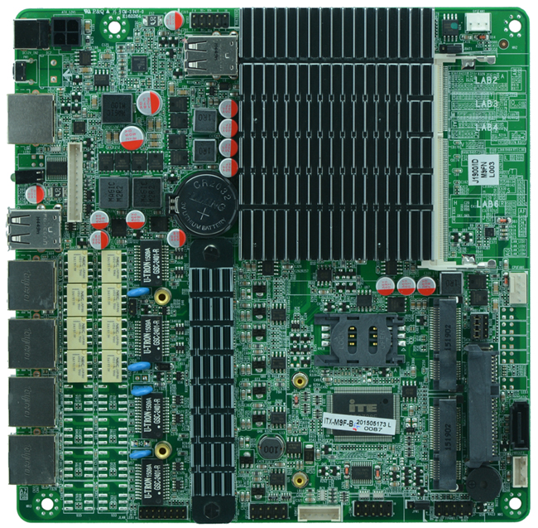
2. I/O Panel Front View
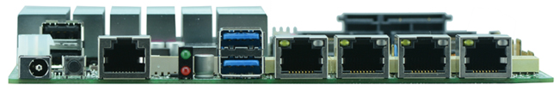
3. I/O Panel Side View
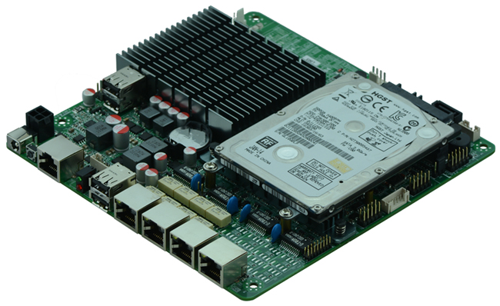
4. Memory Side View
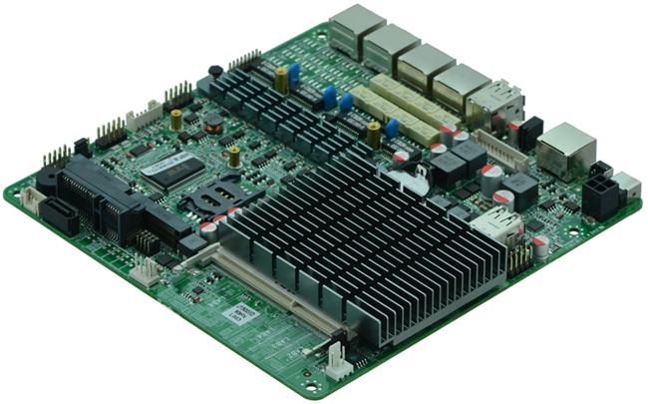

Product Model | FMITX-M9F_B
CPU | Onboard Intel Celeron J1900 Bay Trail quad core processor(2.0GHz)
Chipset | Based on Intel Bay Trail SOC platform, CPU integrated
Memory | 1 x SO-DIMM DDR3 memory slot, supports 1333/1066 Mhz, Max. 8GB.
Video | Integrated Intel HD graphics core
Expansion Slot | 1 x MSATA slot  1 x MINI PCIE slot(supports wifi, 3g module)
LAN | Integrated 4 x Intel 82574L 1000M Ethernet card, support Wake On LAN, 1 set BYPASS
Storage | 1 x 2.5 inch notebook hdd bay, can install hdd directly  1 x SATAII HDD interface(alternative to 2.5 inch hdd)  1 x MSATA
Rear I/O Panel | 1 x COM CISCO standard port  2 x USB ports(Upper USB 2.0, down USB 3.0)  4 x RJ-45 ports  1 x POWER switch  1 x LED1(POWERLED/HDDLED)  1 x 12V-19V DC_JACK input interface
Internal I/O Interface | 1 x VGA header, 1 x 12 -pin  1 x LAN_LED header, 2 x 8-pin  4 x USB 2.0 headers  1 x COM header  1 x PS/2 keyboard and mouse interface  1 x FP1 header(2 x 5-pin, front panel function button and indicating light interface)  1 x ATX 4PIN, can be used as 12V-19V input and output power supply interface  1 x 2PIN power header, can be used as 12V-19V input and output power supply interface  1 x HDD power header  1 x SIM slot
Fan connector | 1 x CPU Fan connector, and 1 x System Fan connector
GPIO | Supports 4 channel GPIO
BIOS | AMI 32MB DPI Flash ROM
Watch Dog | Integrated in the chip(256 level, 0-255 seconds)
PSU | 12V-19V single PSU
Working Temp | -10℃～60℃
Storing Temp | -20℃～70℃
Working Humidity | 5%-95% relative humidity, non-condensing
Dimension | 170mm x 170mm

