Supports Intel LGA1155 Core i3/i5/i7 32nm/22nm CPU
Intel H67 express chipset
Supports dual channel SO-DIMM DDR3 1333/1066 memory, Max. 16Gb
Built in HD graphics core, provides VGA display
Integrated 6 x 82583V 1000M Ethernet card, support Bypass function
1 x PCIe 8x slot, supports fiber optical module
4 x SATA HDD interface, provides 1 MSATA slot and 1 CF card slot
Provides 1 mini PCIe slot, supports Wifi/3G module

I.FMH67SL Motherboard Photos

1. Motherboard Front View
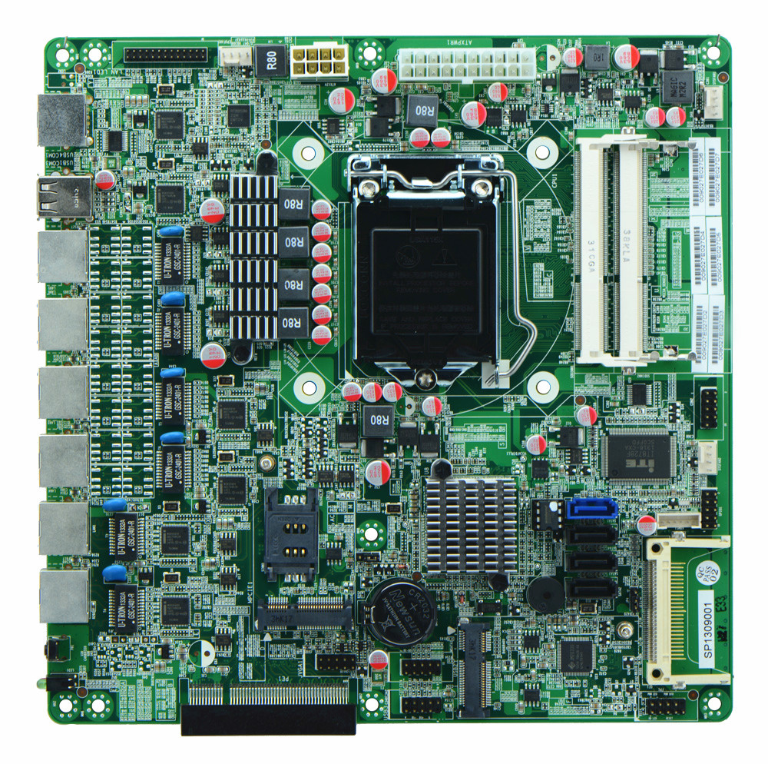
2. I/O Panel Side View
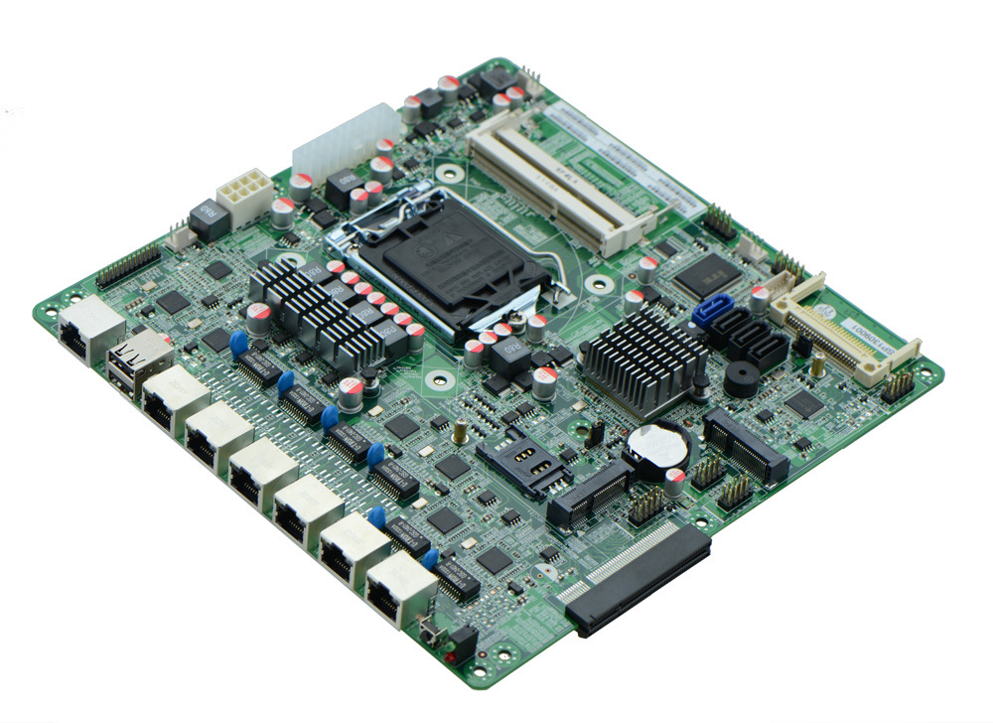
3. Memory Side View
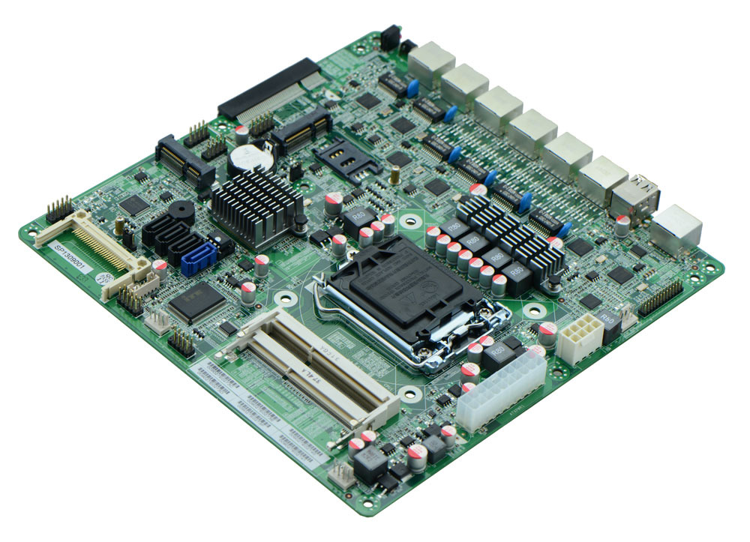

II.FMH67SL/B75SL I/O Front View
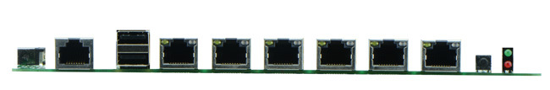
Product Model | FMH67SL
CPU | Supports LGA1155 Intel Core i3/i5/i7 32nm/22nm processors
Chipset | Intel H67 express chipset
Memory | 2 x SO DDR3 memory slots, supports 1333/1066 Mhz, Max. 16GB.
Video | Integrated Intel HD graphics core, supports VGA display ouput
Expansion Slot | 1 x PCI-e 8x slot, supports fiber optical and SFP module  1 x mini PCIe slot, supports Wifi and 3G module
LAN | integrates 6 x Intel 82583V 1000M Ethernet ports
Storage | 1 x SATAIII interface, 6 Gbps  3 x SATAII interfaces, 3 Gbps  1 x MSATA slot(supports SSD, 6Gbps)  1 x CF card slot
Rear I/O Panel | 1 x COM CISCO standard port  2 x USB 2.0 ports  6 x RJ-45 ports  1 x POWER switch  1 x LED1(POWERLED/HDDLED)
Internal I/O Interface | 1 x JVGA header, 2 x 5-pin  1 x LAN_LED header, 2 x 13-pin  1 x RS232 connector  1 x PS/2 keyboard and mouse interface  4 x USB 2.0 headers  1 x FP1 header(2 x 5-pin, front panel function button and indicating light interface)  1 x SIM card slot
Fan connector | 1 x CPU Fan connector; and 2 x System Fan connector, 4-pin
GPIO | Supports 4 channel GPIO
BIOS | 32M SMT Flash ROM
Watch Dog | Supports hardware reset function(256 level, 0-255 seconds)
PSU | ATX 20-pin dedicated PSU
Working Temp | -10℃～60℃
Storing Temp | -20℃～70℃
Working Humidity | 5%-95% relative humidity, non-condensing
Dimension | 220mm x 220mm

