Supports Intel LGA771 Xeon series dual core, quad core processors
Intel G41+ICH7R express chipset
Integrated Intel GMA4500 graphics core(supports DirectX 10)
2 x 204-pin dual channel 1333/1066/800 memory, Max. 8Gb
1 x PCIe 8x slot, supports fiber optic module
3 x Serial ATA2 3Gb/s controller
1 x 52P CF card slot
6 x 82574L 1000M auto adaptive Ethernet card
2 x RS232 headers, CISCO standard interface for COM1

G41XE Motherboard Photos

1. Motherboard Front View
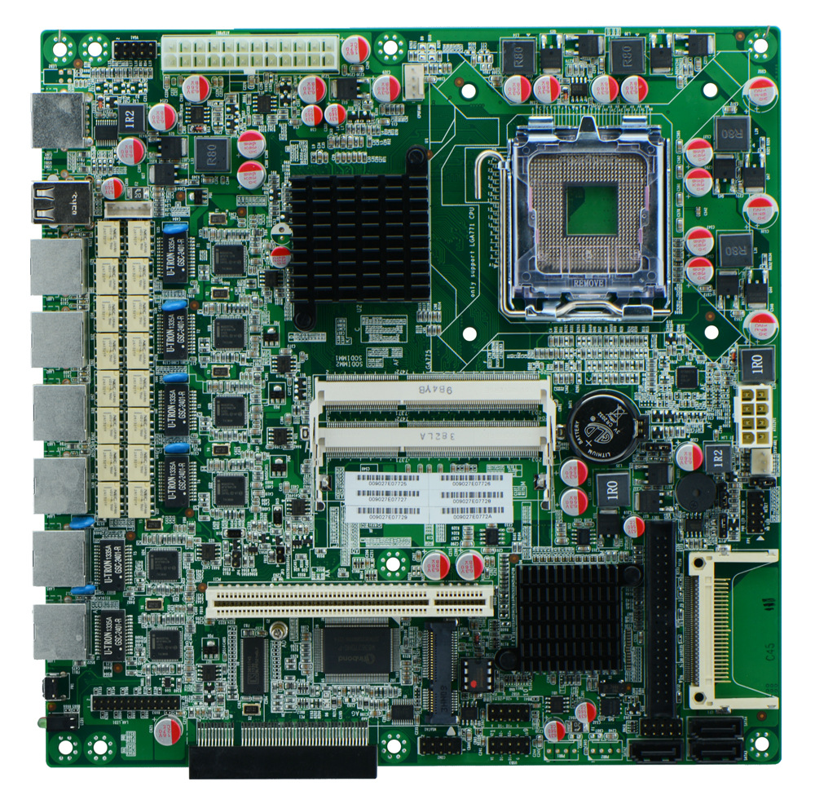
2. I/O Panel Front View
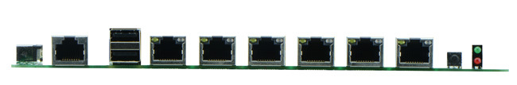
3. I/O Panel Side View
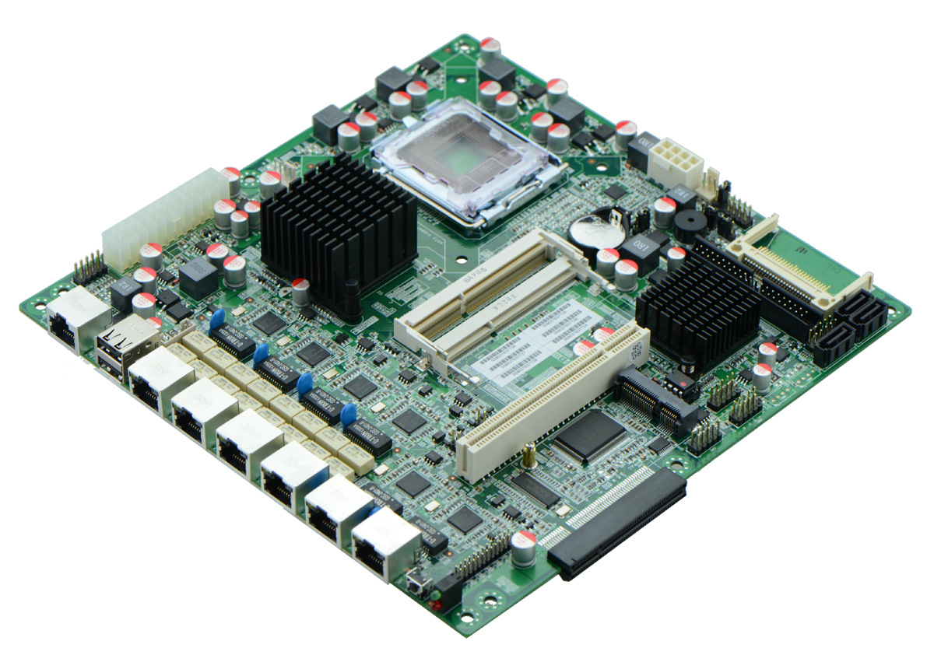
4. Memory Side View
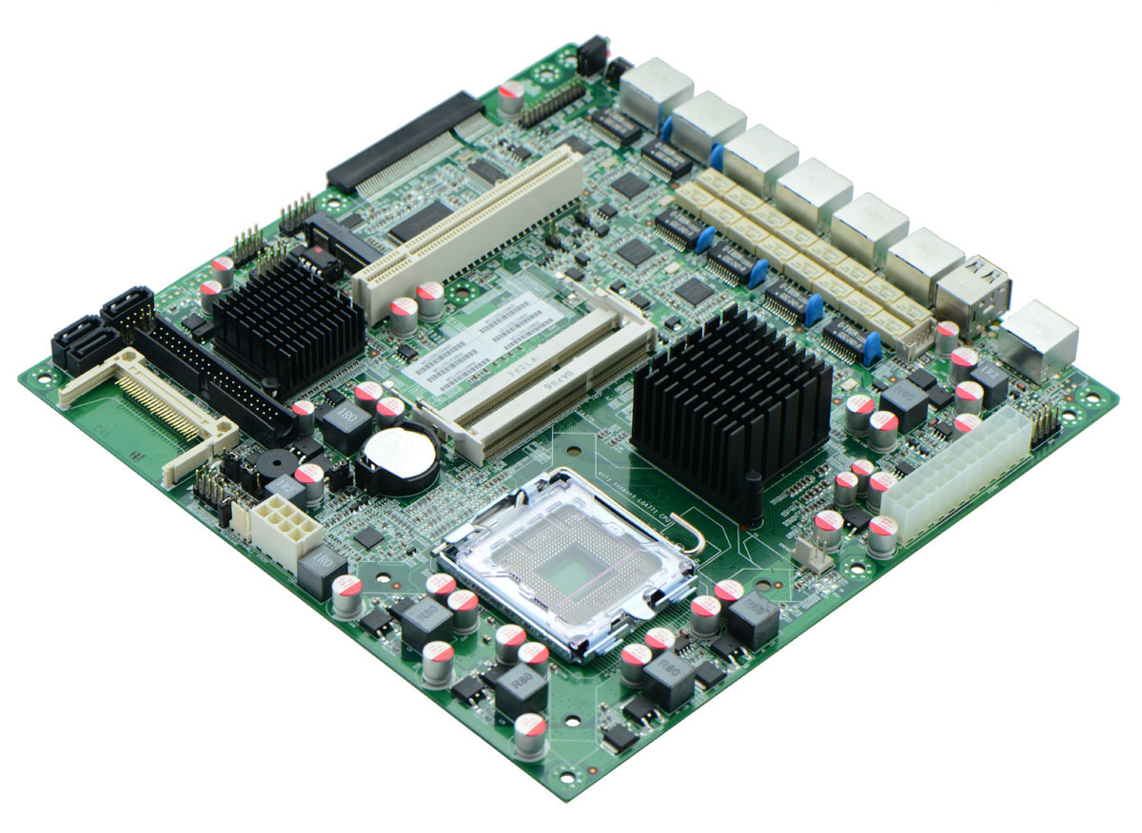

Product Model | FWMG41XE
CPU | Supports Intel LGA771 Xeon series dual core, quad core processors
Chipset | Intel G41+ICH7R Chipset
Memory | 2 x SO-DIMM DDR3 memory slot, supports 1333/1066 Mhz, Max. 8GB.
Video | Integrated Intel GMA4500 graphics core, supports VGA display ouput
Expansion Slot | 1 x PCI-e 8x slot, supports fiber optical and SFP module  1 x PCI slot
LAN | Integrated 6 x Intel 82574L 1000M Ethernet chip  Supports Wake On LAN, PXE booting, LAN1-4 supports bypass
Storage | 3 x SATA2 HDD interfaces, transfer rate reaches 3Gbps, supports RAID function  1 x MSATA slot, supports SSD  1 x IDE interface  1 x CF card slot
Rear I/O Panel | 1 x COM CISCO standard port  2 x USB 2.0 ports  6 x RJ-45 ports  1 x POWER switch  1 x LED1(POWERLED/HDDLED)
Internal I/O Interface | 1 x JVGA header, 2 x 5-pin  1 x LAN_LED header, 2 x 13-pin  4 x USB 2.0 headers  1 x COM header  1 x FP1 header(2 x 5-pin, front panel function button and indicating light interface)  1 x PS/2 keyboard and mouse interface
Fan connector | 1 x CPU Fan connector and 1 x System Fan connector, 3-pin
GPIO | Supports 4 channel GPIO
BIOS | AMI 8MB DPI Flash ROM
Watch Dog | Supports hardware reset function(256 level, 0-255 seconds)
PSU | ATX PSU, 24-pin
Working Temp | -10℃～60℃
Storing Temp | -20℃～70℃
Working Humidity | 5%-95% relative humidity, non-condensing
Dimension | 220mm x 220mm

