Integrated Intel Atom D2550 dual core processor(1.86GHz)
Intel ICH10R express chipset
Integrated Intel GMA3600 graphics core, provides VGA display
Supports SO DDR3 1333/1066/800 memory, Max. 4Gb
Provides 1 x PCI slot and MSATA slot
6 x Intel 82583V 1000M Ethernet port, and supports Bypass function
4 x SATA interfaces, and provides 1 50-pin CF card slot
Supports 256 level Watch Dog function

I.D25SL Motherboard Photos

1. Motherboard Front View
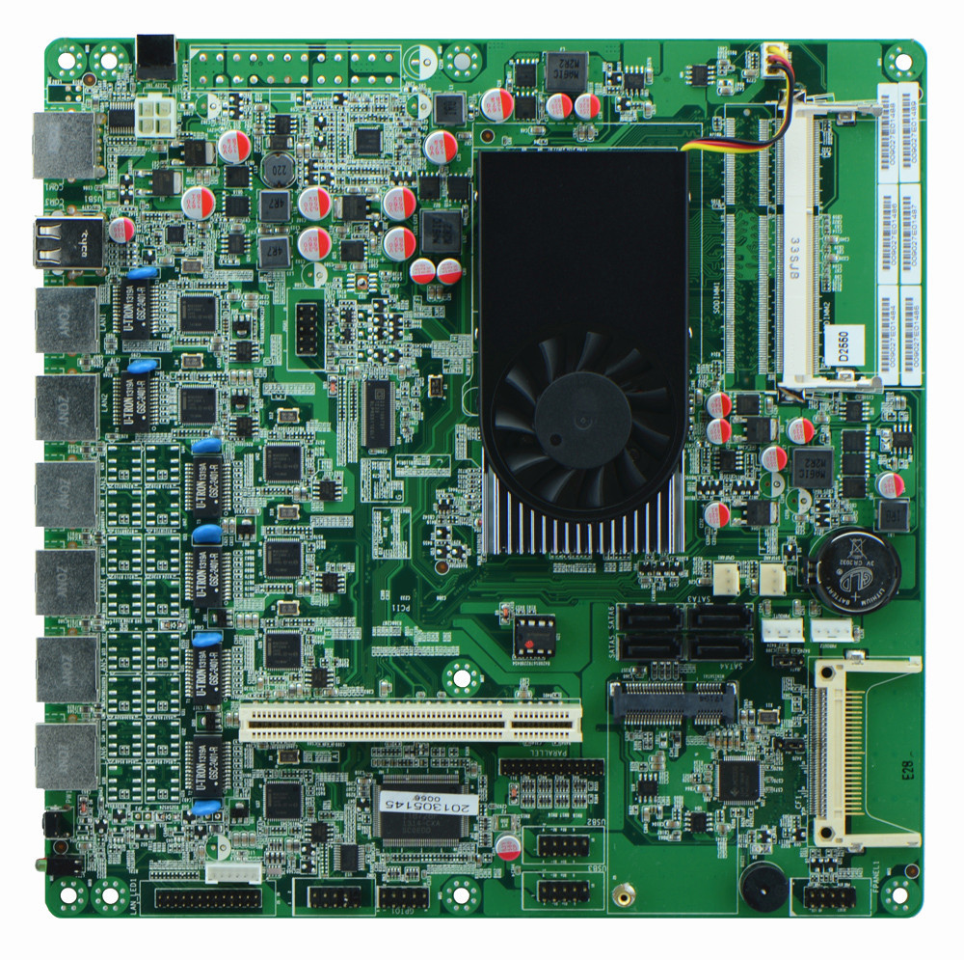
2. I/O Panel Side View
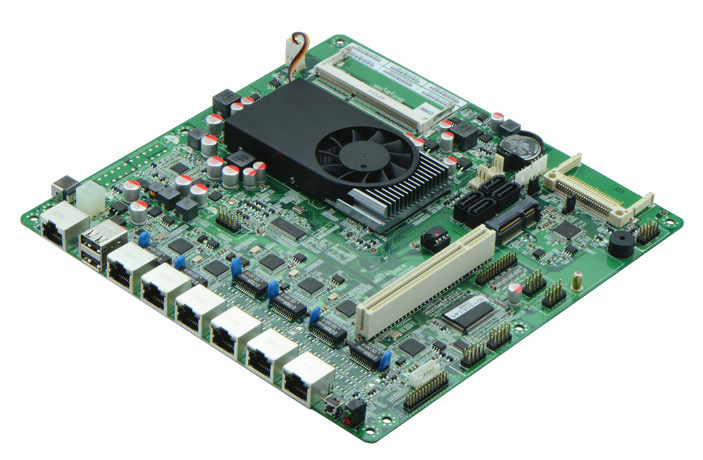
3. Memory Side View
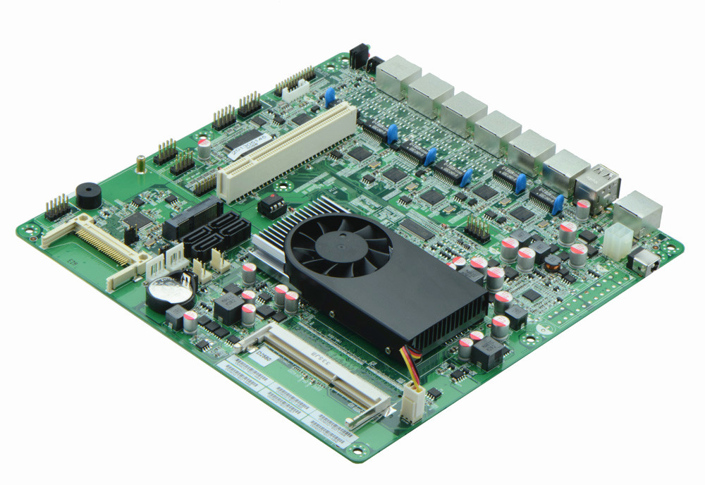

II. Motherboard I/O Front View
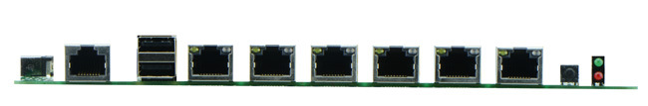
III. D25SL_B Motherboard Photos

1. Motherboard Front View
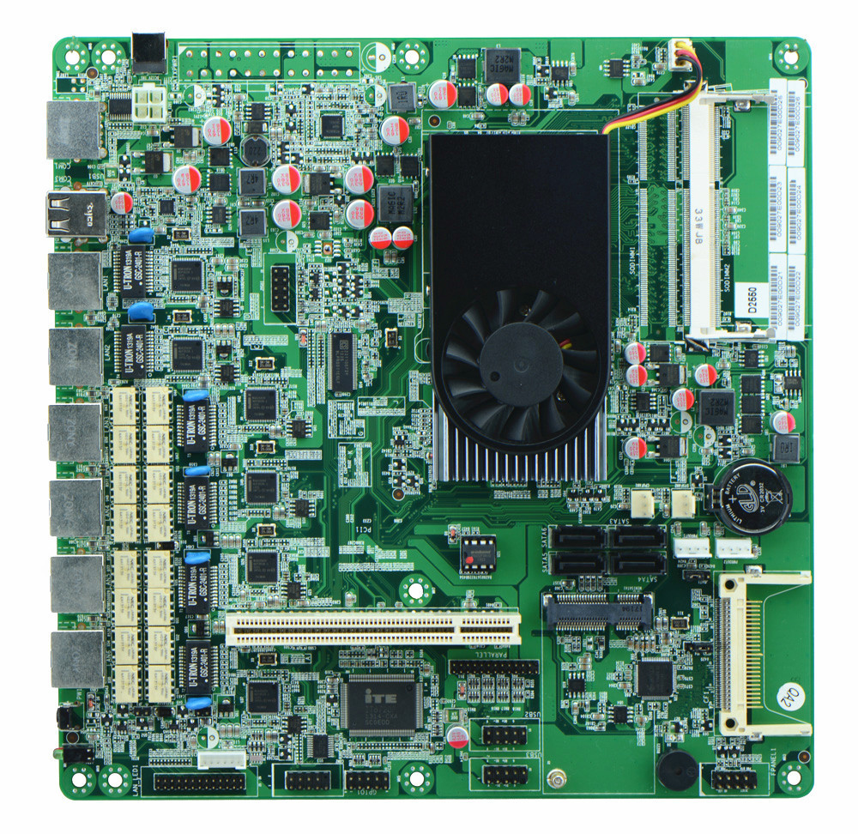
2. I/O Panel Side View
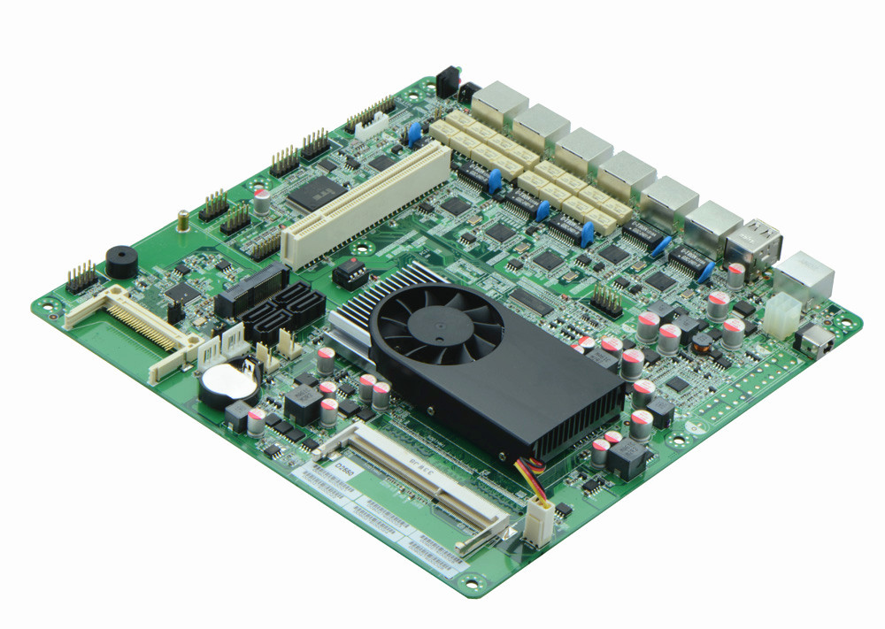
3. Memory Side View
Product Model | D25SL/D25SL_B
CPU | Onboard Intel Atom D2550 dual core processor(1.86GHz)
Chipset | Intel ICH10R express chipset
Memory | 1 x SO-DIMM DDR3 memory slot, supports 1066/800 Mhz, Max. 4GB.
Video | Integrated Intel GMA3600 graphics core, supports VGA display ouput
Expansion Slot | 1 x MSATA slot, supports SSD, USB Wifi  1 x PCI slot
LAN | Integrated 6 x Intel 82583V 1000M Ethernet card, support Wake On LAN, PXE booting, among which LAN1-4 supports 2 sets of Bypass function(D25SL cannot support Bypass)
Storage | 4 x SATAII HDD interface 3Gb/s  1 x CF card slot
Rear I/O Panel | 1 x COM CISCO standard port  2 x USB 2.0 ports  6 x RJ-45 ports  1 x POWER switch  1 x LED1(POWERLED/HDDLED)  1 x 12V DC_JACK input interface(on the side)
Internal I/O Interface | 1 x JVGA header, 2 x 5-pin  1 x LAN_LED header, 2 x 13-pin  1 x LPT interface  4 x USB 2.0 headers  1 x RS232 header  1 x PS/2 keyboard and mouse interface  1 x FP1 header(2 x 5-pin, front panel function button and indicating light interface)  1 x ATX_12V, can be used as +12V input and output power supply interface  2 x PWROUT, HDD power supply interface
Fan connector | 1 x CPU Fan connector, and 2 x System Fan connectors, 3-pin
GPIO | Supports 4 channel GPIO
BIOS | AMI 16MB DPI Flash ROM
Watch Dog | Integrated in the chip(256 level, 0-255 seconds)
PSU | DC_12V single PSU
Working Temp | -10℃～60℃
Storing Temp | -20℃～70℃
Working Humidity | 5%-95% relative humidity, non-condensing
Dimension | 220mm x 220mm

