PPC-P133-HY
13.3 inch TFT Touch Screen Embedded Industrial Panel PC powered by Intel Celeron J1900/ Core i5 4200U, 6 x COM, 2 x LAN, 4 x USB
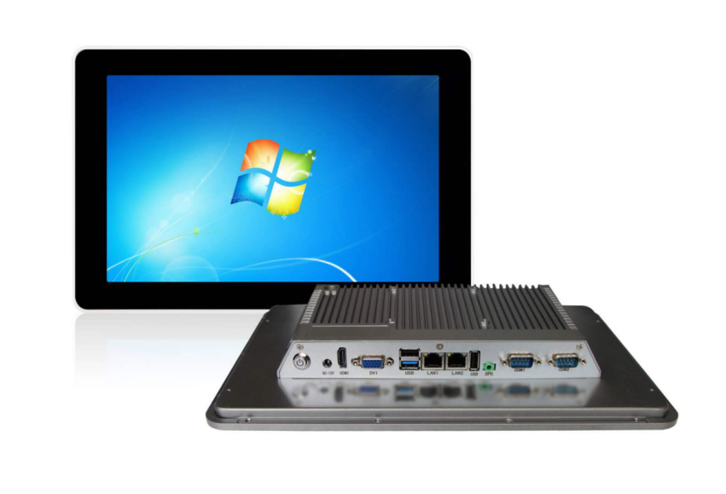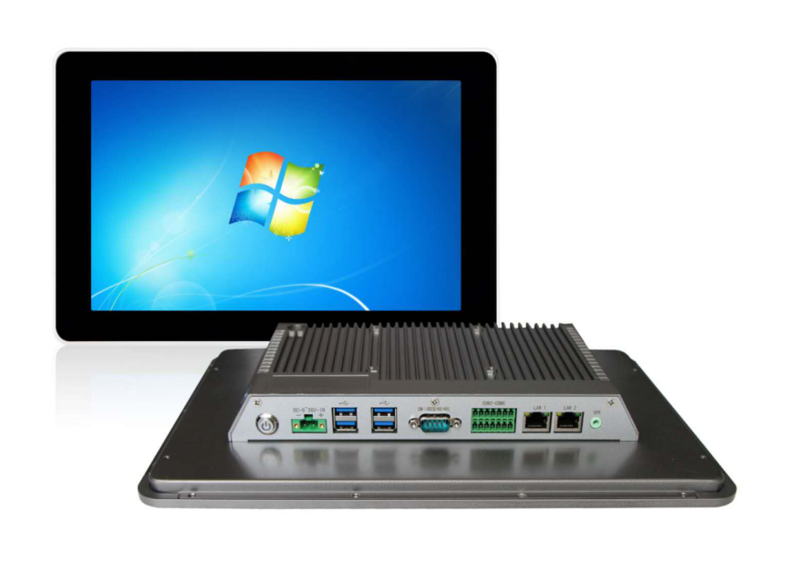
Product description:
PPC-P133-HY is a touch panel computer solution designed for human-machine interface applications. It uses Intel® J1900 processor/Intel I5 4200U processor, onboard 4GB DDR3 memory (upgradeable), and a resolution of 1920x 1080 LCD display and full flat capacitive touch screen. The whole machine adopts 9～36V DC power supply, which effectively controls the internal heat of the computer; provides a more diversified data storage device, and supports MSATA/SSD and SATA2.5" notebook hard disks; integrates a wealth of I/O interfaces, 6 x RS232 Or 4 x RS232/2-485, 2 x 10～1000M Ethernet ports and 4 x USB3.0 ports.

PPC-P133-HY supports a variety of installation methods such as wall hanging and swing arm, which is very convenient for installation and maintenance; the front panel complies with NEMA/IP65 waterproof and dustproof standards, which can effectively control the splashing of water droplets and water vapor from the site to enter the host and affect the normal operation of the equipment Work; the equipment adopts a fanless design, limited control of dust entering the equipment, ensuring a more stable operation of the equipment, and quickly dissipating the internal heat of the system through the external surface heat sink, so that it can adapt to the harsher site environment; the most suitable application Factory automation, machinery manufacturing, numerical control equipment, textile equipment, intelligent power, food traceability and other host computer monitoring and control.

PPC-P133-HY is compatible with mainstream operating systems and embedded operating systems such as Windows7, Windows10, Linux, etc. It can run application software and programs based on the above operating systems independently developed by customers, and install industrial automation configuration software to form a powerful man-machine interface.
Feature:
13.3" true color LCD display, resolution 1920x1080, backlight service life up to 50,000 hours
The front panel reaches IP65 protection level to prevent dust and splashed water from entering the display
Ultra-thin design, save cabinet space, shock and vibration resistance
9～36V wide-voltage DC power input, which meets industrial field supply
Electric high-precision capacitive screen, with many industrial field application characteristics
Support panel embedded and standard VESA installation at the same time, users can flexibly choose the installation method
Specification: PPC-P133-HY
System parameters | CPU | J1900/I5-4200U processor
System parameters | RAM | Onboard 4GB DDR3 (expandable)
System parameters | Disk | Support MSATA / SSD and SATA2.5 "notebook hard drives
I/O interface | Network port | 2 x Intel Gigabit Ethernet
I/O interface | Audio | RTLALC662 audio controller, LINE-out port
I/O interface | USB | 3/4 x USB3.0
I/O interface | Serial port | 3/6 x RS232/(2 can be set to RS485/RS422)
I/O interface | GPIO | 14 channels (custom)
LCD screen | Display | 13.3”TFT LED
LCD screen | Resolution | 1920x1080
LCD screen | Brightness | 350cd/m2
LCD screen | Contrast | 800:1
LCD screen | Maximum color | 16M
Touch screen | Types of | Capacitive
Touch screen | Click life | 250 grams of force, 50 million times
Touch screen | Response time | <5ms
Touch screen | Transmittance | above 91%
Touch screen | High temperature test | 85℃/1000hrs
Touch screen | Constant temperature and humidity test | 85℃/90%RH/1000hrs
Mechanism parameters | Panel cabinet | Aluminum profile face frame
Mechanism parameters | Installation method | Wall mount
Mechanism parameters | Power input | 9～36V DC power supply
Mechanism parameters | Overall dimensions | 338mmx215mmx43mm
Mechanism parameters | Power | 30W
Mechanism parameters | Weight | 2KG
Environmental parameters | Operating temperature | -20～60℃（Electronic disk）
Environmental parameters | Storage temperature | -30～80℃
Environmental parameters | Front panel protection | IP65 standard
Ordering Information:
Product number | Configuration
PPC-P133-HY/J1900  (economical type) | J1900/2 x RJ-45/3 x USB/2 x RS232/12v
PPC-P133-HY/J1900 (industrial type) | J1900/onboard 4G/2 x RJ-45/4 x USB/4 x RS232+1 x RS485+1 x (RS232/422/485)/optional 9-36V
PPC-P133-HY/I5-4200U  (industrial type) | I5-4200U/onboard 4G/2 x RJ-45/4 x USB/4 x RS232+1 x RS485+1 x (RS232/422/485)/optional 9-36V
Dimensions:
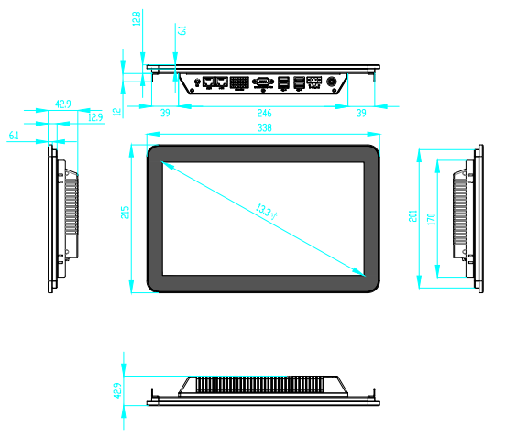

Contact:
Allen Dai / Sales Manager
Armortec Technology Limited
Email: allen.y.dai@armortec.net
Skype: allen.dai89
Tel: +86 150 1266 9595

