Supports Intel Atom D525 dual core processor(1.80GHz)
Adopts Intel Atom D525+ICH8M express chipset
Processor integrated GMA3150 graphics(shared 128/224MB memory)
1*204 pin single channel SO-DIMM DDR3 1066/800/667 memory, Max. 2GB
2*Serial ATA2 3Gb/s controller
1*MSATA slot, supports SSD, USB WiFi, alternative to SATA2
4*Intel 82583V GbE, LAN1-4 supports BYPASS function
1*12V/5A DC_JACK power input
Mini ITX form factor(17cmx17cm)

- FMITX-M5V_B VER:1.1 front view
Onboard Intel Atom D525 dual core 1.8GHz processor, adopts Intel ICH8M high speed chipset, supporting DDR3
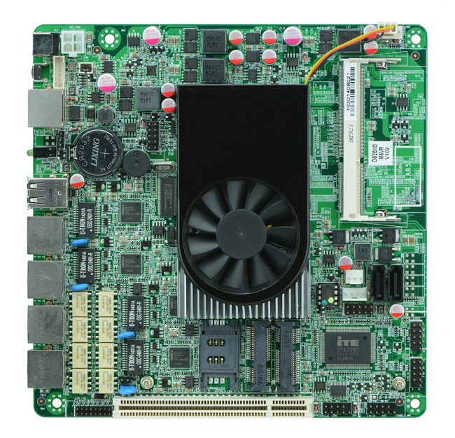
- FMITX-M5V_B VER:1.1 I/O panel view
Integrated Intel GMA3150 graphics, supports VGA display output
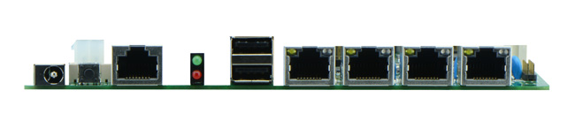
- FMITX-M5V_B VER1.1 side view
Integrated 4 Intel 82583V GbE Ethernet controller, supporting 1 group BYPASS function, wake-on-LAN/PXE function, supporting WIFI/3G/SSD/6 USB/2 COM
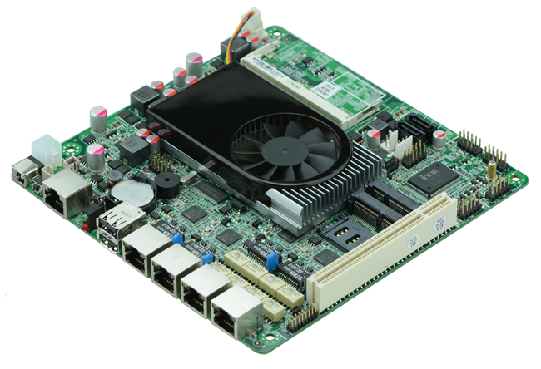

With 2 SATA/1 PCI slot, motherboard DC 12V power supply
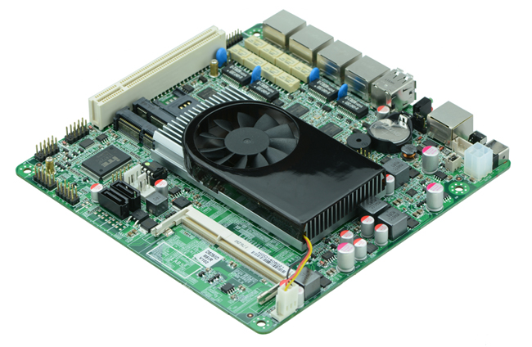

Model | FMITX-M5V_B VER:1.1
Processor | Intel Atom D525 dual core 1.8GHz
Chipset | Adopts Intel ICH8M express chipset
Memory | 1*SO DDRIII memory slot, support 1066/800 memory, Max. 2GB
Graphics | Embedded Intel GMA3150 display(shared memory 128/224MB)
Expansion slot | 1*PCI slot  1*MPCIE slot(supports WIFI and 3G module)
Ethernet | Integrated 4*Intel 82583V GbE Ethernet controller, supports wake-on-LAN  Supports 1 group BYPASS function
Storage | 2*SATAII HDD interface  1*MSATA slot(supports SSD/USB WIFI)
Rear I/O Panel | 1*12VDC_JACK input  1*POWER switch  1*COM CISCO standard port  1*LED1(POWERLED/HDDLED)  2*USB 2.0ports  4*RJ-45 network ports
Internal I/O | 1*JVGA header(2*5pin)  1*LAN_LED header(2*8pin)  1*COM header  4*USB 2.0 headers  1*FP1 header(2*5pin front panel function button and indicating light port)  1*ATX_12V(Can be +12V input and output power interface)  1*PS/2 mouse and keyboard header  1*PWROUT(HDD power supply interface)  1*SIM card slot
Fan header | 1*CPU FAN and SYSFAN interface
GPIO | Supports 4 channel input and output GPIO
BIOS | AMI 8MB DPI Flash ROM
Watch dog | Supports hardware reset function(256level, 0-255 second)
PSU type | DC_12V single PSU input
Working Temperature | -10℃～60℃
Storage Temperature | -20℃～70℃
Working Humidity | 5-95% relative humidity, non-condensing
Size | 170mm*170mm

