Atom D525 dual core 1.8GHz processor
Adopts Intel ICH8M express chipset
2 x SATA HDD ports
1 x IDE HDD port
6 x 82583V GbE Ethernet card
Supports Wake-on-LAN and PXE function
Supports 2 x RS232 headers
- D52SL VER:1.1 front view

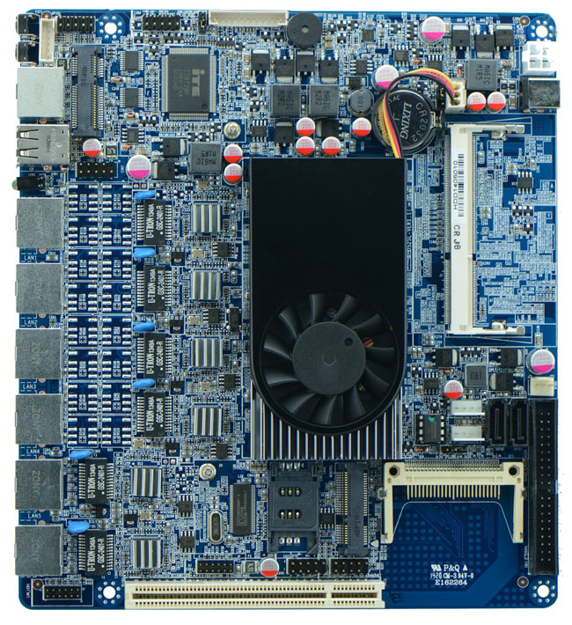
- D52SL VER:1.1 IO panel view
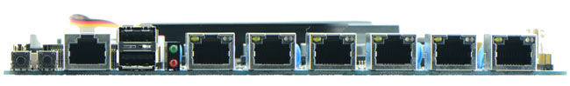

Model | FMD52SL
Processor | Onboard Intel Atom dual core D525 processor 1.8GHz
Chipset | Intel ICH8M express chipset
Memory | 1 x SO DDR3 slot, supports 800/1066 memory, Max. 2GB
Graphics | Embedded Intel GMA3150 graphic core, supporting VGA display output
Expansion slot | 1 x MPCIE slot, supporting USB WIFI, 3G module  1 x MSATA slot, supporting SSD, USB WIFI  1 x PCI slot
Ethernet | Integrated 6 x Intel 82583V GbE Ethernet controller, supports wake-on-LAN and PXE function
Storage | 2 x SATAII interface 3Gb/s  1 x CF card slot  1 x IDE HDD interface
Rear I/O | 1 x COM(CISCO standard)  2 x USB 2.0 ports  6 x RJ-45 ports  1 x POWER(power switch)  1 x RESEST(resetting switch)  1 x LED1(POWERLED/HDDLED)  1 x 12V DC_JACK input and output(rear panel)
Internal I/O | 1 x JVGA header(1 x12pin)  2 x LAN_LED headers(2 x6pin)  4 x USB 2.0 headers  1 x RS232 connectors  1 x FP1 front panel function button and indicating light header(2 x5pin)  1 x PS/2 keyboard and mouse interface  1 x ATX_12V(Can be +12V input and output interface)  2 x PWOUT HDD power interfaces
Fan connectors | 1 x CPUFAN and SYSFAN(3pin)
GPIO | Supports 4 channel input and output GPIO
BIOS | AMI 8MB DPI Flash ROM
Watch dog | Integrated chip: 256 level, 0-255 seconds watch dog function
PSU type | DC 12V single PSU supply
Working Temperature | -10℃～60℃
Storage Temperature | -20℃～70℃
Working Humidity | 5%-95% relative humidity
Dimension | 200mm x180mm

